

Project Zipline LZ77

Micro Architecture Specification

**Authors:**

**Microsoft Corporation**

**Broadcom Corporation**

**Revision History**

|  |  |
| --- | --- |
| Date | Description |
| 03/11/2019 | Version 1.0 |
|  |  |

**License**

Contributions to this Specification are made under the terms and conditions set forth in the Open Web Foundation Contributor License Agreement (“OWF CLA 1.0”) (“Contribution License”) by:

Microsoft Corporation

Broadcom Corporation

Usage of this Specification is governed by the terms and conditions set forth in Open Web Foundation Final Specification Agreement (“OWFa 1.0”) (“Specification License”).

**Note**: The following clarifications, which distinguish technology licensed in the Contribution License and/or Specification License from those technologies merely referenced (but not licensed), were accepted by the Incubation Committee of the OCP:

**None.**

NOTWITHSTANDING THE FOREGOING LICENSES, THIS SPECIFICATION IS PROVIDED BY OCP "AS IS" AND OCP EXPRESSLY DISCLAIMS ANY WARRANTIES (EXPRESS, IMPLIED, OR OTHERWISE), INCLUDING IMPLIED WARRANTIES OF MERCHANTABILITY, NON-INFRINGEMENT, FITNESS FOR A PARTICULAR PURPOSE, OR TITLE, RELATED TO THE SPECIFICATION. NOTICE IS HEREBY GIVEN, THAT OTHER RIGHTS NOT GRANTED AS SET FORTH ABOVE, INCLUDING WITHOUT LIMITATION, RIGHTS OF THIRD PARTIES WHO DID NOT EXECUTE THE ABOVE LICENSES, MAY BE IMPLICATED BY THE IMPLEMENTATION OF OR COMPLIANCE WITH THIS SPECIFICATION. OCP IS NOT RESPONSIBLE FOR IDENTIFYING RIGHTS FOR WHICH A LICENSE MAY BE REQUIRED IN ORDER TO IMPLEMENT THIS SPECIFICATION. THE ENTIRE RISK AS TO IMPLEMENTING OR OTHERWISE USING THE SPECIFICATION IS ASSUMED BY YOU. IN NO EVENT WILL OCP BE LIABLE TO YOU FOR ANY MONETARY DAMAGES WITH RESPECT TO ANY CLAIMS RELATED TO, OR ARISING OUT OF YOUR USE OF THIS SPECIFICATION, INCLUDING BUT NOT LIMITED TO ANY LIABILITY FOR LOST PROFITS OR ANY CONSEQUENTIAL, INCIDENTAL, INDIRECT, SPECIAL OR PUNITIVE DAMAGES OF ANY CHARACTER FROM ANY CAUSES OF ACTION OF ANY KIND WITH RESPECT TO THIS SPECIFICATION, WHETHER BASED ON BREACH OF CONTRACT, TORT (INCLUDING NEGLIGENCE), OR OTHERWISE, AND EVEN IF OCP HAS BEEN ADVISED OF THE POSSIBILITY OF SUCH DAMAGE.

Contents

1 Overview 9

1.1 Conventions 9

1.2 LZ77 Compression Engine Block Diagram 9

1.2.1 LZ77 Compression Top Level 10

1.2.2 AXI interface and TLV Parser 11

1.2.3 LZ77 Compressor 11

1.2.4 LZ77 Output 12

1.2.5 Performance Monitor Unit 12

1.2.6 TLV Reassembler and AXI Master 12

2 Interface Signals 13

3 AXI input Streaming interface and TLV Parser 16

3.1.1 AXI4S Slave 16

3.1.2 TLV Parser 16

3.1.3 TLV Parser (LZ77 Instantiation) 21

4 TLV Processing Block 21

5 LZ77 Compressor Overview and Context 31

5.1 General Concept 31

5.2 Vocabulary 33

5.2.1 Match Representation 33

6 LZ77 Implementation Overview 35

6.1 LZ77 Major Blocks 35

6.1.1 Logic Per Offset (LPO) 35

6.1.2 Tile 36

6.1.3 Cluster 36

6.1.4 Match Engine (ME) 37

6.2 Decision Flow 37

6.3 Control Signals & Timing 38

6.3.1 NEW and CONT State - Timing 41

7 Cluster 49

7.1 Cluster Top Level 49

7.1.1 Cluster Inputs 50

7.1.2 Cluster Outputs 50

7.2 Logic Per Cluster (LPC) 51

7.2.1 Search Trees 51

7.2.2 Continuing State 53

7.2.3 Cluster MTF 55

7.3 Truncation 56

7.3.1 Purpose and Scope 56

7.3.2 Some Assumptions 56

7.3.3 Overview 58

7.3.4 Match Length approach 58

7.3.5 Summary 60

7.3.6 Calculate the Running Size per Phase from the DMW 60

7.3.7 Compute Truncation 61

7.3.8 End Matches in LPO 64

8 Tile 64

8.1 Tile Top Level 65

8.1.1 Tile Inputs 65

8.1.2 Tile Outputs 66

8.2 Logic Per Tile (LPT) 67

8.2.1 Search Trees 67

8.2.2 len4_ind and len5_6_ind 67

8.2.3 Control signals – State 67

8.2.4 Tile MTF 69

9 LPO – Logic Per Offset 70

9.1 LPO Top Level 70

9.1.1 LPO Inputs 71

9.1.2 LPO Outputs 72

9.2 LPO Theory of Operation 73

9.3 LPO History Buffer & Comparators 74

9.4 LPO Match Output 74

9.4.1 fwd_therm 75

9.4.2 Functionality 77

9.4.3 LPO Length Indicators 80

9.5 LPO Match State 82

9.5.1 BM_REG 83

9.5.2 BK_MEM 83

9.5.3 Functionality 85

9.6 LPO MTF Output 87

9.7 The Virtualized LPO 87

9.7.1 Offset selection 87

9.7.2 Forward thermometer 88

9.7.3 Early indicators 89

9.8 History Buffer 90

9.8.1 Dynamic Power Optimization of Shift Data 90

9.8.2 Reduction of Simultaneous Switching Events 93

10 Match Engine 97

10.1 Introduction 97

10.1.1 Purpose and Scope 97

10.1.2 Some Assumptions 97

10.1.3 Overview 103

10.2 State Machine 105

10.2.1 New Matches 106

10.2.2 Phase 4 Continuing Matches 125

10.2.3 Phase 3 Continuing Matches 134

10.2.4 Phase 2 Continuing Matches 142

10.2.5 Phase 1 Continuing Matches 150

10.3 Move To Front (MTF) 159

10.3.1 Cluster Winners Move To Front (MTF) 160

10.3.2 Tile0 Move To Front (MTF) 161

10.4 Unsupported Matches 163

10.4.1 Unsupported phase 4 match 163

10.4.2 Unsupported phase 3 match 167

10.4.3 Unsupported short matches 170

11 LZ77 Output 177

11.1.1 Packing 179

11.1.2 Performance Monitor Unit / Statistics 180

12 TLV Reassembler and AXI Master (LZ77 instantiation) 184

12.1.1 AXI4S Master 187

13 Backpressure 188

14 Debug 189

14.1.1 Statistics 189

15 Software Interface Overview 190

Appendix A. Vocabulary 192

Appendix B. Match Examples 196

Table of Figures

Figure 1 : Huffman Encoder Block Diagram 8

Figure 2 : CFH Reduced Mode 1 Block Header 16

Figure 3: Symbol Mapper Functionality 18

Figure 4 : XP10 Symbol Mapping 19

Figure 5 : Deflate Symbol Mapping 24

Figure 6 : Symbol Collapser Block Diagram 31

Figure 7 : Insertion Sort Block Diagram 35

Figure 8: Insertion sort with one symbol inserted per cycle. 36

Figure 9: Insertion Sort with up to four symbols per cycle. 37

Figure 10: Insertion of two new symbols, and creation of reorder tables for each symbol and for the pair of symbols. 38

Figure 11: Per-symbol reorder table elements used in the creation of the final reorder table. 39

Figure 12: Huffman Tree Builder Block Diagram 45

Figure 13 : Tree Builder Logic 46

Figure 14 : Two instances of Tree Builder 48

Figure 15 : Tree Walker Block Diagram 50

Figure 16 : Tree Walker Bit Length Bins 51

Figure 17 : Tree Walker State Transitions 53

Figure 18 : Tree Walker Output 56

Figure 19 : LUT Block Diagram Short Symbols 61

Figure 20 : LUT Block Diagram Long Symbols 62

Figure 21 : Symbol Table Block Diagram 65

Figure 22 : Symbol Table Tree Builder State Transitions 67

Figure 23 : Reconstructor 74

Figure 24 : Stream Assembler Overview 75

Figure 25 : Bus monitors inside Huffman encoder 91

Table of Tables

Table 1: LZ77 Compression Engine Block Top Level Interfaces 13

Table 2: Interfaces to AXI input and TLV parser Block 18

Table 3:TLV Parser Parse Actions 21

Table 4: CMD TLV 22

Table 5: Configuration needed by Compressor 26

Table 6: Legal Configurations by Protocol 27

Table 7: Configuration Errors 27

Table 8 Reported errors 28

Table 9: TLV Processing Block Interfaces 28

Table 10 LZ77 Key Control Signals 43

Table 11 Cluster Inputs 50

Table 12 Cluster Outputs 50

Table 13: Phase Length counters initial values 60

Table 14 Cluster Inputs 65

Table 15 Cluster Outputs 66

Table 16 LPO Inputs 71

Table 17 LPO Outputs 72

Table 18 LPO Match Output 75

Table 19 LPO Match Output Encoding 76

Table 20 Continuing Match Criteria 79

Table 21 Summary of BK_MEM & DMW for CONT 80

Table 22 LPO Match State 82

Table 23 BKWD_FROM12 Mapping 84

Table 24 BK_MEM State 86

Table 25 Byte Permutation/Scramble Function *S* 95

Table 26: State U0 Transitions 109

Table 27: State U1 Transitions 113

Table 28: State U2 Transitions 116

Table 29: State U3 Transitions 117

Table 30: State UM1 Transitions 119

Table 31: State UM2 Transitions 122

Table 32: State U0 Transitions 125

Table 33: State UM8 Transitions 128

Table 34: State UM4_1 Transitions 130

Table 35: State UM4 Transitions 131

Table 36: State C4 Transitions 132

Table 37: State UM7 Transitions 137

Table 38: State UM3 Transitions 139

Table 39: State C3 Transitions 140

Table 40: State UM2D Transitions 145

Table 41 State UM6 Transitions 146

Table 42: State C2 Transitions 148

Table 43: State UM1D Transitions 154

Table 44 State UM5 Transitions 155

Table 45: State C1 Transitions 157

Table 46:Examples of case a XP9 Max Length MTF Miss 174

Table 47: Examples of cases b thru h XP9 Max Length MTF Miss 175

Table 48: LZ77 Output Block Interfaces 177

Table 49: LZ77 payload TLV Format 178

Table 50: Performance Monitor Events 180

Table 51: Performance Monitor Interfaces 181

Table 52: TLV Reassembler and AXI Master Block Interfaces 184

Table 53: TLV Parser Action Settings for LZ77 Compression Engine 190

# Overview

The LZ77 Compression Engine Block implements the Lempel-Ziv compression algorithm published in 1977 (LZ77). The LZ77 compression block implements window sizes (W) of 64, 4K, 8K, 16K, 32K, and 64K. The throughput rate supported is 3.2 GB/sec and so the LZ77 compression block must process 4 Bytes (samples) per 800 MHz clock cycle. The input samples come from the prefix engine block which may provide a 1K predefined prefix (or an up to 64K user defined prefix) which is data used to fill the LZ77 compression block window but not processed to produce an output.

The input bytes are assigned to the most recent positions in a *W+*4length window (Win[3:0]). The rest of the window (Win[(W+3):4]) is filled with *W* bytes of previously received data. The 4 new bytes are compared with all the bytes in the window to determine byte matches (BM). The byte matches are used to determine matches. The lengths of the matches are compared to determine the longest match. As more samples are input to the block, the matches will grow or end. When all the matches have ended, the offset and length corresponding to the longest match are output from the block. The first byte after the end of the match represented by the offset, length pair that was the output is the first byte of the next match. If no match that starts with the next byte in the input stream is longer than MINLENGTH (3 or 4 bytes), the sample itself is output as a LITERAL and the next byte will be first in the next match. The LZ77 compressor supports a Delay Match Window (DMW) of 0, 1 or 2 bytes. LZ77 compressor supports Move To Front (MTF) of 0 or 4 offsets.

The LZ77 compressor receives data and configuration in TLVs that come from the Prefix Engine Block. After the data is compressed, it is sent as TLVs to the Huffman Encoder Block.

## Conventions

Throughout this document a lower index value refers to an earlier element in time, and higher indices refer to element further back in time. For example, index 0 in the history buffer refers to the “newest” byte in the buffer (i.e. last byte to enter the history buffer), and index 10 refers to a byte which is 10 time units back in history buffer. Higher indices are further in the past.

The following nomenclature for primitive binary units are used:

* **Nibble** is 4 bits.
* **Byte** is 8 bits.
* **Word** is 32 bits or 4 bytes.

The following nomenclature for binary sizes are used:

* Lower case b is bits and upper case B is bytes
* 1Kb = 1024 bits
* 1KB = 1024 bytes
* 1MB = 1024 KB

## LZ77 Compression Engine Block Diagram

The LZ77 Compression Engine Block consists of 9 primary blocks. The LZ77 compressor itself is the central block. There are three blocks to receive and interpret the AXI input stream TLVs (AXI Slave Streaming IF, TLV Parser and TLV Processing,) create the sample stream, and configuration for the compressor. The output of the compressor is processed through three blocks (LZ77 output, TLV Reassembler and AXI Master Interface) to be aligned into the expected data stream to the Huffman Encoder block. The final 2 blocks (control registers and Performance Monitor Unit) are used to collect statistics and provide debug features.



Figure 1: LZ77 Compression Engine Block Diagram

### LZ77 Compression Top Level

The LZ77 compression Engine top level is responsible for implementing the LZ77 compression logic. Of special interest is the following:

1. Provide overall frame sequencing and ensure that any state which is communicated to sub-blocks is coherent with the current frame in a fully pipelined manner.
2. Compression Headers are “sticky” in that the default behavior of the compression header is that it is valid from one frame to the next, if not present in the TLV stackup prior to the DATA TL arriving.
3. Examine and update the frame footer for errors. This block will handle a frame with an error in the footer as well as generate the frame footer and pass it to the TLV Reassembler.
4. This block will extract the DEBUG bit from the FRAME TLV.

The following sections provide a brief description of the key blocks which amounts to a frame walk-through.

### AXI interface and TLV Parser

The TLV Parser and AXI Slave Streaming Interface are common blocks that can be instantiated in any Project Zipline block. The TLV Parser is used to split out of the inbound TLV data stream, into TLV’s of interest to the user function and those which are simply passed through. TLVs may be passed through, replicated, modified or deleted based on how the block will interact with the data in the TLV. The CMD TLV, DATA TLV, PRD TLV and FOOTER TLV are forwarded to the TLV Processing Block via the user inbound interface.

TLV Processing

This block takes the output from the TLV Parser (user inbound interface) and interprets the TLV configuration to configure the LZ77 compressor. The data stream of samples is also passed through this block to the LZ77 compressor. If bypass mode is selected the data samples will be sent directly to the LZ77 output block. The TLV processing block will detect illegal LZ77 configuration settings and set error status bits.

### LZ77 Compressor

The LZ77 Compressor block implements the LZ77 algorithm. It receives configuration and data from the TLV processing block and generates match and literal outputs for the LZ77 output block. The implementation in based on Match Tiles, each of which implement 512 samples of the 64K sample window (History Window). The Match Tiles outputs are aggregated by the Match Selection circuitry to, detect matches, select matches. The Match Output function receives information from the Match Selection and generates the length, offset pairs and literals to send to the LZ77 Output block.

#### Match Tile

The Match Tile is the basic building block of the LZ77 compressor block. Each match tile implement 512 samples of the History Window. Four samples are input to all the Match Tiles. The Match Tile will detect any matches in the 512 samples. 128 tiles are used to implement the 64K window. The tile will maintain matches of samples and forward the best matches to the Match Selection circuitry. The Delay Match Window (DMW) and Move to Front (MTF) circuitry resides in the Match Tile.

#### Match Selection

The Match Selection function receives the matches from the Tiles and determines if the longest current match has ended. An MTF match will be favored over a non-MTF (pointer (PTR)) match if it is within 2 or 3 bytes (LZ77MinMatchLen -1) of the longest match.

If there are 2 MTF matches, the longer one, then the one with the fewest literals and then the lowest MTF index will be favored. For the PTR matches, the longest is favored and then the one with the fewest literals and then the earliest match (shortest offset). If a match due to a DMW has one or two leading literals, they are sent out along with the match (length and offset). It is possible that there are samples (among the 4 current input samples) that are not part of a match which exceeds the minimum length match (3 or 4). If these samples are not part of a DMW, they are output as literals. Up to 4 literals can be output in a single cycle when none of the samples are part of a match that meets or exceeds the minimum length.

### LZ77 Output

This block takes the LZ77 compression symbol stream and enforces rules to ensure compatibility with the Huffman Encoder block. The goal is to ensure that coding block boundaries are predictable regardless of the bus occupancy of the LZ77 symbol data. The standard mode input to this block is from the LZ77 compressor. The matches and literals are then packed appropriately to send to the TLV reassemble and ultimately to the Huffman Encoder block. In bypass mode, the data from the TLV processing block will be sent directly to the LZ77 output and then to the TLV reassembly block as 8 sample bytes.

#### LZ77 Output TLV Packing

The TLV packing receives literals and matches from the LZ77 compressor. It maintains the correct order of the data while maximally packing the data into the correct format for the Huffman Encoder block. The Huffman Encoder block can accept either 1 match and up to 3 literals or up to 4 literals with no match per cycle. If the output from the LZ77 compressor does not fill an entry for the Huffman Encoder block the data is retained and becomes “left over” to be added to (or “forced out”) by future outputs from the LZ77 compressor. For example, if a match comes out of the LZ77 compressor, it would be retained. If then, 3 literals come out of the LZ77 compressor, that would be added to the “left over” match to “fill” the entry to the Huffman Encoder block and so the data would be sent to the TLV Reassembler. If a match comes out of the LZ77 compressor, it would be retained. If it is followed by a second match, the first match would be “forced out” and so the first match would be sent to the TLV reassemble and the second match would be retained. This is because an entry to the Huffman Encoder block may only include a maximum of one match.

### Performance Monitor Unit

This unit looks at the compressed LZ77 symbol stream and drives event indicators which can be used at the full CCEIP statistics engine to increment counters. A set of statistics may be selected from to drive pulses to the statistics engine for accumulation. The information for driving the pulses resides in the LZ77 output block. The pulses are enabled on a per frame basis.

### TLV Reassembler and AXI Master

The TLV Reassembler and AXI Master Streaming Interface are common blocks that can be instantiated in any Project Zipline block. The TLV Reassembler combines the data stream from the Passthrough FIFO and from the TLV Output block (User TLVs). The TLV Order Number is used to sequence the TLVs that are then sent to the AXI Master and then the Huffman Encoder block.

The AXI4S master reads data from the TLVP output FIFO, registers it, and drives the AXI4 Streaming interface. The input tready is used along with the FIFO flags to create the FIFO read.

# Interface Signals

The LZ77 Compression Engine interfaces are shown in Table 1 below.

Table 1: LZ77 Compression Engine Block Top Level Interfaces

|  |  |  |  |
| --- | --- | --- | --- |
| ***Signal*** | ***Width*** | ***I/O*** | ***Description*** |
| **Clocks and resets** | | | |
| clk | 1 | I | Block Clock. 800 Mhz |
| rst_n | 1 | I | Asynchronous block reset. Active Low |
| **AXI Stream In (AXI4S Slave from Prefix Engine)** | | | |
| tid[8:0] | 9 | I | Data block identifier. |
| tvalid | 1 | I | TVALID indicates that the master is driving a valid transfer.  A transfer takes place when both TVALID and TREADY are asserted.  0: not valid; 1: valid. |
| tlast | 1 | I | Last data phase of the data block. |
| tstrb[7:0] | 8 | I | Byte strobes corresponding to:  TSTRB[0] : TDATA[7:0]  TSTRB[1] : TDATA[15:8]  …  TSTRB[7] : TDATA[63:0]  Data Byte Valid: 0 : Not valid; 1 : Valid.  Only thermometer codes allowed (e.g. 0000_0001 through 1111_1111) |
| tuser[7:0] | 8 | I | TUSER[0] : Start of TLV (first beat)  TUSER[1] : End of TLV (last beat)  TUSER[7:2] : All 0 |
| tdata[63:0] | 64 | I | TDATA is the primary payload that is used to provide the data that is passing across the interface. The width of the data payload is an integer number of bytes. |
| tready | 1 | O | TREADY indicates that the slave can accept a transfer in the current cycle.  0: not accepted; 1: accepted |
| **Performance Monitor Unit** | | | |
| LZ77_Strobes |  | O | Strobes to the global counters |
| **AXI Master (LZ77 Symbol Data to Huffman Encoder)** | | | |
| tid[8:0] | 9 | O | Data block identifier. |
| tvalid | 1 | O | TVALID indicates that the master is driving a valid transfer.  A transfer takes place when both TVALID and TREADY are asserted.  0: not valid; 1: valid. |
| tlast | 1 | O | Last data phase of the data block. |
| tstrb[7:0] | 8 | O | Byte strobes corresponding to:  TSTRB[0] : TDATA[7:0]  TSTRB[1] : TDATA[15:8]  …  TSTRB[7] : TDATA[63:0]  Data Byte Valid: 0 : Not valid; 1 : Valid.  Only thermometer codes allowed (e.g. 0000_0001 through 1111_1111) |
| tuser[7:0] | 8 | O | TUSER[0] : Start of TLV (first beat)  TUSER[1] : End of TLV (last beat)  TUSER[7:2] : All 0 |
| tdata[63:0] | 64 | O | TDATA is the primary payload that is used to provide the data that is passing across the interface. The width of the data payload is an integer number of bytes. |
| tready | 1 | I | TREADY indicates that the slave can accept a transfer in the current cycle.  0: not accepted; 1: accepted |
| **RDB interface(RBUS)** | | | |
| rbus_addr_i[15:0] | 16 | I | RDB ring address input |
| rbus_wr_strb_i | 1 | I | RDB ring write strobe input |
| rbus_wr_data_i[31:0] | 32 | I | RDB ring write data input |
| rbus_rd_strb_i | 1 | I | RDB ring read strobe input |
| rbus_rd_data_i[31:0] | 32 | I | RDB ring read data input |
| rbus_ack_i | 1 | I | RDB ring ack input |
| rbus_err_ack_i | 1 | I | RDB ring error input |
| rbus_addr_o[15:0] | 16 | O | RDB ring address output |
| rbus_wr_strb_o | 1 | O | RDB ring write strobe output |
| rbus_wr_data_o[31:0] | 32 | O | RDB ring write data output |
| rbus_rd_strb_o | 1 | O | RDB ring read strobe output |
| rbus_rd_data_o[31:0] | 32 | O | RDB ring read data output |
| rbus_ack_o | 1 | O | RDB ring ack output |
| rbus_err_ack_o | 1 | O | RDB ring error output |

# AXI input Streaming interface and TLV Parser

The TLV Parser and AXI Slave implement the standard AXI Streaming protocol and redirect TLVs of interest to the LZ77 Compressor. Any TLVs that aren’t used by the IP are passed through unmodified. The AXI Slave streaming interface and TLV parser are shared blocks that are documented separately. See the Project Zipline_TLV_parser.doc.

### AXI4S Slave

The AXI4S Slave block is available as a separate block which is instantiated into the Project Zipline LZ77 Compression Engine block. The inbound AXI data frames are written into an inbound FIFO. A programmable watermark exists to apply backpressure via the AXI Streaming interface READY signal. This block will have all inputs and outputs registered*.*

### TLV Parser

The TLV Parser block is available as a separate block which is instantiated into the Project Zipline LZ77 Compression Engine block. The input interface to the TLV Parser will be the AXI Slave Read side FIFO. The TLV parser will include the following:

* Logic to read input data from the FIFO interface into a register stage
* Perform BIP-2 (even parity) checking of the TLV BIP-2 field. An ERROR signal will be output when errors are detected.
* Generate a sideband order number for each TLV type. The order number begins at 1 for the first TLV type received and increments by 1 for each successive TLV type. The order number will reset to 0 after the AXI4S signal tlast is received.
* Generate sideband signals: Start of TLV(SOT) and End of TLV (EOT) for each TLV type number. Note: the inbound AXI user bits are used to generate the SOT/EOT signals.
* Note inbound frame data and axi tid are persevered unmodified.

The output from the TLV Parser to the LZ77 TLV processing block is the User Inbound TLV interface. The connections to the TLV Parser are shown in Figure 2 and Table 2.



Figure 2: AXI interface and TLV Parser

Table 2: Interfaces to AXI input and TLV parser Block

| Name | I/O | Description |
| --- | --- | --- |
| **Clocks and resets** |  |  |
| clk | I | 800MHz clock |
| Rst_n | I | Active low reset |
| **AXI4S Slave** |  |  |
| tid[8:0] | I | Data block identifier. |
| tvalid | I | TVALID indicates that the master is driving a valid transfer. A transfer takes place when both TVALID and TREADY are asserted. 0: not valid; 1: valid. |
| tlast | I | Last data phase of the data block. |
| tstrb[7:0] | I | Byte strobes corresponding to:  TSTRB[0] : TDATA[7:0]  TSTRB[1] : TDATA[15:8]  …  TSTRB[7] : TDATA[63:0]  Data Byte Valid: 0 : Not valid; 1 : Valid.  Only thermometer codes allowed (e.g. 0000_0001 through 1111_1111) |
| tuser[7:0] | I | TUSER[0] : Start of TLV (first beat)  TUSER[1] : End of TLV (last beat)  TUSER[7:2] : All 0 |
| tdata[63:0] | I | TDATA is the primary payload that is used to provide the data that is passing across the interface. The width of the data payload is an integer number of bytes. |
| tready | O | TREADY indicates that the slave can accept a transfer in the current cycle.  0: not accepted; 1: accepted |
| **Config In from TLV Processing Block** | | |
| tlv_parse_action[63:0] | I | TLV input parse action |
| **TLV User Inbound to TLV Processing Block** | | |
| usr_ib_rd | I | User inbound FIFO read strobe |
| usr_ib_empty | O | User inbound FIFO empty |
| usr_ib_aempty | O | User inbound FIFO almost empty (parameter AEMPTY_VAL) |
| usr_ib_tlv.insert | O | TLV insert (will always be 0 for usr_ib interface) |
| usr_ib_tlv.ordern[7:0] | O | TLV order Number |
| usr_ib_tlv.typen[7:0] | O | TLV type number |
| usr_ib_tlv.sot | O | Start of Type |
| usr_ib_tlv.eot | O | End of Type |
| usr_ib_tlv.tlast | O | AXI4S tlast |
| usr_ib_tlv.tid[8:0] | O | AXI4S tid |
| usr_ib_tlv.tuser[7:0] | O | AXI4S tuser  TUSER[0] : Start of TLV  TUSER[1] : End of TLV |
| usr_ib_tlv.tdata[63:0] | O | User inbound FIFO read data |
| **TLV Passthrough to TLV Reassembler** | | |
| tlvp_pt_rd | I | Passthrough FIFO read strobe |
| tlvp_pt_empty | O | Passthrough FIFO empty |
| tlvp_pt_aempty | O | Passthrough FIFO almost empty (parameter AEMPTY_VAL) |
| tlvp_pt_tlv.insert | O | TLV insert (will always be 0 for Pass through interface) |
| tlvp_pt_tlv.ordern[7:0] | O | TLV order Number |
| tlvp_pt_tlv.typen[7:0] | O | TLV type number |
| tlvp_pt_tlv.sot | O | Start of Type |
| tlvp_pt_tlv.eot | O | End of Type |
| tlvp_pt_tlv.tlast | O | AXI4S tlast |
| tlvp_pt_tlv.tid[8:0] | O | AXI4S tid |
| tlvp_pt_tlv.tuser[7:0] | O | AXI4S tuser |
| tlvp_pt_tlv.tdata[63:0] | O | Passthrough FIFO read data |

### TLV Parser (LZ77 Instantiation)

The parser receives a 64 bit TLV Parse Action word to control the behavior of the parser. Table 3 shows the control bits which are set for each TL type. For the LZ77 compression block the configuration as follows: CMD_TLV = replicate, PRD TLV = replicate, DATA TLV = modify, Footer TLV = modify, Others = Pass-through.

Table 3:TLV Parser Parse Actions

|  |  |
| --- | --- |
|  | TLV Parse Action |
| 00 | Replicate – The TLV will be written into both FIFO’s. The User logic can use this TLV but must not write out a TLV corresponding to this Order #. The TLV from the Passthrough FIFO will be used in the output data stream, unmodified. |
| 01 | Pass-through – The TLV will be written into only the Passthrough FIFO and will not be available to the User Logic |
| 10 | Modify – The TLV will be written into the Usr inbound FIFO only. The User logic can use this TLV and must write out a TLV corresponding to this Order #. This is used for TLV’s the User logic will modify. |
| 11 | Delete – The TLV will be written into the Usr inbound FIFO but no order number is assigned. This action is used when the user logic will remove a TLV from the output bound data stream. |

# TLV Processing Block

The TLV processing block receives data on the User Inbound TLV interface from the TLV Parser block. It provides the TLV parse action information to control the TLV Parser block. The TLV processing block updates the configuration for the LZ77 compressor from the TLVs and provides it to the LZ77 compressor block. The data samples are received 4 at a time from the TLV Parser on the User Inbound TLV interface and are output to the TLV compressor block. The configuration for the compressor arrives in a CMD TLV which is shown in Table 4. The data samples arrive in the DATA TLV. The prefix data arrives in the PRD TLV.

The TLV processing block will read (usr_ib_rd) data from the TLV Parser if the parser has data (usr_ib_empty = 0) and if there is no back pressure from the LZ77 Output block (out_stall = 0). The CMD TLV sets up the configuration for a subsequent DATA TLV. If a CMD TLV is not present, the current configuration is not changed.

Table 4: CMD TLV

|  |  |  |  |
| --- | --- | --- | --- |
| **Field** | **Size** | **Word** | **Notes** |
| Type | 8 | 0 | See Project Zipline TLV Type Reference Table  Type = 1 |
| Length | 24 | 0 | Length = 24 |
| Engine ID | 4 | 0 | 0-3 CCEIP  4-7 CDDIP |
| Sequence Num | 8 | 0 | Increments per RQE/Command |
| Frame Num | 11 | 0 | 0 – Simple Command  0-2047 for Compound Commands |
| Reserved | 7 | 0 |  |
| compound_cmd_frm_size | 2 | 1 | 0: Simple Command  1: Compound Command w/ 4K Frames  2: Compound Command w/ 8K Frames  3: Reserved |
| guid_present | 1 | 1 | 0: None  1: GUID is in AUX_FRMD  *CCEIP and CDDIP Pipelines do not use this field.* |
| frmd_crc_in | 1 | 1 | 0: Not Present  1: Present and Verified  *CCEIP and CDDIP Pipelines do not use this field.* |
| frmd_in_aux_size | 7 | 1 | AUX_FRMD_SIZE (in bytes)  *CCEIP and CDDIP Pipelines do not use this field.* |
| frmd_in_type | 8 | 1 | AUX_FRMD_Type  *CCEIP and CDDIP Pipelines do not use this field.* |
| md_type | 2 | 1 | Defines CRC information in AUX_FRMD_xx the information (e.g. NVMe MD) format:  0 = No CRC  1 = 8B_PIB with CRC-16T  2 = 8B_CRC-64  3 = 8B_CRC-64E  If CCEIP this is the input format  If CDDIP this is the output format |
| md_op | 2 | 1 | Operation to be performed with contextual information:  CCEIP:  0 - Verify CRC based on md_type; drop data  CDDIP:  0 - Generate NVMe CRC based on md_type; include in AUX_FRMD_OUT  Remaining code points reserved |
|
|
|
|
|
|
| frmd_out_type | 8 | 1 | Defines format of outgoing FRMD that is built from the Footer. |
| Reserved | 1 | 1 | Reserved bit |
| CCEIP_CDDIP_Debug | 32 | 1 | Debug - see other table for details. |
| CompAlgorithm | 4 | 2 | 0: Passthrough (NOP) 1: ZLIB (DEFLATE) 2: GZIP (DEFLATE) 3: XP9 4: XP10  5: XP10CHU4K  6: XP10CHU8K |
| LZ77WinSize | 4 | 2 | LZ77 Window Size  0: 512B (Debug)  1: 4KB  2: 8KB  3: 16KB  4: 32KB  5: 64KB  6-7: Reserved |
| LZ77DelayMatchWin | 2 | 2 | LZ77 Delay match window:  0: none 1: 1 char 2: 2 char |
| LZ77MinMatchLen | 1 | 2 | 0: 3 char 1: 4 char |
| LZ77MaxMatchLen | 2 | 2 | Maximum symbol length  00: LZ77 window size,  01: 258B (Deflate)  10: reserved  11: 64 Bytes (Debug) |
| XP10PrefixMode | 2 | 2 | Prefix Mode  00: No Prefix  01: User Prefix  10: Predefined Prefix  11: Predetermined Huffman and Predefined Prefix |
| XP10PrefixSel | 6 | 2 | XP10PrefixMode = 0 : Ignore this field  XP10PrefixMode = 1 (User): Size of User Prefix in 1KB units+1KB.  XP10PrefixMode = 2,3 :   * If 0, Run Prefix Engine and select prefix * If NonZero, Use this Predetermined Prefix, do not run prefix engine |
| XP10CrcMode | 1 | 2 | XP10 Trailer CRC Configuration.  0: CRC32  1: CRC64 |
| CompressThresh | 2 | 2 | Output size check on the emitted frame. ZLIB, GZIP, XP9 will be set for Frame Size. CHU modes can force a check of minus 16 bytes. The last option is for debug or systems that do not want raw data, unencoded.  0: Frame Size  1: Frame Size minus 16 Bytes  2: Force Coding Blocks – do not emit raw data. |
| Reserved | 7 | 2 |  |
| RawAuthOp | 4 | 2 | 0: NULL  1: SHA2  2: HMAC-SHA2 |
| AuthOp | 4 | 2 | 0: NULL  1: SHA2  2: HMAC-SHA2 |
| CipherOp | 4 | 2 | 0: NULL  1: AES-GCM  2: AES-XTS (Use CipherPadOp for XEX mode)  3: AES-GMAC |
| AADLen | 8 | 2 | Length of AAD from start of frame (AES-GCM only) |
| IVOp | 2 | 2 | 0: Directly from IVSrc 1: Random 2: Increment 3: Reserved |
| CipherPadOp | 1 | 2 | 0: No Padding (AES-XTS)  1: ANSI Padding to 16B (AES-XEX) |

The information from the CMD TLV is used to populate the configuration sent to the compressor. The configuration for the compressor is shown in Table 5.

Table 5: Configuration needed by Compressor

|  |  |
| --- | --- |
| LZ77MaxMatchLen[1:0] | Max match length: window_size, 258B, 64B |
| DMW_size[1:0] | LZ77 Delay match window: 0: none, 1: 1 char, 2: 2 char |
| Window_size[2:0] | LZ77 Window Size:64B, 4KB, 8KB, 16KB, 32KB , 64KB |
| Number_MTF | Number of MTF offsets 0: 0 offsets, 1 : 4 offsets |
| isXp9 | 1: indicates algorithm is XP9 |
| data_vld[3:0] | 1: indicates sample Byte is valid |
| load | 1: indicates sample Byte is prefix data not to be compressed |
| last | 1: indicates that sample is End Of Frame (EOF) |

1. The LZ77MaxMatchLen[1:0] is computed directly from the CMD TLV value LZ77MaxMatchLen.
2. The DMW_size comes directly from the CMD TLV value LZ77DelayMatchWin.
3. The Window_size[2:0] comes directly from the CMD TLV value LZ77WinSize.
4. The Number_MTF is derived from the CompAlgorithm with Deflate(Zlib,Gzip) having 0 and the others having 4.
5. A register bit (MTF_EN) enables Move To Front (0 or 4 offsets).
6. The isXp9 is derived from the CompAlgorithm being XP9.
7. The data_vld[3:0] which indicates if the data being sent to the compressor is valid, is determined by the TLV Type value being PRD (Prefix Data) or DATA.
8. The load which indicates if the data being sent to the compressor is data to be compressed, is determined by the TLV Type value being PRD (Prefix Data).
9. The last is determined by the end of the command.

Checking is done to determine if the configuration to be sent to the LZ77 compressor is legal. If it is not legal, an error indicating the incorrect configuration is set. The legal configurations by algorithm are shown in Table 6. The illegal configurations are shown in Table 7.

Table 6: Legal Configurations by Protocol

|  |  |  |  |  |  |  |
| --- | --- | --- | --- | --- | --- | --- |
| Control/Protocol | Deflate (Zlib, Gzip) | XP9 | XP10 | CHU 4K | CHU 8K | note |
| Window_size[2:0] | 32K | 64K | 4k, 8k, 16k, 32k, 64k | 4k | 8k | 512B, 4KB, 8KB, 16KB, 32KB , 64KB |
| LZ77MaxMatchLen [1:0] | 258 | W | W | W | W | window size(W), 258B, 64B |
| DMW_size[1:0] | 1 | 0,1,2 | 0,1,2 | 0,1,2 | 0,1,2 |  |
| isXp9 | 0 | 1 | 0 | 0 | 0 |  |

Table 7: Configuration Errors

|  |  |  |  |  |  |  |  |  |
| --- | --- | --- | --- | --- | --- | --- | --- | --- |
|  | Deflate(Zlib, Gzip) | XP9 | XP10 | CHU4K | CHU8K | Always Good | Always Bad | name: |
| CompAlgorithm | CompAlgorithm = 1 or 2 | CompAlgorithm = 3 | CompAlgorithm = 4 | CompAlgorithm = 5 | CompAlgorithm = 6 | 0: NONE = bypass | 7:15 | BAD_CompAlg |
| Window_ size[2:0] | 1,2,3,5 | 1,2,3,4 | 4 | 2,3,4,5 | 1,3,4,5 | 0 = 512B: debug | 6:7 | BAD_WinSize |
| LZ77WinSize[3:0] | 1,2,3,5 | 1,2,3,4 | 4 | 2,3,4,5 | 1,3,4,5 | 0 = 512B: debug | 6:15 | BAD_WinSize |
| LZ77MaxMatchLen[1:0] | 0 | 1 | 1 | 1 | 1 | 2 = reserved ,3 = 64B: debug |  | BAD_MaxPTR |
| DMW_size[1:0] | 0,2 |  |  |  |  |  | 3 | BAD_DMWSize |
| isXp9 | 1 | 0 | 1 | 1 | 1 |  | 3 | BAD_DMWSize |

The complete set of errors reported by the LZ77 compression block are shown in Table 8 Reported errors.

Table 8 Reported errors

|  |  |
| --- | --- |
| Error | Description |
| Prefix CRC error | Bad crc detected on the prefix TLV |
| Bad Compression Algorithm | Invalid compression algorithm value detected. A value of 7 to 15 will trigger this error. |
| Bad Window Size | Invalid window size value detected. The configured window size is checked against the compression algorithm according to Table 7: Configuration Errors, and reports an error for an invalid window size setting. |
| Bad Max Pointer | Invalid max length setting. For ZLIB and GZIP the match max length must be 258 bytes. For all other compression algorithms the max match length must be equal to the window size. (Note: a max len of 64B is for debug and will never trigger this error). |
| Bad DMW | Invalid DMW setting. For ZLIB and GZIP the DMW must be 1. For all other compression algorithms the DMW may be 0, 1 or 2. |
| LZ error | Internal state machine error. The current frame is corrupt and will be discarded. |

A bypass path exists to transfer data directly to the LZ77 output for debugging. This may be selected by CompAlgorithm = 0. It and other debug features may also be selected by register value or certain CMD_TLV settings. Other debug information such as configuration errors or framing errors are available as status bits in the TLV_Processing_status word. The interfaces to the TLV processing block are shown in Table 8.

Table 9: TLV Processing Block Interfaces

|  |  |  |
| --- | --- | --- |
| Name | I/O | Description |
| **User Inbound to TLV Processing block from TLV Parser** | | |
| usr_ib_rd | O | User inbound FIFO read strobe |
| usr_ib_empty | I | User inbound FIFO empty |
| usr_ib_aempty | I | User inbound FIFO almost empty (parameter AEMPTY_VAL) |
| usr_ib_tlv.insert | I | TLV insert (will always be 0 for usr_ib interface) |
| usr_ib_tlv.ordern[7:0] | I | TLV order Number |
| usr_ib_tlv.typen[7:0] | I | TLV type number |
| usr_ib_tlv.sot | I | Start of Type |
| usr_ib_tlv.eot | I | End of Type |
| usr_ib_tlv.tlast | I | AXI4S tlast |
| usr_ib_tlv.tid[8:0] | I | AXI4S tid |
| usr_ib_tlv.tuser[7:0] | I | AXI4S tuser  TUSER[0] : Start of TLV  TUSER[1] : End of TLV |
| usr_ib_tlv.tdata[63:0] | I | User inbound FIFO read data |
| **Config In From TLV Processing Block to TLV Parser** | | |
| tlv_parse_action[63:0] | O | TLV input parse action |
| **Config out From TLV Processing Block to Compressor** | | |
| LZ77MinMatchLen | O | Minimum match length: 0: 3 char, 1: 4 char |
| LZ77MaxMatchLen[1:0] | O | Max match length: window_size, 258B, 64B |
| DMW_size[1:0] | O | LZ77 Delay match window: 0: none, 1: 1 char, 2: 2 char |
| Window_size[2:0] | O | LZ77 Window Size:64B, 4KB, 8KB, 16KB, 32KB , 64KB |
| Number_MTF | O | Number of MTF offsets 0: 0 offsets, 1 : 4 offsets |
| Min_MTF_Length | O | Minimum MTF match length: 0: 3 char, 1: 4 char |
| isXp9 | 0 | 1: indicates algorithm is XP9 |
| data[63:0] | O | prefix data or data to be compressed |
| Data_vld[3:0] | O | 1: indicates sample Byte is valid |
| load | O | 1: indicates sample Byte is prefix data not to be compressed |
| last | O | 1: indicates that sample is End Of Frame (EOF) |
| **TLV processing block to LZ77 Output** | | |
| out_stall | I | LZ77 output block cannot accept any more data |
| out_ready | O | 1: indicates that output sample is Valid on the output interface |
| out_data[63:0] | O | bypass Data Sample on the output interface |
| out_tid[8:0] | O | AXI4 tid |
| out_tuser[7:0] | O | AXI4S tuser |
| out_ordern[7:0] | O | TLV order Number |
| out_typen[7:0] | O | TLV type number |
| out_sot | O | Start of TLV |
| out_eot | O | End of TLV |
| out_bypass_active | O | 1: indicates that bypass mode is on |

The TLV Parse Action value indicates to the TLV Parser how to treat each TLV. The TLV Parse actions are shown in Table 3. The LZ77 Compression Engine will need to pass most of the TLV type, Replicate CMD and PRD TLVs and Modify DATA and Footer TLVs.

# LZ77 Compressor Overview and Context

LZ77 is the second stage in a 3-stage compression. The prefix engine selects the optimal prefix to initialize the LZ window based on the first 4 kB of data. Lempel-Ziv LZ77 removes redundancy by replacing data with pointers to matching data. That is, LZ77 replaces strings of bytes with pointers to the same string of bytes that arrived earlier. Each pointer is a {length, offset} pair. Bytes that are not represented by a pointer are output as literals, meaning without modification.

LZ77 output is a series of literals and pointers. Huffman coding maps the most frequent LZ77 outputs to Huffman symbols with the fewest bits. In most cases the output data is a smaller number of bytes than the input data.

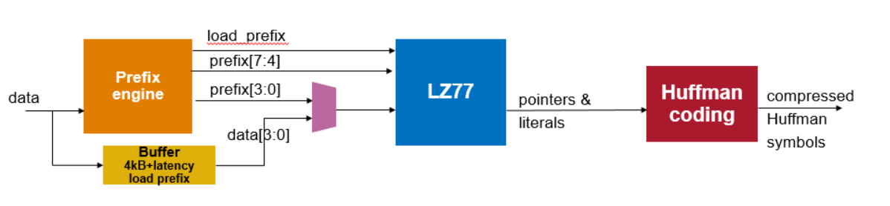Figure 3 LZ77 Compressor

## General Concept

In a nutshell, LZ77 operates as follows:

* Maintain a history buffer
  + A shift register holding previously entered data
* Identify sequences of bytes in the history window that match sequence of bytes at the input
* The longest sequence of bytes that match is the winner 🡪 there is a minimum match length (MinMatchLen) which must be met
* ‘Winning’ matches are represented as a pointer = {length, offset} and output as compressed data
  + Length = the length of the match (# of consecutive matching bytes in the sequence)
  + Offset = distance in bytes from the start of the match (matching sequence) to the first byte of the input sequence
* Inputs that are not part of a winning match are output unchanged 🡪 called ‘literals’
* Virtualized LPO’s
  + In an effort to reduce size and power upper ordered offsets collapse LPO’s into groups of 8 or 16, and each group implements a set of common logic which is shared by the group thus reducing the amount of overall logic required per offset. Within a group a winning offset is selected each cycle to which the common logic is applied, thereby created a set of 8 (or 16) “virtual lpo’s” which share the single set of common logic.
  + Only the first tile (tile 0) implements a full set of logic per offset. Tile 0 contains the first 512 LPO’s.
  + In tiles 1 to 31 offsets are collapsed into 8 offsets per group
  + In tiles 32 to 127 offsets are collapsed into 16 offsets per group
  + Testing has shown that virtualizing LPO’s results in only a slight, acceptable, reduction in compression quality, and provides a significant power/area savings.



Figure 4 LZ77 Block Diagram - Simplified

**Three STAGES within LZ77 processing:**

* #1 Find matches
  + Identify runs of consecutive matches starting at a coding position
  + Coding position is the first input which has not yet been represented as part of an output from the LZ77 compressor
    - Note: once a match reaches length = MinMatchLen = 4, then a match cycle is started and a pointer will be output
  + Track the length of these matches
* #2 Select winner
  + When all matches have ended, pick the longest 🡪 If there is a tie pick the one with the smallest offset
  + Winner decision is impacted by delay match window (DMW) and move to front (MTF)
* #3 Output compressed data
  + Any literals before the match followed by the pointer = {length, offset) of the match

## Vocabulary

* Literal Output that is exactly the input, not compressed;  
  A literal is 1B
* Pointer Output when a match is found, format is {type, length, offset};  
  Defines the length of the match and where the matching data is located relative to the start of the match;  
  Two pointer types: ptr & mtf
* Coding Position The point in the input byte stream at which a new match may begin 🡪 the first byte that is not yet output as a literal or part of a pointer
* MinMatchLen Minimum match length = 4B;  
  A consecutive run of byte matches shorter than 4 will be ignored
* MaxMatchLen Configured value, set to one of:  
   - size of history buffer  
   - 256B  
   - 64B
* Delay Match Window DMW, delay in bytes over which multiple matches are tracked to allow finding longer matches starting later in the input byte stream;  
  e.g. if DMW = 2, one match starts at input byte 500 and has length 24 and another match starts at input byte 502 and has length 28 🡪 the longer match starting at byte 502 would be selected.
* Move To Front Method for compressing the offset field in the pointer;  
  special type of output pointer
* History Buffer Shift register holding earlier input bytes to which the current input bytes are compared
* Window Size How far back into the history buffer to look for a match;  
  Defines the size of the history buffer used in finding matches
* Output Types Literal, Pointer, MTF Pointer
* Phase A four byte aligned, one’s based, index (i.e. 1, 2, 3 or 4) used to indicate the starting position of a run within a 4B window aligned to positions 15:12. For example, a “phase 1” run has positions 15:12 = 4’bxx01, and a phase 4 run has positions 15:12 = 4’b1111.

### Match Representation

There are two representations used for a match in this document. Both are interchangeable.

With the first type, matches at the LPO, Tile and Cluster are represented using the tuple {phase, fwd_therm, format} where:

* phase = start phase 🡪 # of consecutive matches in positions 15:12 starting at position 12 and going backward to position 15
  + i.e. 0’b1111 = phase 4, 0’b0111 = phase 3; 0’b0011 = phase 2; 0’b0001 = phase 1
* Format represents the base length of the matches going forward from 11 to 0
  + S = Short format = for matches starting at position 12 and ending before 8
  + M = Mid format = for matches starting at position 12 and ending between 8 and 5
  + L = Long format = for matches starting at position 12 and ending between 4 and 0
* fwd_therm = end partial quad match length 🡪 # of matches in last quad with a match
  + If short then the number of consecutive matches from 11 to 9
  + If middle then the number of consecutive matches from 7 to 5
  + If long then the number of consecutive matches from 3 to 0

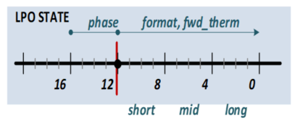

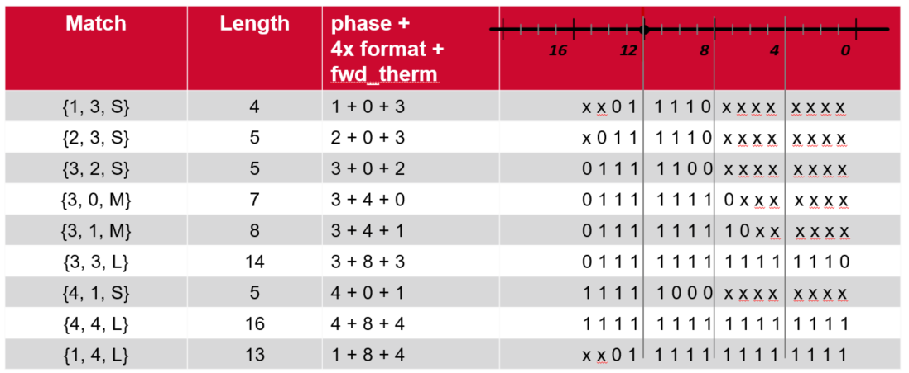

Figure 5 Illustration of Match Representation

With the second type, the format and fwd_therm are combined (expanded) into a single, fwd_therm value. In this type the fwd_therm is expanded from 4b to 12b, and the format is removed. The match tuple is thus, {phase, fwd_therm}.

|  |  |  |  |  |  |  |
| --- | --- | --- | --- | --- | --- | --- |
| Match | Length | phase +  fwd_therm | 15:12 | 11:8 | 7:4 | 3:0 |
| {1, 3} | 4 | 1 + 3 | xx01 | 1110 | xxxx | xxxx |
| {2,3} | 5 | 2 + 3 | x011 | 1110 | xxxx | xxxx |
| {3,2} | 5 | 3 + 2 | 0111 | 1100 | xxxx | xxxx |
| {3,4} | 7 | 3 + 4 | 0111 | 1111 | 0xxx | xxxx |
| {3,5} | 8 | 3 + 5 | 0111 | 1111 | 10xx | xxxx |
| {3,11} | 14 | 3 + 11 | 0111 | 1111 | 1111 | 1110 |
| {4,1} | 5 | 4 + 1 | 1111 | 10xx | xxxx | xxxx |
| {4,12} | 16 | 4 + 12 | 1111 | 1111 | 1111 | 1111 |
| {1,12} | 13 | 1 + 12 | xx01 | 1111 | 1111 | 1111 |

# LZ77 Implementation Overview

The Project Zipline LZ77 Compression Engine implementation is illustrated in below.

**Note, this section intentionally omits any reference to virtualized LPO’s.** For the purposes of the following discussion we consider 64K physical LPO’s, each with their own copy of byte match logic. This is done in order to simply the concepts which follow.



Figure 6 LZ77 Top Level Block Diagram

## LZ77 Major Blocks

### Logic Per Offset (LPO)

There are 64K of these elements, grouped in sets of 512 per Tile. Each LPO provides the following functions:

* Holds one byte of data for one offset in the history buffer
* Compares the input data to its local history buffer data 🡪 4 input bytes per clock cycle
* Tracks match state for its offset
* Generates outputs which are aggregated at the Tile level:
  + Current match is output as: valid, starting phase and length
  + Forward looking state for control signals: two indicators of upcoming matches and the associated length
    - len4_ind = indicates whether a length 4 match is present in forward byte match state
    - len5_6_ind = indicates whether a length 5 or 6 match is present in forward byte match state

### Tile

There are 128 of these blocks, grouped in sets of 16 per Cluster. Each Tile provides the following functions:

* Aggregates LPO match outputs
  + Groups matches by start phase and finds longest, selecting the lowest numbered offset when there is a tie – this is done using 4 search trees
* Collects length indicators for upcoming matches, aggregates outputs from all 512 LPOs
  + Aggregates len4_ind and len5_6_ind indicators
  + This aggregation function is a simple combinatorial OR of outputs
* Forwards results to Cluster
  + 4 search tree results plus 2 length indicators
* Generates control signals to all LPOs
  + Accepts control signals from Cluster & Match Engine and generates signals to LPOs
    - Moves the LPOs between NEW and CONT (continuing) states
  + Note that all Tiles generate exactly the same control signals to all LPOs in a Cluster
    - Control signals are generated in each Tile for convenience from a physical design perspective however the state is completely controlled by Cluster
    - Different Clusters may be in different states
* Tracks matches for MTF offsets – this is only supported in the 1st 512 LPOs (tile #0).
* Tile #0 collects MTF offset match information for every LPO and sends match results for all LPOs on the MTF offset list to Cluster
  + This is done in Tile 0 only where MTF winners are sent along with “regular” (i.e. non-MTF) winners to the cluster.
  + In all other Tiles the only the 4 regular winning matches (one per phase) are sent to the cluster

### Cluster

There are 8 of these blocks. Each Cluster provides the following functions:

* Aggregates Tile outputs:
  + 4 search trees for the match results, one per phase – finds longest match per phase (same as the tiles)
  + 2 forward looking match length indicators: len4_ind & len5_6
* Send match results to Match Engine
  + 4 search tree match results (one per phase) plus len4_ind & len5_6
  + Sends the MTF match results
    - Cluster 0 checks all LPOs in Tile 0; other clusters check Tile winners
* Manages the transition into and out of Continuing State
  + Clusters operate in one of two modes: NEW and CONT (continuing)
  + Each cluster accepts control information from the Match Engine as well as forward match information from all the LPOs – this is used to set the state
  + Cluster sends control information to all the Tiles: cont_phases

### Match Engine (ME)

There is one Match Engine. It accepts inputs from the 8 Clusters and provides the following functions:

* Aggregates the search tree results from all Clusters
* Decides which match result is the winning match on each clock cycle
  + Finds longest match in DMW
  + Check if there is an MTF winner over that longest match
* Drives the output based on selected winner
  + May output pointers and/or literals
  + Determines the new coding position
* Using the new coding position, len4_ind and len5_6_ind sets the allowed DMW
  + This DMW is sent to all clusters and conditions the move to CONT state

Refer to the Match Engine section for more details on ME.

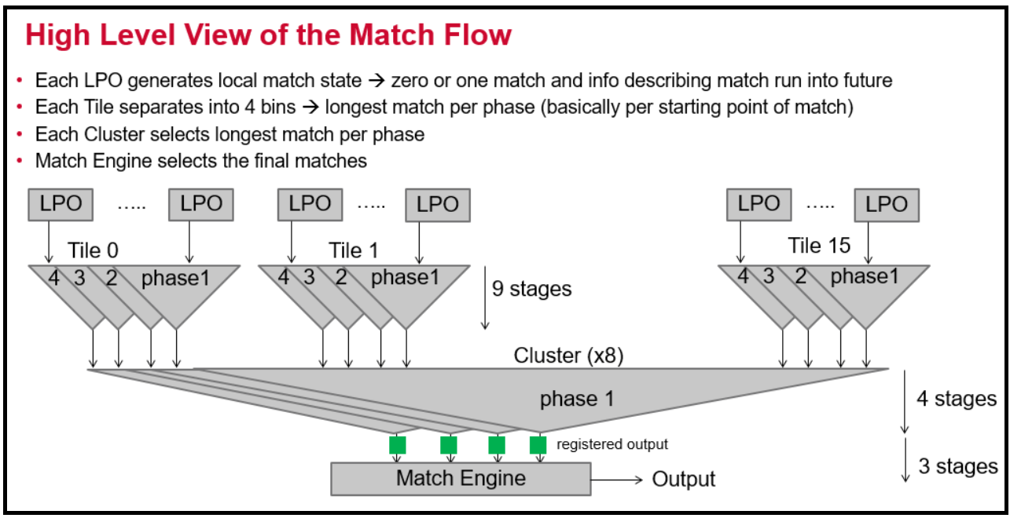

Figure 7 Match Flow

## Decision Flow

The following summarizes the decision flow within the compressor.

* **Match Engine makes a decision based on state anchored on a specific input byte**
  + The anchor is position 12 in LPO and position 16 in Match Engine
    - Position 16 in Match Engine due to 1 clock delay between LPO and Match Engine 🡪 4 more bytes arrived at LPO
  + The anchor byte is processed at the match engine 4 clocks after it arrived at the LPO
* **Forward state allows Match Engine to quickly determine the longest match(es)**
  + If no match runs longer than the byte matches represented in data from LPOs, the winner can be selected
  + When a match or no match decision is reached, Match Engine outputs literals and/or pointer and returns to look for the next match
* Notes:
  + Smallest match is 4B
  + Once any match of length 4 is found, there will be a {pointer, offset} output
    - However, the exact start of the match is not known until the initial match ends and any other matches within the DMW (if any) also end

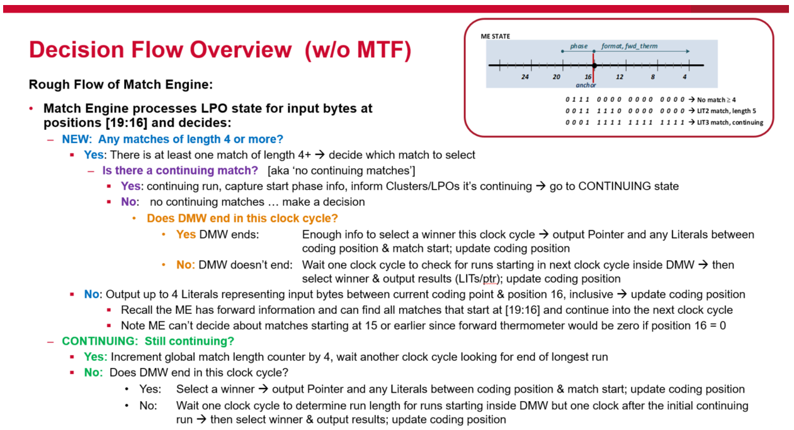

Figure 8 Summary of Match Engine Decision Flow

## Control Signals & Timing

This section describes the timing of the critical paths in the LZ77 compressor. Timing here refers to across multiple clock cycles.

The first sub-section covers the timing for moving into and out of continuing state.

The second sub-section covers timing around qualifying matches to be valid outputs based on the cluster thresholds.

BACKGROUND

A key aspect of the implementation is a 3 clock cycle feedback loop between the LPOs and the Match Engine. Physical timing is designed around registering all signals at the Cluster output, Match Engine output and Cluster/Tile inputs. This results in the following timing:

* One register from LPOs to Match Engine 🡪 1 clock delay
* Two registers from Match Engine back to all LPOs 🡪 2 clock delay

The figure below illustrates these implementation details.



Figure 9 Control & State Timing in LZ77

**This 3 clock feedback cycle is accommodated by accumulating 4 clock cycles worth of state before beginning to generate match information and decisions.** Therefore, when match state results are generated for the 4 bytes arriving at clock N, the byte match results for the next 12 bytes (3 clocks) is also available. The 4 bytes arriving at clock N, for which the match output results are generated, are referred to as the anchor position 🡪 the match decision for the clock cycle is anchored on the match results for those 4 bytes. See the figure below.



Figure 10 Timing of LPO Byte Matches

In the example above, in clock 1 the first byte match is detected at the LPO. LPO accumulates the state until clock 4 when a valid match output is generated. At clock 4 the LPO generates match results which the Match Engine will use to decide how to process the input bytes from clock 1. The LPO match output is registered in the Cluster and arrives at the Match Engine in clock 5. A control signal generated by the Match Engine in clock 5 will reach LPOs in clock 7.

The figure below represents the byte matches (bm) with numbering from 15 to 0, where 0 is the byte match result for the newest input byte. The results match the example in Figure 10, where N = 0. This numbering is used throughout the design where 0 = newest byte. Note that the Match Engine anchor is 19:16 since there is an additional clock cycle of delay before the bm results reach the ME.



Figure 11 Illustration of Byte Match Results over 4 Clock Cycles

### NEW and CONT State - Timing

Each cluster operates in either NEW or CONT state. The decision to move into and out of CONT state is a critical aspect of the system. The single cycle state transitions between NEW or CON’T are called ENTERING_NEW and ENTERING_CONT.

Referring to Figure 10 above, at clock 4 the LPO has byte match results from clock 1 plus 3 additional clock cycles – 12 bytes – into the “future”. The match output is based on the match at position [15:12] (=phase) plus the length of the match going forward (a.k.a looking into the future) from 12 to 0.

The 12 bytes of match state associated with clocks 2-3-4 are referred to as ‘forward looking state’. Forward state allows the match engine to determine if the match ends within the next 3 clocks. If all matches end within the next 3 clock cycles the Match Engine can immediately determine which match should be selected as the winning match. Clusters free run, sending the ME the current match state at [15:0] each clock cycle and the ME makes all the decisions with no feedback to the Clusters. This is called the NEW state.

Note: Given 4 input bytes per clock and a minimum match length of 4, only one match can start, within those 4 bytes, in a clock cycle and only one match can end, within those 4 bytes, in a clock cycle. In other words, if, for example, we received 32 bytes per cycle with a minimum match length of 3 bytes, there would be multiple places within the 32 bytes where runs could start or stop. This situation does not occur with this design.

If a match runs beyond the next 3 clock cycles it may be a continuing match. A cluster with a continuing match will move to CONT state. In NEW state the ME has all the information about the start and end of every run. When a continuing match is present, the ME cannot select the winning match immediately (i.e. in the given clock cycle). This requires each LPO to keep track of where its local run started and whether that run is competing to be the longest match. LPOs keeping state is a challenge because registers/latches add size to the engine – increasing die cost and making closing timing in physical design more challenging. Therefore, the state is made as small as practical.

In order to decide if a long match should be treated as a continuing match the clusters need to know the allowed start window, DMW. The DMW is distributed to the clusters so they can determine if the long match qualifies to be a continuing match and if the cluster should move to CONT state. The ME needs to know the DMW early so it can send it to the clusters since it takes 2 clock cycles to reach all LPOs. The clusters generate the control signal len4_ind to enable the ME to determine the DMW early.

When cluster & tiles determine a continuing run is present the dmw_cont signal is set and each LPO determines if its run is qualified. The decision to move to CONT is made 2 clock cycles after the continuing run was at the anchor position of 12 in the LPO. Once in CONT mode the cluster & tiles set the ti_lpo_cont signal to indicate CONT mode is still active; this signal is cleared when cluster moves back to NEW state.

In CONT mode the ME knows each valid match it receives is an extension of a continuing run – the LPOs have filtered out all other matches. This allows ME to track the longer runs and find the eventual winning match.

Note: The LPOs operate differently in NEW and CONT state:

* NEW: free run (aka skate) with match output based on byte match from last 4 clocks
* CONT: track start of the match and corresponding DMW, if local run is candidate longest match then generate output; otherwise no output even if a length 4+ match is present
  + Phrase ‘get on the train’ refers to an LPO deciding its match is qualified to be output in CONT state

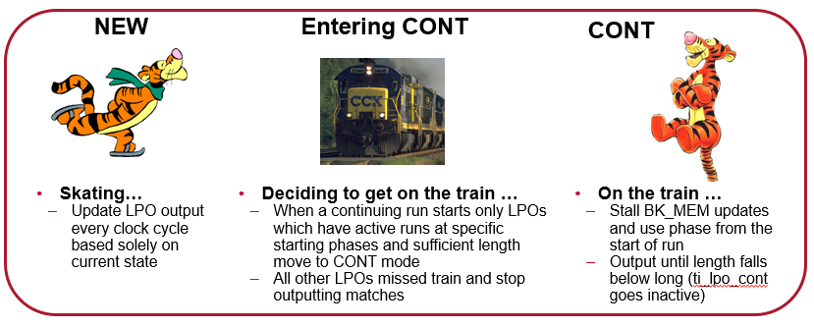

It is important that the Clusters & LPOs move back to NEW mode quickly at the end of a continuing run so the Match Engine can find new matches that start immediately after the continuing run. Once a cluster moves to CONT state it remains in CONT state until the continuing run is no longer continuing thru position 0.

HIGHLIGHT NOTES:

* Only a match in the DMW may move the cluster to continuing state. The window position is held in the Match Engine. There is a 2 clock cycle delay from when the ME generates the control signal defining the allowed start window (me_dmw_cont) before that signal will reach the LPOs.
  + Clusters generate len4_ind to provide early info to ME for this
* Cluster decides whether to move to CONT state 2 clock cycles after a match of continuing length is at the anchor position 12 in the LPO. Only move to continuing if:
  + There is a continuing length match in the cluster within the me_dmw_cont (i.e. within the DMW)
* Clusters move back to NEW state when continuing match ends
  + There is always at least one clock cycle of NEW state between consecutive continuing matches
  + There are 2 scenarios for moving back to NEW state:
    - Continuing run that is of length greater than (phase + 12) will eventually move to a length long run with fwd_therm <4; this will trigger the move to NEW
    - Continuing run that is exactly of length (phase + 12) will result in a single clock cycle of CONT state; it will be of length middle during the CONT state clock cycle

The design relies on the following controls:

1. LPOs provide ME with early indication of length 4 matches: len4_ind
   1. len5_6_ind are used to handle 3 special corner cases surrounding short runs and MTF.
2. ME provides Cluster with allowed start window: me_dmw_cont
   1. Uses current coding position along with len4_ind to set DMW
3. Cluster tracks the match data sent to ME: cont_phases
   1. Records each phase which has a potential continuing run – i.e. (x, 4, L)
4. Clusters combine cont_phases with me_dmw_cont to determine when to move to CONT state
5. Clusters use match outputs to determine when continuing matches end and moves LPOs back to NEW state when continuing runs end.

The key control signals are listed in the table.

Table 10 LZ77 Key Control Signals[1]

| Source | Signal Name | Width | Description |
| --- | --- | --- | --- |
| Match Engine | **me_dmw_cont** | 6 | Defines at which position a continuing match may start – up to 3 bits may be set based on DMW configuration |
| Cluster | **cont_phases** | 4 | Stores which phases had a continuing match on the previous clock cycle   * Delayed one clock to align with decision to move in to CONT   Not delayed one clock on move out of CONT back to NEW immediately |
| Cluster | **cluster_cont** | 1 | Indicates cluster has a continuing match that is still continuing through position 0 and is in the allowed DMW – if set the LPO output was generated in CONT state |
| Tile | **tile_cont,**  **tile_cont_r** | 1  1 | Indicates cluster has moved to CONT state:   * Same state as cluster_cont, duplicate generation in Tile for timing * _r is one clock cycle delayed version |
| Tile | **tile_dmw_cont** | 4 | Generated from me_dmw_cont and cont_phases, is non-zero when cluster enters CONT state; sent to all LPOs   * one hot encoding of start of DMW |
| LPO/Tile/Cluster | **len4_ind** | 4 | Early indication of length 4 match, per phase   * generated in LPOs and aggregated by Tiles & Clusters |
| LPO/Tile/Cluster | **len5_6_ind** | 3 | Early indication that a run of (at least) 5B or 6B starts at position 7 or 6   * len5_6_ind[2] - 6B in postions 7:2 * len5_6_ind[1] - 5B in postions 7:3 * len5_6_ind[0] - 5B in postions 6:2 |
| LPO | **valid_phase**  **fwd_therm** | 4  12 | Match Outputs   * generated in LPOs and aggregated by Tiles & Clusters |
| Tile | **offset x4**  **fwd_therm x4** | 9  13 | Match outputs from Tile to Cluster – 4 outputs, one per start phase. Bit[0] of fwd_therm is a “valid” bit which qualifies the run length captured in bit[12:1] |
| Cluster | **offset x4**  **fwd_therm x4** | 13  13 | Match outputs from Cluster to ME – 4 outputs, one per start phase. Bit[0] of fwd_therm is a “valid” bit which qualifies the run length captured in bit[12:1] |

#### High Level Timing

The figure below shows the general timing across clocks when match length is greater than (phase+12) – meaning the match continues beyond the initial [p,4,L] length, where p is 1, 2, 3 or 4. The cluster tracks the match outputs and detects when fwd_therm msb is 0 (i.e. the run does not continue into the next clock cycle). This triggers the move back to NEW.



Figure 12 Move to CONT on Match Length > (phase + 12)

When the match is exactly [p,4,L] length (p+12B) the run has already ended by the time the cluster moves to CONT state. In this case CONT state only lasts one clock cycle. See figure below.



Figure 13 Move to CONT on Match Length = (phase + 12)

#### Top Level Control Signal Flow

Figure 14 below shows the control signals between the major blocks. Only one of each block type is shown for clarity; the control signals and outputs are identical on all LPOs, Tiles and Clusters except for Tile 0 in Cluster 0 which has additional logic for MTF. Refer to the Sections 7.2.3 and 8.2.4 for information on MTF.

Refer to sections on Cluster, Tile and LPO for details on how the various signals are generated.



Figure 14 State Control Signals

#### Detailed Timing

The timing for the state controls is illustrated in the figure below.



Figure 15 Continuing Match Timing - Basic

* GREEN = Continuing match at LPO output (clk 4)
* PURPLE = LPO moves to CONT state (clk 6)
* RED = LPO output that will cause Cluster to return to NEW state (clk 7)

The following describes the timing associated with the len4_ind and me_dmw_cont. The len4_ind is used with coding position (as determined by MSM state) to calculate the DMW. The DMW is sent to the Cluster/Tile/LPO such that it aligns with the clock cycle when the decision to go to CONT is made in the cluster.

* DMW TIMING:
  + len4_ind[3:0] is generated using BM[7:1] 🡪 it is valid in the LPO/Cluster in clock 2
  + len4_ind is registered at cluster output and reaches ME in clock 3
  + len4_ind is registered in ME one clock and used in clock 4
  + me_dwm_cont[5:0] output is registered in ME, output on clock 5, and registered again at Tile/Cluster inputs so arrives at LPO in clock 6
  + len5_6_ind handle 3 corner-cases involving small runs combined with MTF, and is not shown here for simplicity.
* MATCH TIMING
  + The continuing match (1, 4, L) reaches LPO anchor position in clock 4 🡪 reaches ME in clock 5
  + ME recognizes the long run, sets the coding position @ minus1 [state = UM1D]
    - State goes to UM1D: (Used Minus 1 Dummy)
    - ‘used minus 1’ because it’s phase 1 so relative to position 16 in ME, minus one 1 byte needs to be represented in the output – the other 3 bytes in this clock cycle are output as literals
    - ‘dummy’ because the ME ignores the output this clock and waits to see if any cluster(s) go to CONT
  + In clock 5, the LPO continues in NEW state
    - The clock cycle after a continuing match starts is always NEW state
    - LPO uses [15:0] to generate an output = (4, 4, L)
  + At clock 6 the cluster goes to continuing state and LPO determines it has a qualified match
    - Cluster detects the long match in clock 4 (when output [1,4,L] was sent to ME)
    - cont_phases[3:0] tracks when matches long enough to be continuing are sent to Match Engine; this is maintained per phase
    - If cont_phases > or equal to me_dmw_cont, go to CONT state
    - At clock 8 the long match is middle format
    - This is the last CONT state output, the cluster will move to NEW on the next clock cycle
    - Cluster cont_phases shows no continuing long runs 🡪 match output in clock 7 was (1, 2, L) indicating the run is ending

# Cluster

There are 8 clusters in the LZ77 compression engine. Clusters are the same except for Cluster 0 which includes additional logic to support MTF across all LPOs in Tile 0.

**Note, this section intentionally omits any reference to virtualized LPO’s.** For the purposes of the following discussion we consider 64K physical LPO’s, each with their own copy of byte match logic. This is done in order to simply the concepts which follow.

## Cluster Top Level

The figure below illustrates the Cluster components. In addition to 16 Tiles, each cluster includes the following logic:

* 4 search trees for aggregating the match results from the Tiles
* MTF match collection
* Aggregation for len4_ind and len5_6_ind
* Control logic for states: NEW & CONT

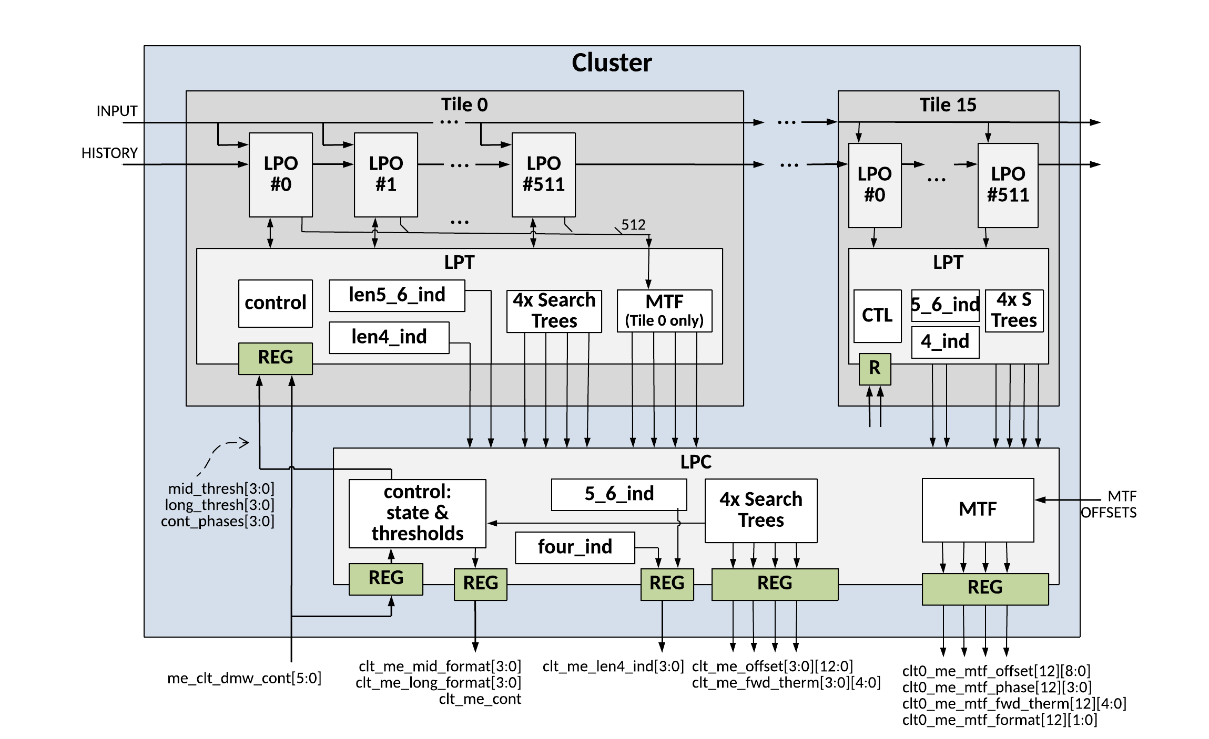

Figure 16 LZ77 Cluster Top Level

### Cluster Inputs

The table below lists the cluster input signals.

Table 11 Cluster Inputs

| Signal Name | Width | Description |
| --- | --- | --- |
| **clk** | 1 | clock |
| **raw_rst_n** | 1 | reset |
| **bypass_reset** | 1 | dft use |
| **test_rst_n** | 1 | dft use |
| **clt_shift_data** | 4x 8 |  |
| **clt_shift_data_vld** | 4x 1 | Control bits indicating shift data is valid |
| **clt_shift_en** | 1 | Set to one if history buffer is shifting – accept new sdi |
| **clt_prefix_data** | 8x 8 | Data for pre-loading the history buffer |
| **clt_prefix_data_vld** | 8x 1 | Control bits indicating prefix data is valid |
| **clt_prefix_en** | 1 | Set to one if history buffer is loading prefix |
| **clt_input_data** | 4x 8 | Input data fanned out to the input of all clusters/tiles |
| **clt_input_data_vld** | 4x 1 | Control bits indicating input data is valid |
| **clt_input_en** | 1 | Set to ‘1’ if input_data is valid and LPO should process the input_data and generate match results |
| **clr_valid** | 1 | Clear the history buffer. Asserted for one cycle between frames |
| **tile_enable** | 1 | Enabled tiles participate in matching the input to the history buffer. Used to set the history buffer depth. |
| **me_clt_dmw_cont** | 6 | Control from Match Engine setting allowed start windows for continuing matches |
| **CLUSTER 0 ONLY** |  |  |
| **me_clt0_mtf_list** | 4x 9 | List of 4 MTF offsets, only those in Tile 0 |
| **me_clt0_mtf_list_valid** | 4x 1 | Valid bit for MTF offset list |

### Cluster Outputs

The table below lists the cluster output signals.

Table 12 Cluster Outputs

| Signal Name | Width | Description |
| --- | --- | --- |
| **clt_shift_data_out[1:0]** | 4x 8 |  |
| **clt_shift_data_out_vld** | 4x 1 | Control bits indicating shift data out is valid |
| **clt_prefix_data_out[2:0]** | 8x 8 | Data for pre-loading the history buffer |
| **clt_prefix_data_out_vld** | 8x 1 | Control bits indicating prefix data out is valid |
| **clt_me_offset[3:0]** | 4x 13 | Lowest number offset with longest match starting at each of 4 phases |
| **clt_me_fwd_therm[3:0]** | 4x 5 | fwd_therm for longest match starting at each of 4 phases |
| **clt_me_cont** | 1 | When set, indicates the cluster match outputs were generated in CONT state |
| **clt_me_len4_ind** | 4 | State indicating a length 4 match is present at the corresponding start phase; this state generated with bm[7:4] and is used by Match Engine to determine the DMW |
| **clt_me_len5_6_ind** | 3 | Early indication that a run of (at least) 5B or 6B starts at position 7 or 6   * len5_6_ind[2] - 6B in postions 7:2 * len5_6_ind[1] - 5B in postions 7:3   len5_6_ind[0] - 5B in postions 6:2 |
| **clt_me_truncated** | 4 | Indicated the output run has been truncated due to reaching a maximum configured length |
| **CLUSTER 0 ONLY** |  |  |
| **clt0_me_mtf_offset[20]** | 20 x9 | MTF: offsets in Tile 0 which may be mtf based on MTF list from ME and winners from previous 4 clk cycles |
| **clt0_me_mtf_phase[20]** | 20 x4 | MTF: phases associated with matches at above offsets |
| **clt0_me_mtf_fwd_therm[20]** | 20 x12 | MTF: fwd_therm associated with matches at above offsets |

## Logic Per Cluster (LPC)

This section describes the functions performed in the LPC.

### Search Trees

A search tree implements an ordered comparison of run lengths. The input ports of a search tree are driven with thermometers which hold runs corresponding to physical offset positions which are spatially aligned at the input to the search tree. (i.e. lower offsets starting on the left side of the search tree, and moving right with increasing offset number). Each input is a forward thermometer of some, configured, length. Each comparison point within a search tree is called a node, and each node compares the length of two thermometers at two different offsets; ties go to the lower offset. The diagram below depicts a single node which compares two 5b thermometers at offsets 6 and 7. Offset 6 has a length of 2 and offset 7 has a length of 4 so offset 7 is output as the winner.

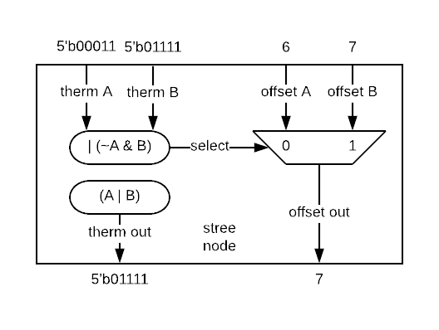

Figure 17 Single search tree node

Nodes are combined to create a larger search tree where the number of levels in a tree (L) is equal to the log of the number of offsets (O) being compared, L = log2O.

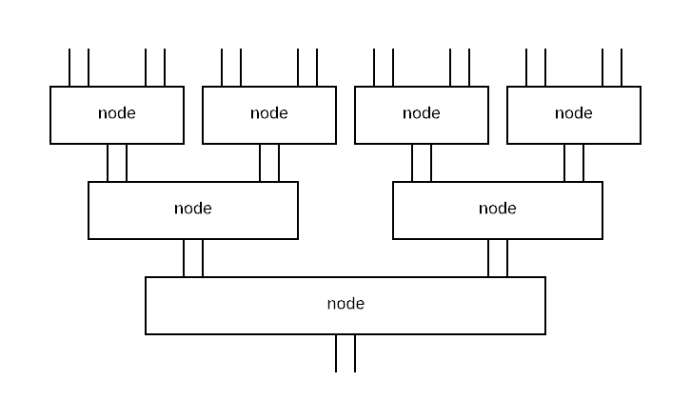

Figure 18 Search Tree comparing 8 offsets

### Continuing State

The Cluster LPC (logic per cluster) generates one of the two control signals used to enter and leave CONT state. It monitors the match outputs to determine if a match of sufficient length to move to CONT state is present and generates:

* cont_phases used, along with me_dmw_cont, to determine when to go to CONT

Cluster tracks the output match state sent to the Match Engine and keeps a record of which phases had a continuing match of format [p, 4, L]. This is done by checking the msb of the fwd_therm at each of the 4 start phases:

* cont_phases[3] = phase 4 fwd_therm[12]
* cont_phases[2] = phase 3 fwd_therm[12]
* cont_phases[1] = phase 2 fwd_therm[12]
* cont_phases[0] = phase 1 fwd_therm[12]

Two versions of cont_phases are maintained:

* cont_phases[3:0] = directly taken from winning fwd_therms
* cont_phases_r[3:0] = registered version of cont_phases

The ME sends me_dmw_cont[5:0] which is registered at the Cluster input as me_dmw_cont_r[5:0]. This signal indicates where continuing runs are allowed to start. The figure below illustrates how the DMW relates to the state in the LPO. Recall the decision to get on the train is made 2 clocks after the continuing match started at the anchor positions [15:12].



Note that the window may extend into positions [19:18] however it cannot start there – it can only start at [23:20] – so cont_phases need only be 4 bits.

If cont_phases_2r[3:0] indicates a continuing match is present in the cluster which starts before or within the me_dmw_cont_r[5:2] window then the Cluster will enter CONT state. If not, then the cluster remains in NEW state. Note that this decision is based solely on the stored state at cont_phases_r and me_dwm_r. The current fwd_therm state is not relevant.



Figure 19 Timing for cont_phases

Once the cluster has moved to CONT state, the cont_phases[3:0] is used to determine when to return to NEW state. As soon as fwd_therm msb = 0 the cluster returns to NEW state the next clock cycle. This timing on leaving CONT state relies directly on cont_phases.

The cluster generates cont_phases which is distributed directly to all Tiles as well as registered locally in the LPC. LPC generates the cluster_continuing based on its local cont_phases state. Each Tile also generates ti_lpo_cont using the cont_phases and me_dmw_cont_r signals. The logic is replicated at the Tile for PD timing.

Summary:

* cluster_continuing = REG[ (cont_phases_r[3:0] > me_dmw_cont_r[5:2]) or   
   (cont_phases_r[3:0] & me_dmw_cont_r[5:2]) or  
   ((cont_phases_r[3:0] > 0) & cluster_continuing) ]

### Cluster MTF

MTF offsets are held in the Match Engine. All clusters except cluster 0 send the 4 longest matches, one per phase, to the ME. The ME checks if any of these winners is an MTF offset and if so includes it as a possible winner with the benefit of being up to 3 matches shorter than non-MTF winners in the DMW.

Cluster 0 includes Tile 0 which checks all its LPOs. These LPOs have a second interface which outputs the match results regardless of the thresholds. The tile keeps the list of 4 offsets from the ME as well at the 4 winners from the previous four clock cycles. The match results from the resulting 20 offsets are sent through the LPC to the ME.

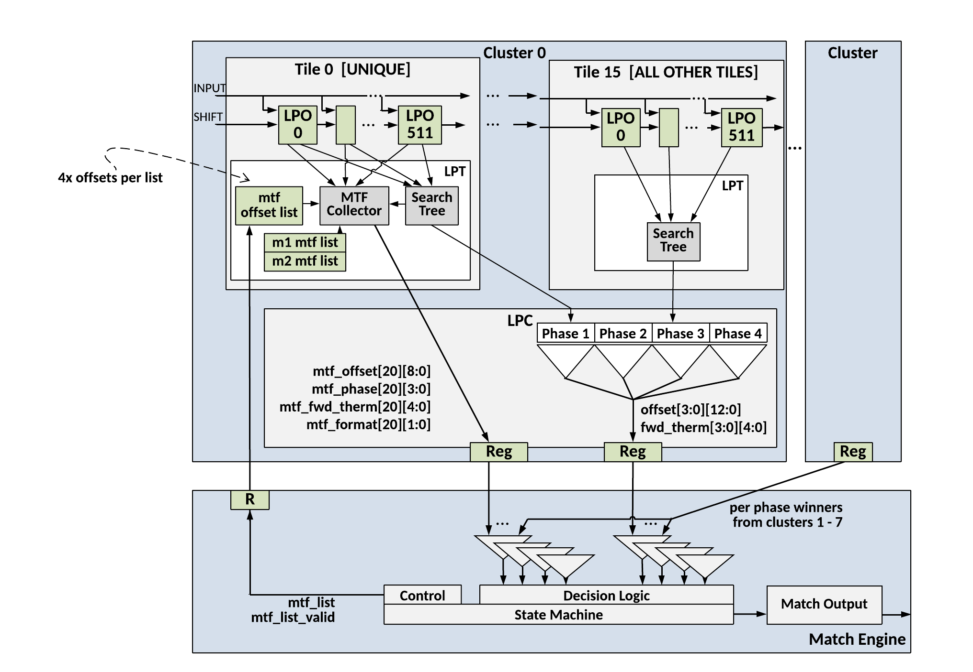

Figure 20 Cluster MTF

## Truncation

### Purpose and Scope

This section describes the behavior of implementing a Maximum match length for the LZ77 compressor.

### Some Assumptions

This is the match format for this document:

[1,3] = phase 1 len 4

[1,4] = phase 1 len 5

[1,5] = phase 1 len 6

[1,6] = phase 1 len 7

[1,7] = phase 1 len 8

[1,8] = phase 1 len 9

[1,9] = phase 1 len 10

[1,10] = phase 1 len 11

[1,11] = phase 1 len 12

[1,12] = phase 1 len 13 =C

[2,2] = phase 2 len 4

[2,3] = phase 2 len 5

[2,4] = phase 2 len 6

[2,5] = phase 2 len 7

[2,6] = phase 2 len 8

[2,7] = phase 2 len 9

[2,8] = phase 2 len 10

[2,9] = phase 2 len 11

[2,10] = phase 2 len 12

[2,11] = phase 2 len 13

[2,12] = phase 2 len 14 =C

[3,1] = phase 3 len 4

[3,2] = phase 3 len 5

[3,3] = phase 3 len 6

[3,4] = phase 3 len 7

[3,5] = phase 3 len 8

[3,6] = phase 3 len 9

[3,7] = phase 3 len 10

[3,8] = phase 3 len 11

[3,9] = phase 3 len 12

[3,10] = phase 3 len 13

[3,11] = phase 3 len 14

[3,12] = phase 3 len 15 =C

[4,0] = phase 4 len 4

[4,1] = phase 4 len 5

[4,2] = phase 4 len 6

[4,3] = phase 4 len 7

[4,4] = phase 4 len 8

[4,5] = phase 4 len 9

[4,6] = phase 4 len 10

[4,7] = phase 4 len 11

[4,8] = phase 4 len 12

[4,9] = phase 4 len 13

[4,10] = phase 4 len 14

[4,11] = phase 4 len 15

[4,12] = phase 4 len 16 =C

### Overview

The LZ77 design has 64K offsets. The design is implemented as 8 clusters of 8K offsets each.

Each cluster will output 1 winner for each of 4 phases. The cluster is implemented as a set of 16 tiles of 512 offsets each. Tile0 includes offsets 0 to 511.

The LZ77 compressor has a maximum match length which is fixed for a particular frame of data. This has not yet been implemented in the LZ77 compressor RTL.

### Match Length approach

The goal of the maximum match length is to end matches which reach or exceed the maximum match length and allow them to start again immediately. The MaxMatchLen function, however, is not a valuable feature in that being better at it does not improve compression. Given that, using fewer resources and implementing a less perfect solution should be considered.

The primary issue is the truncation gates which amount to 26 gates per offset which would be maybe a percent or more of the design. If the truncation is not done at the offset but at the cluster or CIF level, there will be some deviation from the idea. The effect would be 2 fold. First, a match of say 22 would beat a match of 18 even though they will both be truncated to 18 after the STREEs. This would cause the design to select matches with larger offsets than the ideal which is acceptable since the impact on compression would be insignificant. This happens because the STREE will simply select the offset for the longest match if the matches are not truncated before the STREE. The second part of the effect is due to the STREE implementation. The STREE will select the correct length for match which is [X, 4, L] but will not necessarily select the correct offset. The STREE will select the lowest offset of all matches which are [X, 4. L] and [X, 3 L]. The length will be [X, 4, L]. If we always either wait for the end or truncate an [X, 4, L] after the STREE, then the effect will essentially be that the resulting offsets for truncated matches might differ from the ideal. Again, the impact on compression would be insignificant.

This would create more (maybe not insignificant) model work but it should not create another MS approval cycle.

The MaxMatchLen can be set to 3 values:

Maximum symbol length

00: LZ77 window size,

01: 258B (Deflate)

10: reserved

11: 64 Bytes (Debug)

The window size can be set to 6 values:

LZ77 Window Size

0: 512B (Debug)

1: 4KB

2: 8KB

3: 16KB

4: 32KB

5: 64KB

6-7: Reserved

All of the window sizes are divisible by 4 but use a -1 in the model. This means that the maximum length match is, for example, 64KB -1 or 4KB -1.

For a Phase 4 match supporting a maximum length of 64B, when 64B is exceeded, if a [4, 4, L], [4, 3, L], [4, 2, L] or [4, 1, L] exists in a cluster, the output of the cluster will be truncated to [4, 0, L]. If a [4, 4, L] or [4, 3, L] exists in a cluster, the offset output from the cluster will reflect the lowest offset of all [4, 3, L] and [4, 4, L] matches. If a [4, 4, L] or [4, 3, L] does not exist in a cluster, the offset output from the cluster will reflect the lowest offset of all [4, 2, L] if one exists. If a [4, 4, L], [4, 3, L] or [4, 2, L] does not exist in a cluster, the offset output from the cluster will reflect the lowest offset of all [4, 1, L] if one exists. If a [4, 4, L], [4, 3, L], [4, 2, L] or [4, 1, L] does not exist in a cluster, the offset output from the cluster will reflect the lowest offset of all [4, 0, L]. In terms of the offset output, this is not optimal behavior.

For a Phase 3 match supporting a maximum length of 64B, when 64B is exceeded, if a [3, 4, L], [3, 3, L] or [3, 2, L] exists in a cluster, the output of the cluster will be truncated to [3, 1, L]. If a [3, 4, L] or [3, 3, L] exists in a cluster, the offset output from the cluster will reflect the lowest offset of all [3, 3, L] and [3, 4, L] matches. If a [3, 4, L] or [3, 3, L] does not exist in a cluster, the offset output from the cluster will reflect the lowest offset of all [3, 2, L] if one exists. If a [3, 4, L], [3, 3, L] or [3, 2, L] does not exist in a cluster, the offset output from the cluster will reflect the lowest offset of all [3, 1, L] if one exists. In terms of the offset output, this is not optimal behavior.

For a Phase 2 match supporting a maximum length of 64B, when 64B is exceeded, if a [2, 4, L] or [2, 3, L] exists in a cluster, the output of the cluster will be truncated to [2, 2, L]. If a [2, 4, L] or [2, 3, L] exists in a cluster, the offset output from the cluster will reflect the lowest offset of all [2, 3, L] and [2, 4, L] matches. If a [2, 4, L] or [2, 3, L] does not exist in a cluster, the offset output from the cluster will reflect the lowest offset of all [2, 2, L] if one exists. In terms of the offset output, this is not optimal behavior.

For a Phase 1 match supporting a maximum length of 64B, when 64B is exceeded, if a [1, 4, L] exists in a cluster, the output of the cluster will be truncated to [1, 3, L]. The offset output from the cluster will reflect the lowest offset of all [1, 3, L] and [1, 4, L] matches if one exists. This is optimal behavior.

### Summary

From a high level, in the clusters, the DMW is used to compute a running size that can be started for each phase in the of DMW. Each clock cycle, 4 is added to the running size for each phase. When the running size reaches the maximum match length, the matches for that phase are truncated at the cluster level. Essentially, the cluster winners are truncated to the maximum match length.

Simultaneously, the LPOs are informed that the match has ended (is no longer continuing).

Since all the LPO are not continuing, there will be no more continuing matches so the STREE will compute the correct offset and winner. The ME will process the end of the match, output the pointer and move to the correct states.

### Calculate the Running Size per Phase from the DMW

The DMW determines the start of the running size per offset, now called Ph1Len, Ph2Len, Ph3Len and Ph4Len in this document. Other than DMW = 0 (meaning no DMW update), there are 12 possible DMWs. The table below shows the starting size of the phase lengths versus the DMW.

Table 13: Phase Length counters initial values

|  |  |  |  |  |
| --- | --- | --- | --- | --- |
| DMW | ph4len | ph3len | ph2len | ph1len |
| 432 | 24 | 23 | 22 | X |
| 321 | X | 23 | 22 | 21 |
| 214 | 20 | X | 22 | 21 |
| 143 | 20 | 19 | X | 21 |
| 43 | 24 | 23 | X | X |
| 32 | X | 23 | 22 | X |
| 21 | X | X | 22 | 21 |
| 14 | 20 | X | X | 21 |
| 4 | 24 | X | X | X |
| 3 | X | 23 | X | X |
| 2 | X | X | 22 | X |
| 1 | X | X | X | 21 |

On each subsequent clock, the phase lengths are increased by 4. If the cluster is not continuing, the phase lengths will provide no value. When the count reaches maximum and the force_end is sent the counts can be safely zeroed until the next DMW.

### Compute Truncation

The truncation of matches is performed on the cluster winners by masking out bits of the 12 bit forward thermometer (cl_longest_therm_out[11:0]) in the cluster. The bits of the mask are computed by comparing the MaxMatchLen to the phase length counters. This is illustrated in the figures below. (MaxMatchLen >= phXLen_r – 0) is the equation for the MSB of the mask for each phase.

(MaxMatchLen >= phXLen_3r – 1) is the equation for MSB -1 of the mask for each phase. And so on. The truncation used the phXLen delayed 3 clocks in order to line up the timing with the LPOs coming out of continuing.









### End Matches in LPO

One signal is needed for the LPO. The signal is computed in the cluster and then clocked 2 times on the way to the LPOs. The signal is force_done_2r. me_force_done_r is an output from the Cluster. Force_done happens when all the counts (which are in the DMW) exceed the MaxMatchLen.

The equation for force_done is an AND of the MaxMatchLen < phXlen.



When the force_done_2r signal gets to the LPOs, it will force any LPOs in continuing to go to NEW in that cycle.

# Tile

There are 16 Tiles in each Cluster. Tiles are the same except for Tile 0 which includes additional logic to support MTF across all LPOs in Tile 0.

**Note, this section intentionally omits any reference to virtualized LPO’s.** For the purposes of the following discussion we consider 64K physical LPO’s, each with their own copy of byte match logic. This is done in order to simply the concepts which follow.

## Tile Top Level

The figure below illustrates the Tile components. There are 16 tiles per cluster. Each Tile includes 512 LPOs and one LPT block.

Tile 0 has additional logic to support checking all LPOs for MTF. This is described in Section 8.2.4.

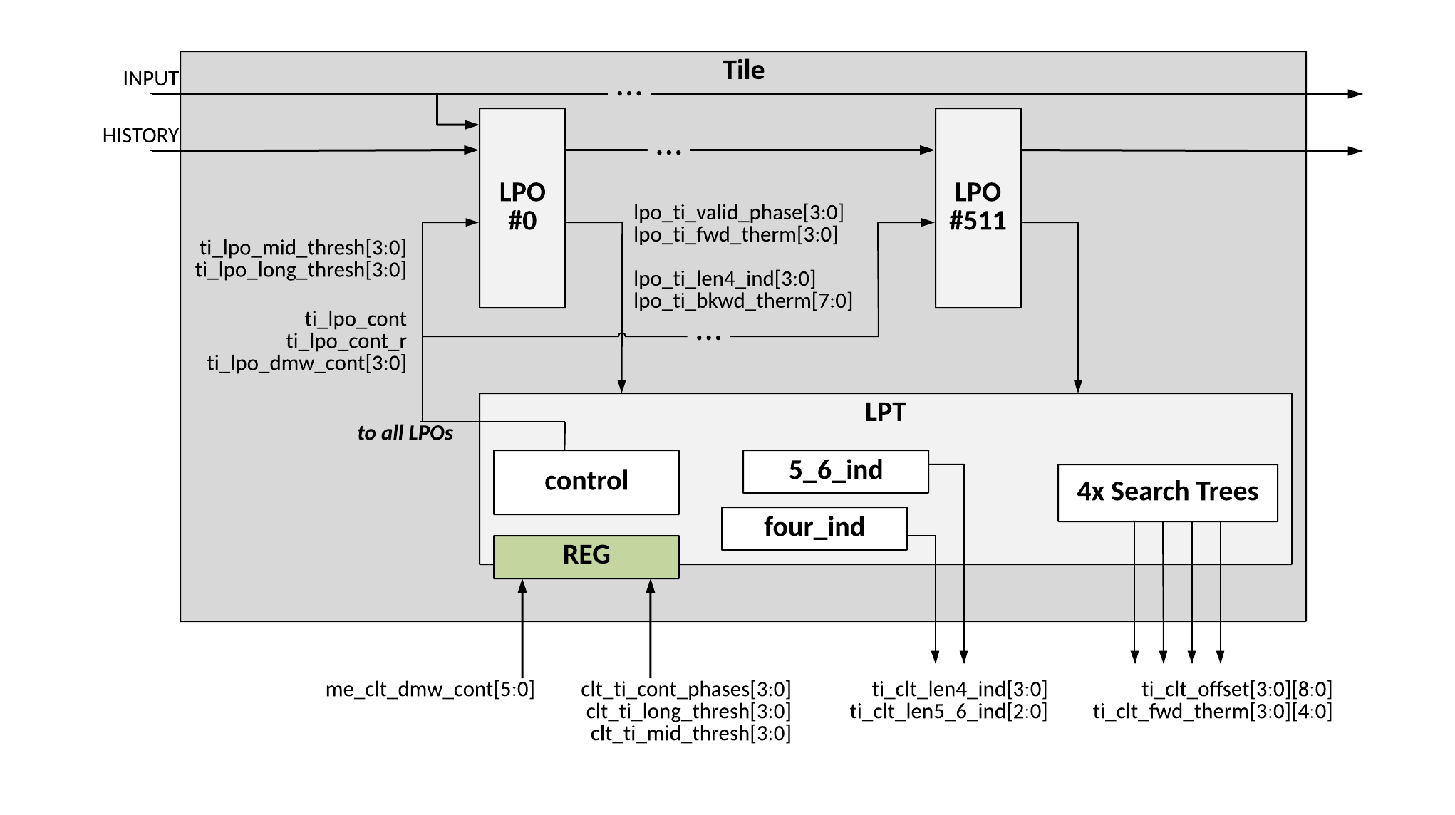

Figure 21 LZ77 Tile Top Level Block Diagram

### Tile Inputs

The table below lists the cluster input signals.

Table 14 Cluster Inputs

| Signal Name | Width | Description |
| --- | --- | --- |
| **clk** | 1 | clock |
| **raw_rst_n** | 1 | reset |
| **bypass_reset** | 1 | dft |
| **test_rst_n** | 1 | dft |
| **ti_shift_data** | 4x 8 | history buffer shift data path |
| **ti_shift_data_vld** | 4x 1 | Control bits indicating shift data is valid |
| **ti_shift_en** | 1 | Set to one if history buffer is shifting – accept new sdi |
| **ti_prefix_data** | 8x 8 | Data for pre-loading the history buffer |
| **ti _prefix_data_vld** | 8x 1 | Control bits indicating prefix data is valid |
| **ti_prefix_en** | 1 | Set to one if history buffer is loading prefix |
| **ti _input_data** | 4x 8 | New input bytes to be compared to the history buffer |
| **ti _input_data_vld** | 4x 1 | Control bits indicating input data is valid |
| **ti_input_en** | 1 | Set to ‘1’ if input_data is valid and LPO should process the input_data and generate match results |
| **me_tile_enable** | 1 | Enable the tile. |
| **me_clt_dmw_cont** | 6 | Control from Match Engine setting allowed start windows for continuing matches |
| **clt_ti_cont_phases** | 4 | Indication which phases in the cluster had matches of length sufficient to qualify as continuing |
| **clt_ti_ongoing_cont_phases** | 4 | Logical equivalent of clt_ti_cont_phases |
| **clt_ti_dmw_cont** | 6 | DMW sourced by the ME |
| **clt_ti_force_done** | 1 | Force all runs to end |
| **clt_ti_clr_valid** | 1 | Clear the history buffer. Asserted between frames |
| **ph4/3/2/1_mask** | 13 | Per phase truncation mask |
| **TILE 0 ONLY** |  |  |
| **me_clt0_mtf_list** | 4x 9 | List of 4 MTF offsets, only those in Tile 0 |
| **me_clt0_mtf_list_valid** | 4x 1 | Valid bit for MTF offset list |

### Tile Outputs

The table below lists the cluster output signals.

Table 15 Cluster Outputs

| Signal Name | Width | Description |
| --- | --- | --- |
| **ti_shift_data_out[1:0]** | 4x 8 |  |
| **ti_shift_data_out_vld** | 4x 1 | Control bits indicating shift data out is valid |
| **ti_prefix_data_out[2:0]** | 8x 8 | Data for pre-loading the history buffer |
| **ti_prefix_data_out_vld** | 8x 1 | Control bits indicating prefix data out is valid |
| **ti_clt_offset[3:0]** | 4x 9 | Lowest number offset with longest match starting at each of 4 phases |
| **ti_clt_fwd_therm[12:0]** | 4x 13 | fwd_therm for longest match starting at each of 4 phases |
| **ti_clt_len4_ind** | 4 | State indicating a length 4 match is present at the corresponding start phase; this state generated with bm[7:4] and is used by Match Engine to determine the DMW |
| **ti_clt_len5_6_ind** | 8 | State indicating a length 5 or 6 match is present at the corresponding start phase |
| **TILE 0 ONLY** |  |  |
| **ti0_clt0_mtf_offset[20]** | 20x 9 | MTF: offsets in Tile 0 which may be mtf based on MTF list from ME and winners from previous 4 clk cycles |
| **ti0_clt0_mtf_phase[20]** | 20x 4 | MTF: phases associated with matches at above offsets |
| **ti0_clt0_mtf_fwd_therm[20]** | 20x 12 | MTF: fwd_therm associated with matches at above offsets |

## Logic Per Tile (LPT)

Each Tile includes one Logic Per Tile (LPT) block. The LPT provides the following functions:

* Aggregates all the LPO match outputs, groups them by start phase and has 4 search trees to find the longest match at each phase which are sent to the cluster
* Aggregates all the LPO len4_ind and len5_6_ind outputs and sends the result to cluster
* Accepts control signals from Match Engine and Cluster and generates control signals to the LPOs
  + State controls which move the LPO between NEW and CONT state

### Search Trees

See section

### len4_ind and len5_6_ind

The tile aggregates the 512 len4_ind[3:0] outputs, combining all the outputs as a single bitwise ‘OR’ function.

The tile aggregates the 512 len5_6_ind[2:0] outputs, combining all the outputs as a single bitwise ‘OR’ function.

### Control signals – State

The Tile accepts control signals from the ME and Cluster:

* me_dmw_cont[5:0] from ME, defines the allowed start phases to go to CONT state
* cont_phases[3:0] from Cluster, defines which start phases have [p,4,L] long matches

These signals are registered in the Tile to generate me_dwm_cont_r and cont_phases_r.

The Tile block includes logic similar to the Logic Per Cluster (LPC) module to determine if the cluster should move to CONT state. This is done using me_dmw_cont_r[5:2] and cont_phases_r[3:0] as described in Section 7.2.2. Refer to figure below for an illustration of the timing (same as in Cluster section).



Figure 22 Timing for cont_phases

The difference between the cluster and tile continuing controls is the Tile needs to send the ti_lpo_cont signal to the LPOs at the beginning of the clock cycle to cause the LPOs to operate in CONT state.

The clt_me_cont signal is registered before being sent to the Match Engine.

Summary:

* ti_lpo_cont = (cont_phases_r[3:0] > me_dmw_cont_r[5:2]) or   
   (cont_phases_r[3:0] & me_dmw_cont_r[5:2]) or  
  ((cont_phases_r[3:0] > 0) & ti_lpo_cont_r)
* ti_lpo_cont_r = REG ti_lpo_cont

### Tile MTF

Only Tile 0 in Cluster 0 has specific MTF logic. This tile accepts the MTF list from the ME and maintains a list of winning matches from the previous 4 clock cycles. The match results from these 20 offsets are sent to the ME.

The winning matches from all 4 phases of the last 4 clock cycles are held in case any of those matches wins and gets added to the MTF list. It will take 2 clocks for the ME to update the list in the Tile. Sending all 20 potential MTF offsets allows the ME to select the appropriate 4 offsets on the current list.

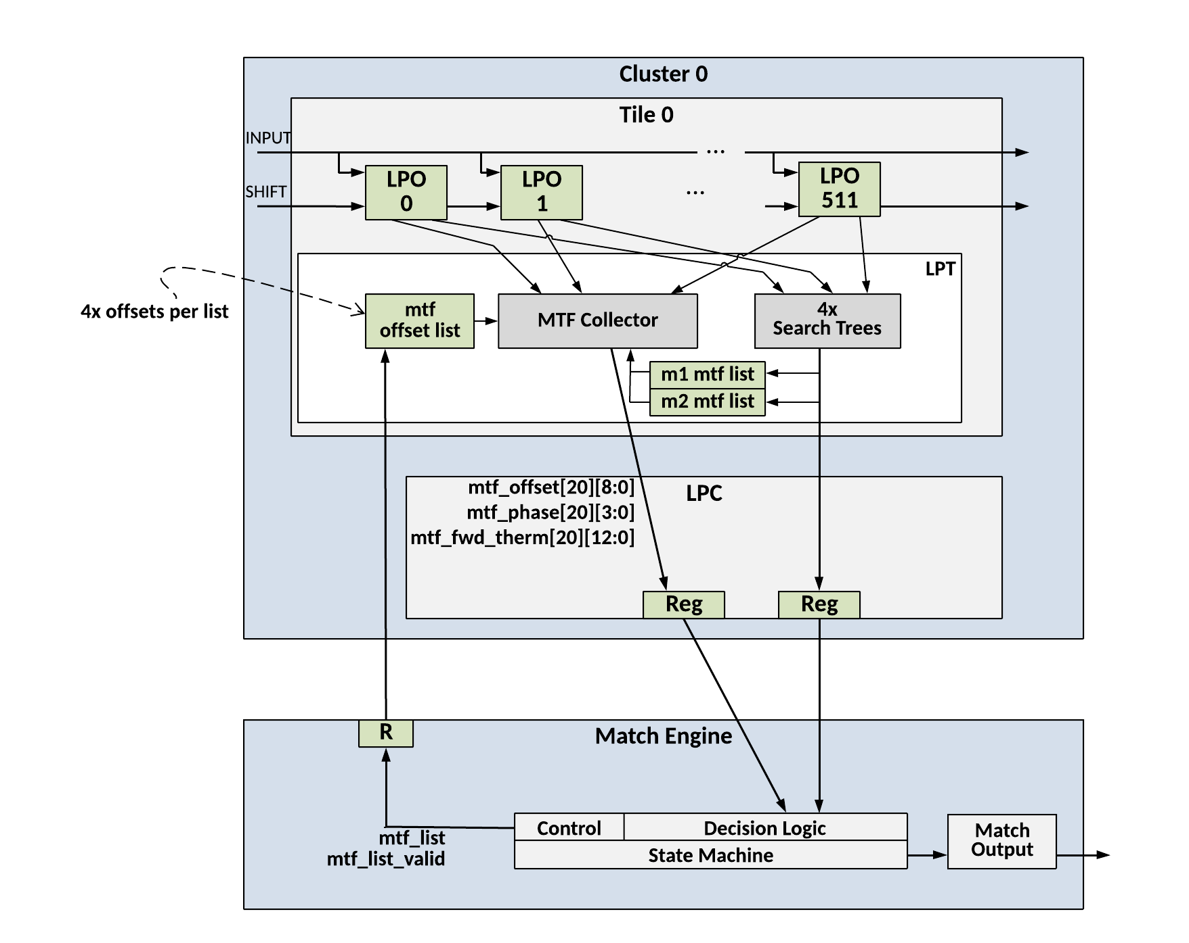

Figure 23 Tile MTF

See section 10.3 Move To Front (MTF) for more detail

# LPO – Logic Per Offset

**Note, this section intentionally omits any reference to virtualized LPO’s.** For the purposes of the following discussion we consider 64K physical LPO’s, each with their own copy of byte match logic. This is done in order to simply the concepts which follow.

There are 64K LPOs in the LZ77 compressor – one for each offset in the history buffer. Each LPO processes the match information associated with its offset. If there is an active, qualified match the LPO generates an output that is processed by the Tile.



Figure 24 LZ77 Compressor - LPO

## LPO Top Level

The LPO has 4 main processing functions, as illustrated in the figure below.

* History Buffer and Comparators
  + History buffer within an LPO is one byte of data and one bit valid;  
    part of 64K long shift register
    - Each clock cycle a new byte arrives (with valid) and current byte is sent to the next LPO
  + 4 byte-wide comparators compare 4 input bytes to the byte in the history buffer;
    - If both history buffer & input are valid and exactly match it is considered a match
  + 3 of the 4 byte match results are sent to 3 neighbor LPOs and 3 results from neighbor LPOs are accepted
    - LPO ‘N’ sends one result to each of LPO N+1, N+2, N+3 and accepts a result from each of LPO N-3, N-2, N-1
* LPO Match State
  + Maintains the specific byte match results from the previous 2 clock cycles
* Match Output
  + Accepts control signals and match state 🡪 determines if there is a match that is qualified to output

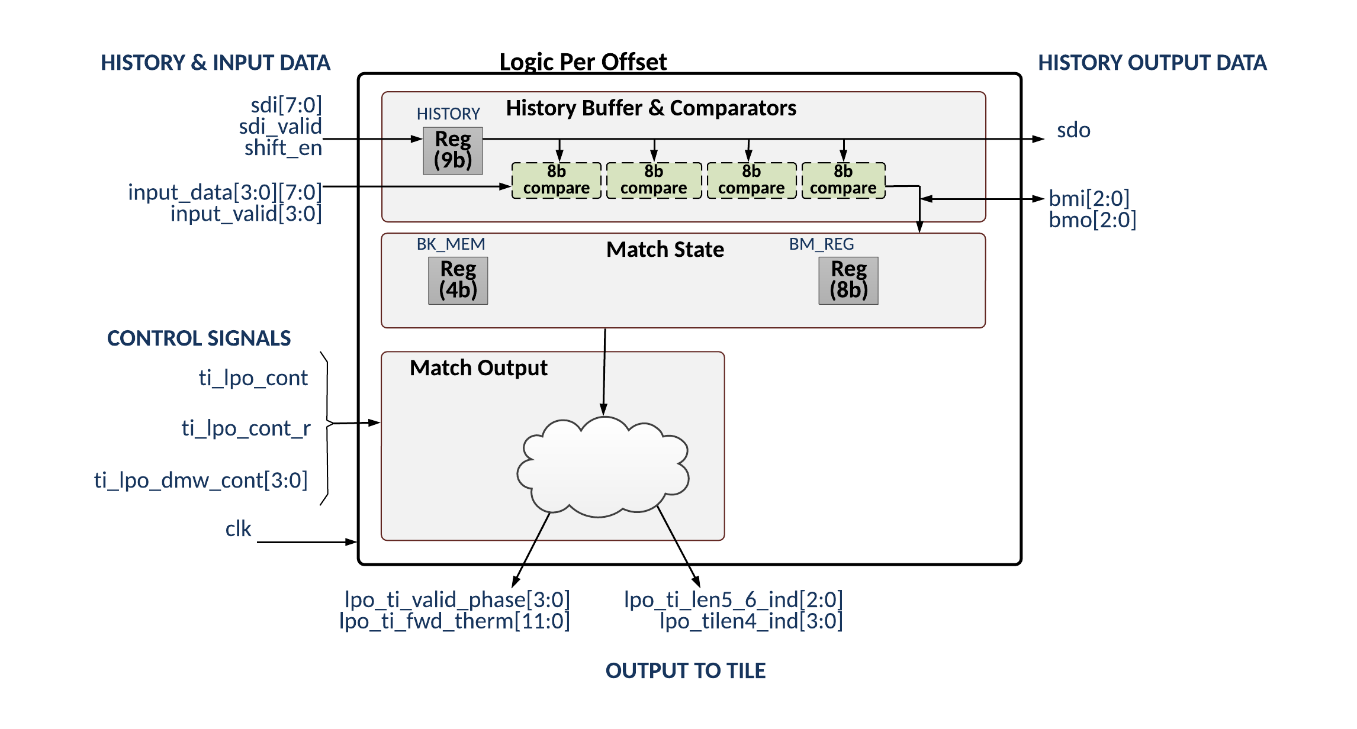

Figure 25 LPO Top Level Block Diagram

### LPO Inputs

The table below lists the LPO input signals.

Table 16 LPO Inputs

| Signal Name | Width | Description |
| --- | --- | --- |
| **clk** | 1 | clock |
| **rst_n** | 1 | When low the match state is cleared to zero |
| **clr_valid** | 1 |  |
| **sdi** | 8 | Shift data in: history buffer data byte |
| **sdi_valid** | 1 | Set to ‘1’ if sdi is valid |
| **shift_en** | 1 | Set to one if history buffer is shifting – accept new sdi |
| **input_data[3:0]** | 8 | 4 input bytes: data to be compressed |
| **input_valid[3:0]** | 4 | 4 valid bits: one per input data |
| **input_en** | 1 | Set to ‘1’ if input_data is valid and LPO should process the input_data and generate match results |
| **bmi[2:0]** | 3 | Byte match results for this offset; generated by neighboring LPOs |
| **ti_lpo_cont** | 1 | Set if the cluster is moving to CONT state; generated in the Tiles to ease timing constraints; consistent across the entire cluster |
| **ti_lpo_cont_r** | 1 | 1 clock cycle delay of ti_lpo_cont 🡪 used to distinguish the transition into CONT state from on-going CONT state |
| **ti_lpo_dmw_cont** | 4 | Registered version of Delay Match Window from Match Engine (me_dmw_cont) 🡪 defines the allowed start phase for continuing runs; only used when entering CONT state; the 1 clock when ti_lpo_cont = 1 and ti_lpo_cont_r = 0 |

### LPO Outputs

The table below lists the LPO output signals.

Table 17 LPO Outputs

| Signal Name | Width | Description |
| --- | --- | --- |
| **sdo** | 8 | Shift data out: history buffer data byte |
| **sdo_valid** | 1 | Set to ‘1’ if sdo is valid |
| **bmo[2:0]** | 3 | Byte match results for neighboring LPOs |
| **lpo_ti_valid_phase** | 4 | One hot encoding of the start phase of an active match; only get if there is a qualified match |
| **lpo_ti_fwd_therm** | 4 | Thermometer encoded state describing the length of the match represented by valid_phase |
| **lpo_ti_len5_6_ind** | 3 | State indicating a length 5 or 6 match is present at the corresponding start phase |
| **lpo_ti_len4_ind** | 4 | State indicating a length 4 match is present at the corresponding start phase; this state generated with bm[7:4] and is used by Match Engine to determine the DMW |
|  |  |  |

## LPO Theory of Operation

Each clock cycle, when shift_en is active, the LPOs effectively shift the history buffer by four offsets – with LPO N sending its byte to LPO N+4 and accepting the next byte from LPO N-4. The LPO also accepts 4 bytes of input data and compares its byte to the four input bytes. Comparison results are then passed between LPOs so each LPO collects the 4 bits of byte match results associated with its offset.

The LPO Match State accepts the newest 4 bits of byte match results and maintains the results from the last 8 bytes such that the LPO has exact byte match results for the last 12 input bytes. The 8 bits of earlier byte match results are held in registers/latches.

The LPO Match State block also maintains 4 bits of state which are used to keep track of earlier byte match results. The exact state is not held, rather a thermometer backwards from position 12 is stored using two fields:

* + bkwd_from12_phase [1:0] decimal representation of the starting phase of the match
  + bkwd_from12_quads [1:0] count of how many quads had all 4 bytes match, backward from 12



Figure 26 LPO Match State

Each LPO effectively generates the state shown in the figure above. The Match Output block uses this local match state and a set of control signals from the Tile to determine if it has a qualified match and should generate a valid output.

A valid output is generated if the local match is long enough to qualify. The control signals indicate the length required to qualify for each starting phase. If the local match qualifies the LPO generates a valid_phase output indicating on which phase the match started and a fwd_therm output describing the length of the match.

## LPO History Buffer & Comparators



## LPO Match Output

Each LPO generates a valid output when its local match qualifies. The valid output has two components as listed in the table below: valid_phase & fwd_therm.

Table 18 LPO Match Output

| Signal Name | Width | Description |
| --- | --- | --- |
| lpo_ti_valid_phase | 4 | One hot encoding indicating at which phase the match starts:   * 0000 = no match * 0001 = phase 1 * 0010 = phase 2 * 0100 = phase 3 * 1000 = phase 4 |
| lpo_ti_fwd_therm | 12 | Encoding of the length of the match forward from position 12 |

A match is qualified to be output if its length is long enough.

### fwd_therm

The output fwd_therm represents the length of a valid match. The entire tuple {valid_phase, fwd_therm} is needed to know the full length.

* Run length = valid_phase + fwd_therm

Fwd_therm is a thermometer encoding of up to 12 bits of byte match data, starting at position 11 walking down to position 0. Fwd_therm is a thermometer where the lsb bit (fwd_therm[0]) corresponds to a match at postion 11, and the msb (fwd_therm[11]) corresponds to a match at position 0. Note that the msb, fwd_therm[11], only valid for runs that may continue past position 0, into the next clock cycle. Runs for which the msb is set are continuing runs, in that cycle. The first bit in the fwd_therm, start at bit[0] and walking toward bit[11], that has a zero value marks the end of the run.

A long format match with fwd_therm = 4 is a potential continuing run. The following figures illustrate fwd_therm encoding. Table 18 provides a full list of the Match Output encoding using fwd_therm.

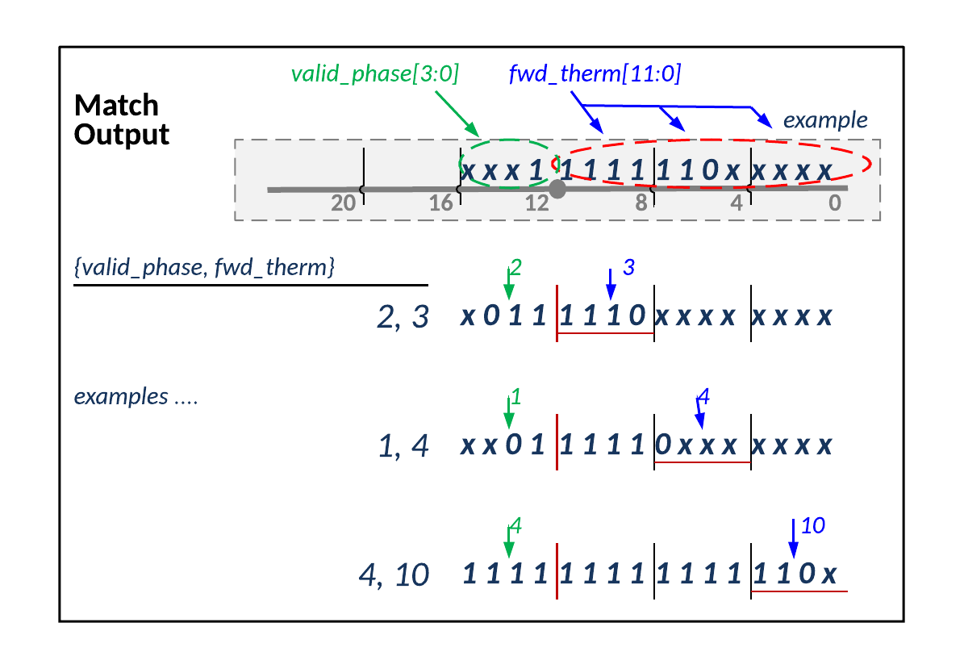

Figure 27 LPO Match Output Encoding

Table 19 LPO Match Output Encoding

| phase | fwd_therm | Run length |  | phase | fwd_therm | Run length |
| --- | --- | --- | --- | --- | --- | --- |
| 1 | 0, 1 | not used |  | 2 | 0,1 | not used |
| 1 | 2 | not used |  | 2 | 2 | 4 |
| 1 | 3 | 4 |  | 2 | 3 | 5 |
| 1 | 4 | 5 |  | 2 | 4 | 6 |
| 1 | 5 | 6 |  | 2 | 5 | 7 |
| 1 | 6 | 7 |  | 2 | 6 | 8 |
| 1 | 7 | 8 |  | 2 | 7 | 9 |
| 1 | 8 | 9 |  | 2 | 8 | 10 |
| 1 | 9 | 10 |  | 2 | 9 | 11 |
| 1 | 10 | 11 |  | 2 | 10 | 12 |
| 1 | 11 | 12 |  | 2 | 11 | 13 |
| 1 | 12 | 13 |  | 2 | 12 | 14 |
| phase | **fwd_therm** | **Run length** |  | **phase** | **fwd_therm** | **Run length** |
| 3 | 0 | not used |  | 4 | 0 | 4 |
| 3 | 1 | 4 |  | 4 | 1 | 5 |
| 3 | 2 | 5 |  | 4 | 2 | 6 |
| 3 | 3 | 6 |  | 4 | 3 | 7 |
| 3 | 4 | 7 |  | 4 | 4 | 8 |
| 3 | 5 | 8 |  | 4 | 5 | 9 |
| 3 | 6 | 9 |  | 4 | 6 | 10 |
| 3 | 7 | 10 |  | 4 | 7 | 11 |
| 3 | 8 | 11 |  | 4 | 8 | 12 |
| 3 | 9 | 12 |  | 4 | 9 | 13 |
| 3 | 10 | 13 |  | 4 | 10 | 14 |
| 3 | 11 | 14 |  | 4 | 11 | 15 |
| 3 | 12 | 15 |  | 4 | 12 | 16 |

### Functionality

In brief form, the Match Output determines if the local match qualifies:

* **NEW** state:
  + Compare byte matches at positions [15:0]
  + If a continuous run of length 4 or more, starting anywhere in positions [15:12], exists then generate a valid output
* Entering **CONT** state:
  + Check byte matches at positions [23:8] in context of DMW
  + If match meets backward criteria, generate a valid output (i.e. get on the train!)
    - Note: phase might be modified if the match started before the DMW
* On-going **CONT** state:
  + If LPO is on the train
    - Stall the state until the ti_lpo_cont goes inactive or match ends
  + Else nop

The states are determined as follows:

* **On-going NEW**: ti_lpo_cont = 0 & ti_lpo_cont_r = 0
* **Entering CONT**: ti_lpo_cont = 1 & ti_lpo_cont_r = 0
* **On-going CONT**: ti_lpo_cont = 1 & ti_lpo_cont_r = 1
* **Entering NEW**: ti_lpo_cont = 0 & ti_lpo_cont_r = 1

===================



In more detail, the Match Output determines:

* Starting phase for this match:
  + If not continuing, lpo_phase = backward from position 12 to 15
    - If position 12 = 0, there is no valid output
  + If entering continuing:
    - if match length qualifies and starts within DMW: (details below)  
      lpo_phase = bkwd_from12_phase (binary)
    - if match length qualifies and starts after DMW: (details below)  
      lpo_phase = tile_dmw_cont
    - else no valid output
  + If continuing, lpo_phase = bkwd_from12_phase (binary)

Table 20 Continuing Match Criteria

| State | Decision Criteria | Description |
| --- | --- | --- |
| **Entering CONT** | **DMW = 4**   * New cont match – get on train or set to 0 | If bkwd_from12_quads = 3:  Get on train  valid_phase = 4  If bkwd_from12_quads = 2 & _phase = 3 or 2:  Get on train  valid_phase = bkwd_from12_phase  Else miss train, no valid output |
| **Entering CONT** | **DMW = 3**   * New cont match – get on train or set to 0 | If bkwd_from12_quads = 3:  Get on train  valid_phase = 3  If bkwd_from12_quads = 2 & _phase = 3, 2 or 1:  Get on train  valid_phase = bkwd_from12_phase  Else miss train, no valid output |
| **Entering CONT** | **DMW = 2**   * New cont match – get on train or set to 0; * Note: {quads = 2, phase = 4} is shorter run getting on train as last position in DMW (phase 4) | If bkwd_from12_quads = 3:  Get on train  valid_phase = 2  If bkwd_from12_quads = 2 & _phase = 3 or 2:  Get on train  valid_phase = 2  If bkwd_from12_quads = 2 & _phase = 1:  Get on train  valid_phase = bkwd_from12_phase  If bkwd_from12_quads = 2 & _phase 4:  Get on train  valid_phase = 4  Else miss train, no valid output |
| **Entering CONT** | **DMW = 1**   * New cont match – get on train or set to 0; * Note: {quads = 2, phase = 4} & {quads = 2, phase = 3} are shorter runs getting on train as 2nd & 3rd position in DMW | If bkwd_from12_quads = 3:  Get on train  valid_phase = 1  If bkwd_from12_quads = 2 & _phase = 3, 2 or 1:  Get on train  valid_phase = 1  If bkwd_from12_quads = 2 & _phase = 4:  Get on train  valid_phase = 4  If bkwd_from12_quads = 1 & _phase = 3:  Get on train  valid_phase = 3  Else set to zero |

Summary representation of above table below. DMW refers to the state of ti_lpo_dmw_cont[3:0] which is a one hot signal. E.g. ti_lpo_dmw_cont = 0’b1000 == DMW = 4. The

Table 21 Summary of BK_MEM & DMW for CONT

| **bkwd _from12 _quads** | **bkwd _from12 _phase** | **Quads** | **Phase** | **lpo_phase if DMW=4** | **lpo_phase if DMW=3** | **lpo_phase if DMW=2** | **lpo_phase if DMW=1** |
| --- | --- | --- | --- | --- | --- | --- | --- |
| 0’b11 | don’t care (0x0) | 3 | 4 | 4 | 3 | 2 | 1 |
| 0’b10 | 0’b11 | 2 | 3 | 3 | 3 | 2 | 1 |
| 0’b10 | 0’b10 | 2 | 2 | 2 | 2 | 2 | 1 |
| 0’b10 | 0’b01 | 2 | 1 | off | 1 | 1 | 1 |
| 0’b10 | 0’b00 | 2 | 4 | off | off | 4 | 4 |
| 0’b01 | 0’b11 | 1 | 3 | off | off | off | 3 |
| 0’b01 | 0’b10 | 1 | 2 | off | off | off | off |
| 0’b01 | 0’b01 | 1 | 1 | off | off | off | off |
| 0’b01 | 0’b00 | 1 | 4 | off | off | off | off |

### LPO Length Indicators

The thermometer encoding allows simple combinatorial logic to identify the longest run.

The len4_ind tracks when a length 4 matches are present. A length 4 match will set the start of the window. Each LPO reports when it has length 4 matches that will be at position 15:12 in the next 2 clock cycles. The Match Engine collects this state for use in determining the DMW.

#### len4_ind

This LPO output is a backward thermometer from position 0. The purpose is to identify length 4 matches that will arrive at the anchor position [15:12] in two clock cycles. These outputs are aggregated across all the LPOs in the Cluster and the result is sent to the Match Engine. The Match Engine aggregates this state from all Clusters and uses it in determining the DMW.

Refer to Section 6.3.1 for more information on the timing between LPO, Cluster and ME related to len4_ind and continuing state.

The 4 bits in len4_ind represent the results for each of the 4 phases.

* If len4_ind[3] = 1 there is a phase 4 match of length 4
* If len4_ind[2] = 1 there is a phase 3 match of length 4
* If len4_ind[1] = 1 there is a phase 2 match of length 4
* If len4_ind[0] = 1 there is a phase 1 match of length 4

This is illustrated in the figure below.



Figure 28 Illustration of len4_ind

The logic for generating len4_ind is:

* len4_ind[3] = &bm_this_offset[7:4]
* len4_ind[2] = &bm_this_offset[6:3]
* len4_ind[1] = &bm_this_offset[5:2]
* len4_ind[0] = &bm_this_offset[4:1]

## LPO Match State

Each LPO maintains 12 bits of match state as described in the table below.

Table 22 LPO Match State

| Signal Name | Width | Description |
| --- | --- | --- |
| **bm_reg** | 8 | Byte match results from previous 2 clock cycles |
| **bwkd_from12_phase** | 2 | Start phase information for currently active match |
| **bkwd_from12_quads** | 2 | Number of quads with all 4 bytes matching over previous 3 clock cycles, backward from position 12 |

This state, in combination with the 4 new byte match results, is used to construct the current match state each clock cycle.

The byte match state is explicit:

* bm_this_offset[11:0] = {bm_reg[7:0], bmi[2:0], bm_phase[0]}

The backward from position 12 thermometer is used to determine if a match is qualified to move to continuing state. This state is held for 3 clock cycles to allow the Match Engine:

* One clock cycle to collect state from all the LPOs and Clusters *and*
* Two clock cycles to provide feedback about start window for continuing matches



Figure 29 LPO Match State Generation

### BM_REG

State in BM_REG is updated every clock cycle as follows:

* State in bm_reg[7:4] is dropped – this is encoded in the backward from 12 state
* State in bm_reg[3:0] is shifted to bm_reg[7:4]
* The new matches from the previous clock cycle are stored in bm_reg[3:0]

### BK_MEM

The BK_MEM is 4 bits of state:

* bkwd_from12_quads [1:0]
* bkwd_from12_phase [1:0]

This state is used to record the length of a match that started in previous clock cycles. The bkwd_from12_phase and bkwd_from12_quads represent the backward from 12 thermometer in compressed format.

The bkwd_from12_quads count the number of clock cycles in which all 4 bytes matches.



The bkwd_from12_phase defines where a currently active match starts.



The bkwd_from12_phase state is encoded in 2 bits to save area as follows:

* Phase 1 = 0’b01
* Phase 2 = 0’b10
* Phase 3 = 0’b11
* Phase 4 = 0’b00 given bwkd_from12_quads is not 0’b00

Note: bkwd_from12_quads * 4 + bkwd_from12_phase = # of consecutive matches backwards from position 12.

The mapping is shown in the table below.

Table 23 BKWD_FROM12 Mapping

| bkwd_from12 _phase | bkwd_from12 _quads | Thermometer | Phase | Notes |
| --- | --- | --- | --- | --- |
| 00 | 00 | 0000 0000 0000 | n/a | No match |
| 01 | 00 | 0000 0000 0001 | 1 | Doesn’t continue |
| 10 | 00 | 0000 0000 0011 | 2 | Doesn’t continue |
| 11 | 00 | 0000 0000 0111 | 3 | Doesn’t continue |
| 00 | 01 | 0000 0000 1111 | 4 | Doesn’t continue |
| 01 | 01 | 0000 0001 1111 | 1 | Doesn’t continue |
| 10 | 01 | 0000 0011 1111 | 2 | Doesn’t continue |
| 11 | 01 | 0000 0111 1111 | 3 | Cont if DMW = 2 or 1 |
| 00 | 10 | 0000 1111 1111 | 4 | Cont if DMW = 3 or 2 |
| 01 | 10 | 0001 1111 1111 | 1 | Cont if DMW = 3, 2 or 1 |
| 10 | 10 | 0011 1111 1111 | 2 | Cont – adjust phase if DMW = 1 |
| 11 | 10 | 0111 1111 1111 | 3 | Cont – adjust phase if DMW = 2 or 1 |
| 00 | 11 | 1111 1111 1111 | 4 | Cont – adjust phase if DMW = 3, 2 or 1 |
| 01, 10, 11 | 11 | n/a | n/a | Not used |

### Functionality

In summary, the BK_MEM state update depends on the state:

* On-going **NEW** state, free run based on last 4 clock cycles of byte match results
  + Update state every clock cycle
* Entering **CONT** state: check if the local match qualifies
  + The phase might be modified if the run starts before the DMW
* On-going **CONT** state: stall the phase until the ti_lpo_cont goes inactive
  + If local match ends then zero out the BK_MEM

In more detail, the BK_MEM state is updated each clock cycle as follows:

* **NEW**: [ti_lpo_cont = 0]
  + Skating 🡪 update to phase & quads each clock cycle - either a current match extends or a new match starts
  + If current match extends thru positions [11:8] the phase stays the same and quads are increment
    - If bkwd_from12_quads = 2 and match extends 4 more bytes while in NEW mode, then bkwd_from12_phase = 0 bkwd_from12_quads = 3
    - This is a phase 4 match of maximum backward length
  + If new match starts, set phase based on that match and quads = 0
    - This happens when positions [11:8] are not all matches
* **Entering CONT**: [ti_lpo_cont = 1 & ti_lpo_cont_r = 0]
  + Decide whether to get on the train
  + When entering continuing, check if local match is qualified based on DMW
    - If yes:
      * If current BK_MEM state is within the DMW, no change
      * If current state starts before the DMW, update to start at DMW
    - If no: then set state to all zero
* **On-going CONT**: [ti_lpo_cont = 1 & ti_lpo_cont_r = 1]
  + As long at the match continues the BK_MEM state remains the same – stalled
  + If local match ends and CONT state remains, set BK_MEM to all zero

Table 24 BK_MEM State

| State | Decision Criteria | Description |
| --- | --- | --- |
| **NEW** | **Position [11:8] not 0’b1111**  Any current match ends, new match may start next clock cycle [current match may have started this clock] | phase is updated based on phase at [11:8]  quads set to 0 |
| **NEW** | **Position [11:8] are 0’b1111**  Current match extends | If bkwd_from12_quads = 2:  phase is set to 0x0 (phase 4)  quads = 3  Else  phase stays same  quads are incremented by 1 |
| **Entering CONT** | **DMW = 4**  New cont match – get on train or set to 0 | If bkwd_from12_quads = 3 or  bkwd_from12_quads = 2 & _phase = 3 or 2:  No change to state  Else set to zero |
| **Entering CONT** | **DMW = 3**  New cont match – get on train or set to 0 | If bkwd_from12_quads = 3:  Set bkwd_from12_phase = 3  Set bkwd_from12_quads = 2  If bkwd_from12_quads = 2:  No change to state  Else set to zero |
| **Entering CONT** | **DMW = 2**  New cont match – get on train or set to 0;  Note: {quads = 2, phase = 0} is shorter run getting on train as last position in DMW | If bkwd_from12_quads = 3:  Set bkwd_from12_phase = 2  Set bkwd_from12_quads = 2  If bkwd_from12_quads = 2 & _phase = 3:  Set bkwd_from12_phase = 2  If bkwd_from12_quads = 2 & _phase = 2 or 1:  No change  If bkwd_from12_quads = 2 & _phase = 0:  No change [last position in DMW]  Else set to zero |
| **Entering CONT** | **DMW = 1**  New cont match – get on train or set to 0;  Note: {quads = 2, phase = 0} & {quads = 1, phase = 3} are shorter runs getting on train as 2nd & 3rd position in DMW | If bkwd_from12_quads = 3:  Set bkwd_from12_phase = 1  Set bkwd_from12_quads = 2  If bkwd_from12_quads = 2 & _phase = 3 or 2:  Set bkwd_from12_phase = 1  If bkwd_from12_quads = 2 & _phase = 1:  No change  If bkwd_from12_quads = 2 & _phase = 0:  No change [2nd position in DMW]  If bkwd_from12_quads = 1 & _phase = 3:  No change [last position in DMW]  Else set to zero |
| **On-going CONT** | **format = long or middle**  current match continues  stay on train | If fwd_from12 is 0’b1111 or more  No change |
| **On-going CONT** | **format = short**  Get off train | If fwd_from12 is 0’b1110 or shorter  Set bkwd_from12_phase = 0  Set bkwd_from12_quads = 0  Else no change |

## LPO MTF Output

The LPT for Tile 0 has a second match output interface. The LPOs will output any match of length 4 or more and include the phase and fwd_therm.

The Tile LPT collects these outputs and sorts them to identify the 20 offsets on it’s lists. See section 10.3 Move To Front (MTF) for details.

## The Virtualized LPO

More than one LPO may be combined so that the state logic, which includes the byte match history and the LPO state machine outputs, are shared by, or common to, multiple consecutive offsets. When N offsets are grouped together like this to share common state (assume N is a power of 2), we have to decide which of the N offsets gets selected (i.e. is being tracked) on each cycle. The selected offset will generate the lower msb’s of the byte match vector, bm[3:0], and the remaining logic will be common. The offset which is selected to create bm[3:0] will be shifted (pipelined) along with the bm vector itself so that we define the offset associated with bm[3:0] as offset_sel[0], and the offsets for bm[7:4] and bm[11:8] as offset_sel[1] and offset_sel[2], respectively. The offset associated with the bkwd_from12 state is defined as offset_sel[3].

### Offset selection

The offset selection will make use of a 4 bit backward thermometer (bwd_therm) which is anchored at position [0], extending backwards to position [3], and has a length of 0, 1, 2, 3 or 4.

The offset associated with the bwd_therm is offset_sel[0] (i.e. the offset selected on the immediately preceding cycle). If the bwd_therm is at least of length 1 and the current 4 bit byte match vector for the same offset extends the run to a length of 4 or more, then offset_sel[0] is selected again (i.e. we don’t switch offsets).

Otherwise, if the bwd_therm is zero, or the bwd_therm cannot be extended to a length 4 (or 5) or more, then we select a new offset. In this case, the new 4 bit byte matches associated with each of the N offsets are processed into backward thermometers anchored at position 0 as follows:

|  |  |
| --- | --- |
| bm[3:0] | bm_therm[3:0] |
| 0000 | 0000 |
| 0001 | 0001 |
| 0010 | 0000 |
| 0011 | 0011 |
| 0100 | 0000 |
| 0101 | 0001 |
| 0110 | 0000 |
| 0111 | 0111 |
| 1000 | 0000 |
| 1001 | 0001 |
| 1010 | 0000 |
| 1011 | 0011 |
| 1100 | 0000 |
| 1101 | 0001 |
| 1110 | 0000 |
| 1111 | 1111 |

Then the N different bm_therm[3:0] vectors are fed into a simple search tree in order to select the longest backward thermometer, and thus the new selected offset, with ties defaulting the lower-indexed offset.

For this implementation, tiles 1 through 31 consist of virtual LPOs with N=8 and tiles 32-127 consist of virtual LPOs with N=16.

### Forward thermometer

The forward thermometer, fwd_therm[11:0], is anchored a position 11 and extends down to position 0. In the lpo the fwd_therm is based on the byte matches, bm[11:0], and signifies the number of consecutive matches, starting in position 11, walking down to position 0. With the vlpo (“virtualized” lpo), the fwd_therm also has to consider which of the four offsets is associated with each quad of the the byte match vector, bm[11:8], bm[7:4] and bm[3:0]. The fwd_therm must be truncated if the selected offset changes as we walk down the bm vector since don’t want to creat a fwd_therm based on the byte matches from two different offsets. If the selected offsets associated with bm[3:0], bm[7:4] bm[11:8], and the encoded backward thermometer from position 12 are offset_sel[0], offset_sel[1], offset_sel[2], and offset_sel[3] respectively, then the truncated bm vector associated with offset_sel[3] is:

bm_this_offset[11:0] = {  
(offset_sel[3] == offset_sel[2]) ? bm[11:8] : 4’b0,  
((offset_sel[3] == offset_sel[2]) &&  
 (offset_sel[2] == offset_sel[1])) ? bm[7:4] : 4’b0,  
((offset_sel[3] == offset_sel[2]) &&  
 (offset_sel[2] == offset_sel[1]) &&  
 (offset_sel[1] == offset_sel[0])) ? bm[3:0] : 4’b0  
};

Finally, 12-bit forward therm can be calculated as follows:

lpo_ti_fwd_therm = {   
&bm_this_offset[11 -: 12],  
&bm_this_offset[11 -: 11],  
&bm_this_offset[11 -: 10],  
&bm_this_offset[11 -: 9],  
 &bm_this_offset[11 -: 8],  
 &bm_this_offset[11 -: 7],  
 &bm_this_offset[11 -: 6],  
 &bm_this_offset[11 -: 5],  
 &bm_this_offset[11 -: 4],  
 &bm_this_offset[11 -: 3],  
 &bm_this_offset[11 -: 2],  
 &bm_this_offset[11 -: 1]  
};

### Early indicators

The early indicators include the len4[3:0] indicator and the len5_6[2:0] indicators. These signals look-ahead into the bm vector at positions [7:1]. They provide an early indication to the match engines about runs that will appear in positions [15:9] in two cycles from now. In the regular LPO this is coded as:

lpo_ti_len4_ind[3] = &bm_this_offset[7:4];   
lpo_ti_len4_ind[2] = &bm_this_offset[6:3];   
lpo_ti_len4_ind[1] = &bm_this_offset[5:2];  
lpo_ti_len4_ind[0] = &bm_this_offset[4:1];  
lpo_ti_len5_6_ind[2] = &bm_this_offset[7:2];   
lpo_ti_len5_6_ind[1] = &bm_this_offset[7:3];   
lpo_ti_len5_6_ind[0] = &bm_this_offset[6:2];

Similar to the fwd_therm the vlpo must make sure that the early indicators are not based on the bm’s from two different offsets. Therefore all of the above except for lpo_ti_len4_ind[3] will be qualified by (offset_sel[1] == offset_sel[0]), since they potentially result from the concatenation of byte match results computed at 2 different offsets.

## History Buffer

Each tile contains a 512 byte section of the history buffer. On each clock cycle, the tile’s history buffer accepts 4 new bytes shifted in from the output of the previous tile, outputs 4 bytes to be shifted out to the next tile, logically shifts all current history buffer bytes forward by 4 offsets, and compares all 4 bytes of input data (NOT the same as the shift-in data), to the current contents of the history buffer (i.e. a total of 512x4 byte compares).

For each of the 512 offsets within the tile, the last 4 byte matches (BM) at that offset position are computed. Understanding that lower-indexed history buffer (HB) bytes are “newer” and lower-indexed input_data bytes are “newer”, the 4 byte matches associated with offset N are, in order from newest to oldest:

BM[N][0] = HB[N] == input_data[0]  
BM[N][1] = HB[N+1] == input_data[1]  
BM[N][2] = HB[N+2] == input_data[2]  
BM[N][3] = HB[N+3] == input_data[3]

Note that each of these compares is qualified by a valid bit for the associated history buffer location and a valid bit for the associated input_data. Also note that computing BM[509][3], BM[510][3], BM[510][2], BM[511][3], BM[511][2], and BM[511][1] require HB bytes outside of the 512 byte window owned by the tile. Therefore, a single tile’s history buffer keeps a copy of the 3 most recent bytes that were shifted out on the previous clock cycle. This is referred to as the endcap.

The 4 bits of byte match results (BM[N][3:0]) are fed into each LPO and used as described in section 9.2 LPO Theory of Operation

Finally, in the case that a tile is populated with virtual LPOs as described in section 9.7, the search trees referred to in section 9.7.1 are implemented within the history buffer module and output an individual result to each virtual LPO in the tile.

### Dynamic Power Optimization of Shift Data

A straightforward shift-register-based implementation of the history buffer requires that EVERY storage flop receives a clock and possibly toggles its output on each clock cycle.

Alternatively, one can imagine an implementation with a circular buffer is used rather than a shift register. For such an implementation, only 4 bytes are written to the history buffer per clock cycle, while the rest of the history buffer remains static. This potentially results in a large reduction in dynamic clock power. For example, the 1st 4 bytes shifted in are written to HB[511:508], the next 4 are written to HB[507:504], and so on until HB[3:0] are written, after which the write index wraps back around in a circular fashion. While this is happening, the bytes are in the history buffer being replaced are shifted out to the next tile.

The tradeoff with such an implementation is that the BM results must be “rotated” to one of 128 possible positions in order to align the results with the correct LPO associated with that logical offset (i.e. the LPOs and associated state logic remain fixed). In the example implementation described in the previous paragraph, the area and power cost of the additional multiplexing of BM results may overshadow the clock and flop power saved by avoiding a straightforward shift register. Therefore, the history buffer is implemented using a hybrid of the 2 approaches.

The hybrid implementation consists of a 16 byte circular buffer at the “newer” end of the history buffer. Over the course of 4 clock cycles, 16 bytes are written to this small circular buffer, 4 bytes at a time, with a descending and wrapping write index. When the write index wraps (i.e. when HB[15:12] are being written), the 16 bytes of the initial circular buffer are shifted down into a 496 byte shift register. With this implementation, the shift register only toggles 1 out of every 4 clock cycles, which yields a 75% reduction in clock and flop power for the shift register portion of the history buffer. The advantage compared to the full circular buffer is that much less muxing is needed as there are only 4 possible rotate positions rather than 128.

Figure 30 is an example showing how the history buffer changes over time. In this example, each square represents 4 bytes and the length of the history buffer is reduced to 32 bytes (i.e. 8 squares) in order to simplify the illustration. The behavior of a 512 byte history buffer can be extrapolated from the illustration by recognizing that each 4 square chunk (i.e. 16 bytes), simply moves 4 squares to the right when a shift occurs on every 4th cycle. The last 4 squares “shifted out” at the end of the history buffer are rotated back into the lowest 4 squares, and the square which is being replaced by the incoming 4 byte value is copied to the endcap. The bold line separating the squares marks the boundary between the first and last offset position within the history buffer. This indicates how much the contents need to be rotated in order to align with the associated LPOs (along with the value of the 2-bit phase counter). Since the square immediately to the left of the bold line stores the last 4 bytes in the history buffer, the oldest 3 offsets associated with this square will incorporate the endcap data when computing their associated BM[N] byte match vectors as described in section 9.8. Blank squares indicate invalid bytes.



Figure 30 Hybrid History Buffer Illustration

#### History Buffer Optimizations for Virtual LPO

For a virtual LPO that aggregates over N offsets, it is implied that each virtual LPO needs a 4 bit wide N:1 mux in order to obtain the byte match results associated with offset_sel[0] (see section 9.7.1), which are used to determine if offset_sel[0] should be re-selected due to a continuing run of length 4 or greater.

When this is combined with the history buffer power optimizations described above, a naive implementation would first rotate ALL 512x4-bit byte match results to align to the correct offset BEFORE feeding the N:1 mux.

For an example virtual LPO with N of 16 (with 32 LPOs per tile), this would require:

* 512x4x3=6144 2:1 mux cells (12 per offset) to perform the rotate of the raw BM results for each of the 512 locations
* 32x4x15=1920 2:1 mux cells to select the 4-bit byte match result associated with the previously selected offsets for each LPO (i.e. 4 bit wide 16:1 mux for each virtual LPO)

This is the equivalent of a 4 bit wide 64:1 mux for each of the 32 virtual LPOs.

In fact, each virtual LPO need only consider N+12 offsets for the inputs to this mux. For example, in a tile with a 16-way virtual LPO, LPO 0 may need 4 bit match results associated with physical location as low as 0, but not higher than location 27. This is because in the worst case, when the 2 bit phase counter is 3, the output of the mux should be BM results from locations 12 to 27. A 5 bit mux index can be computed as follows:

index = LPO_index*16 + phase*4 + offset_sel[0]

where LPO_index is a constant.

Similarly, it is not necessary to rotate all 512 4 bit thermometers before feeding the result into search trees. Instead, since data is shifted in 4 bytes per cycle, each group of 4 adjacent locations can have their associated thermometers reduced down to a single 4 bit thermometer (along with a 2 bit index indicating the winner). This reduction can happen before the rotation muxes, effectively reducing the number of bits that need to be muxed.

### Reduction of Simultaneous Switching Events

Both the loading/shifting of the history buffer data and the bit-wise comparison of the history buffer data against the input data can lead to a large number of simultaneous switching events in the worst case. Figure 31 illustrates how the input data is both at the beginning of the per-tile shift chain, AND is distributed to the contents of each tile for comparison. For example, in terms history buffer shifting, alternating a 16-byte value with the complement of that value will cause ALL history buffer flops receiving a clock to toggle (history buffer shifts 16-bytes per clock). In terms of comparator toggles, if all 64K history buffer bytes and the 4 input data bytes are loaded with the same byte, changing the 4-byte input data to the complement of that byte on the next cycle will result in the output of ALL 64K*8*4=2M 1-bit comparators toggling on the same clock cycle.



Figure 31 LZ77 Engine Without Byte Permutation

Simultaneous switching scenarios like these are mitigated by two mechanisms:

* using a scramble code to permute the byte values as they are shifted from one tile to the next
* clocking all odd-numbered tiles on the negative edge of the clock in order to halve the worst case number of tile-level simultaneous switching events on a given clock edge.

#### Byte Scramble/Permutation

Assume a fixed random permutation of the 256 byte values is applied at the shift output of each tile before the data is shifted into the following tile (i.e. identical permutation function at the output of each tile). Figure 32 illustrates this where the permutation/scramble function is designated ***S***. Note that the input data that is compared against each tile’s history buffer contents must be permuted by consecutively applying ***S*** a number of times equal to its tile number.



Figure LZ77 Engine With Byte Permutation

With knowledge of ***S***, it will still be possible to construct a data pattern such that all the bit comparator outputs in a single tile toggle on a single clock edge. For example, if we fill the history buffer with a particular byte value, and then send in the complement value, tile 0, for which there is no byte permutation, will see all 512x8x4 bit comparators outputs toggle on a single clock edge. However, since the byte values in tiles 1 through 127 are permuted, the associated bit comparators CANNOT experience the same amount of toggles on the same clock edge. With our chosen permutation/scramble function (show below), for any 2 byte values which are bit-wise complements of each other (i.e. all 8 bits differ), the 2 values once permuted, CANNOT also be complements of each other.

Table Byte Permutation/Scramble Function *S*

|  |  |
| --- | --- |
| Input Bit | Ouput Bit |
| i[0] | i[7]^i[5]^i[4]^i[3] |
| i[1] | ~i[0] |
| i[2] | i[1] |
| i[3] | i[2] |
| i[4] | i[3] |
| i[5] | i[4] |
| i[6] | i[5] |
| i[7] | i[6] |

Note that is similar to an LFSR. Bit 0 is inverted before being “shifted” in order avoid the case where a value of 0 will map to itself. Also, note that multiple consecutive applications of ***S*** are simply composed by logic synthesis into a simple XOR tree per bit (with some inverters).

#### Negative edge clocking

Although it doesn’t affect average power consumption, shifting a portion of the logic to run on the opposite edge of the clock spreads out the worst case simultaneous switching events over 2 consecutive clock edges.

Specifically, the odd numbered tiles are clocked with the negative edge of the clock instead of the positive edge. Effectively, the history buffer and byte compares of odd tiles run half of a clock cycle ahead of the even numbered tiles. The byte match results are then delayed by a half cycle in order to be aligned with other tiles before combining the data to producer cluster-level match outputs. This requires transferring signals between positive edge logic and negative edge logic in the following places:

* Shift data transferred from even numbered tiles to odd numbered tiles are launched by the positive edge of the clock from the even tile and captured by the negative edge of the clock half of a clock cycle later in the odd numbered tile.
* Shift data transferred from odd numbered tiles to even numbered tiles are launched by the negative edge of the clock from the odd tile and captured by the positive edge of the clock in an additional pipe stage before moving to the even numbered tile on the next positive clock edge. This data transfer from odd to even tiles effectively takes 1 and ½ clock cycles.
* The byte compare results in each virtualized LPO of an odd numbered tile are fed into an additional pipe stage clocked by the positive edge of the clock before they contribute to downstream per-cluster match results, where everything must be aligned to the positive edge of the clock.

# Match Engine

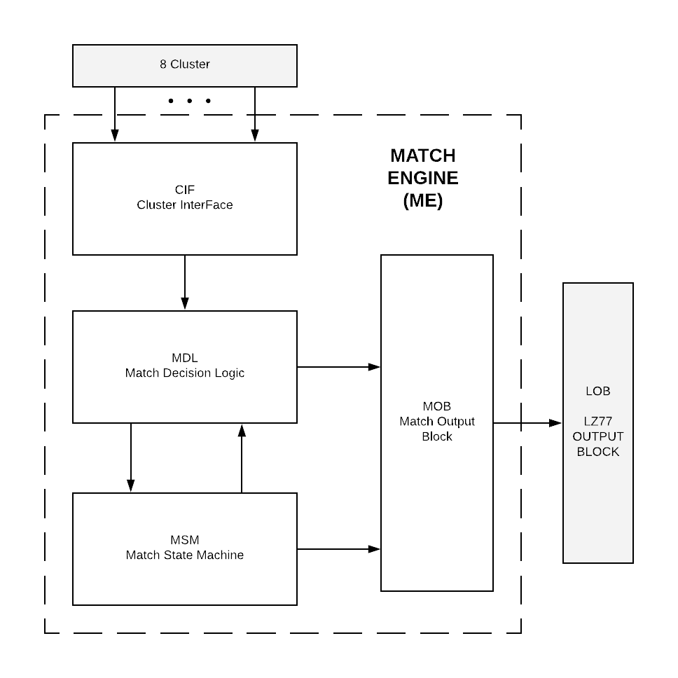

Figure 33 Match Engine

## Introduction

### Purpose and Scope

This section describes the “continuing” function design for the LZ77 compressor. This includes the lit0 location for any possible continuing match. A brief introduction to how the continuing function fits in to the match block is given as an introduction.

### Some Assumptions

The State Machine will assume that all continuing phases in a DMW will go into continuing on the same cycle. In other words, if a DMW starts with a phase 1 match, it will go into continuing 2 cycles later (after 1 dummy cycle). If a phase 4 match is also maximal length and is in the DMW, it will go into continuing at the same time as the phase 1 match. The len4_ind is referred to as “four_indication” in this section, and is defined as {&BM[7:4], &BM[6:3], &BM[5:2], &BM[4:1]}.



In addition to the 4 four indicators which are: {&BM[7:4], &BM[6:3], &BM[5:2], &BM[4:1]}, there are 3 5_6 indicators which are: {&BM[7:2], &BM[7:3], &BM[6:2]}.

The four indicators mean a match of at least 4 starting at ph4, ph3, ph2, ph1 exists while the 5_6 indicators mean a match of at least 6 starting at ph4, match of at least 5 starting at ph4, ph3 exists. The 5_6indicators are used to determine three specific (corner) cases.

* First, when a length 4 phase 2 match will be beaten by a phase 4 match in the current DMW, the MDL will not output a DMW in this cycle.
* Second, when a length 5 phase 2 match will be beaten by a phase 4 match in the current DMW, the MDL will not output a DMW in this cycle.
* Third, when a length 4 phase 1 match will be beaten by a phae 3 or phase 4 match in the current DMW, the MDL will not output a DMW in this cycle. The 3, 5_6 indicator bits follow the same timing as the 4 four_indicators and like the four_indicators, they are ORed across all the offsets.

This is the match format for this section of the document:

[1,3] = phase 1 len 4

[1,4] = phase 1 len 5

[1,5] = phase 1 len 6

[1,6] = phase 1 len 7

[1,7] = phase 1 len 8

[1,8] = phase 1 len 9

[1,9] = phase 1 len 10

[1,10] = phase 1 len 11

[1,11] = phase 1 len 12

[1,12] = phase 1 len 13 =C

[2,2] = phase 2 len 4

[2,3] = phase 2 len 5

[2,4] = phase 2 len 6

[2,5] = phase 2 len 7

[2,6] = phase 2 len 8

[2,7] = phase 2 len 9

[2,8] = phase 2 len 10

[2,9] = phase 2 len 11

[2,10] = phase 2 len 12

[2,11] = phase 2 len 13

[2,12] = phase 2 len 14 =C

[3,1] = phase 3 len 4

[3,2] = phase 3 len 5

[3,3] = phase 3 len 6

[3,4] = phase 3 len 7

[3,5] = phase 3 len 8

[3,6] = phase 3 len 9

[3,7] = phase 3 len 10

[3,8] = phase 3 len 11

[3,9] = phase 3 len 12

[3,10] = phase 3 len 13

[3,11] = phase 3 len 14

[3,12] = phase 3 len 15 =C

[4,0] = phase 4 len 4

[4,1] = phase 4 len 5

[4,2] = phase 4 len 6

[4,3] = phase 4 len 7

[4,4] = phase 4 len 8

[4,5] = phase 4 len 9

[4,6] = phase 4 len 10

[4,7] = phase 4 len 11

[4,8] = phase 4 len 12

[4,9] = phase 4 len 13

[4,10] = phase 4 len 14

[4,11] = phase 4 len 15

[4,12] = phase 4 len 16 =C

In the example tables below, yellow information goes from the LPO to the ME and green information goes from the ME to LPO (i.e. is fedback from the ME to the LPO’s). The ME feeds-back the DMW to the lpo’s via a signal called “dmw_cont”. The dmw_cont is non-zero in any cycle in which the lpo’s are allowed to “go into” continuing mode. When the dmw_cont is non-zero the lpo’s check whether or not the observe a continuing run at their offset and, if so, enter continuing mode (i.e. “get on the train”). For all other cycles the ME sets dmw_cont to zero value during which the lpo’s are not allowed to enter continuing state (the train has left the station). In the tables in the SM section (below), it is assumed that continue will go high at the ME if the DMW > 0. All cases not shown in the SM tables are already continuing and will not enter continuing or provide a DMW.

Typical cycle ph2:

|  |  |  |  |  |  |  |  |
| --- | --- | --- | --- | --- | --- | --- | --- |
| Timing:  At LPO | phase | BM | fwd therm | len | Four ind | ME Cont | DMW |
| Cycle 1 | 0000 | 0000 0000 0011 | [0 0] | 0 | 0000 | 0 | 0 |
| Cycle 2 | 0000 | 0000 0011 1111 | [0 0] | 0 | 0011 | 0 | 0 |
| Cycle 3 | 0000 | 0011 1111 1111 | [0 0] | 0 | 1111 | 0 | 0 |
| Cycle 4 | 0011 | 1111 1111 1111 | [2 12] | 14 | 1111 | 0 | 0 |
| Cycle 5 | 1111 | 1111 1111 1111 | [4 12] | - | 1111 | 0 | 0 |
| Cycle 6 | 0011 | 1111 1111 1100 | [2 10] | 12 | 1110 | 1 | 2 |

|  |  |  |  |  |  |  |  |  |
| --- | --- | --- | --- | --- | --- | --- | --- | --- |
| Timing: At ME | State | Next State | fwd therm | len | Four ind | Four ind_r | ME Cont | DMW |
| Cycle 1 | U0 | U0 | [0 0] |  |  |  | 0 | 0 |
| Cycle 2 | U0 | U0 | [0 0] | 0 | 0000 |  | 0 | 0 |
| Cycle 3 | U0 | U0 | [0 0] | 0 | 0011 | 0000 | 0 | 0 |
| Cycle 4 | U0 | U0 | [0 0] | 0 | 1111 | 0011 | 1 | 2 |
| Cycle 5 | U0 | UM2D | [2 12] | 14 | 1111 | 1111 | 0 | 0 |
| Cycle 6 | UM2D | UM6 | [4 12] | - | 1111 | 1111 | 0 | 0 |
| Cycle 7 | UM6 | U10 | [2 10] | 12 | 1110 | 1111 | 0 | 0 |
| Cycle 8 | U10 | U6 |  |  |  | 1110 | 0 | 0 |

Minimal Cycle ph2:

|  |  |  |  |  |  |  |  |
| --- | --- | --- | --- | --- | --- | --- | --- |
| Timing: At LPO | phase | BM | fwd therm | len | Four ind | ME Cont | DMW |
| Cycle 1 | 0000 | 0000 0000 0011 | [0 0] | 0 | 0000 | 0 | 0 |
| Cycle 2 | 0000 | 0000 0011 1111 | [0 0] | 0 | 0011 | 0 | 0 |
| Cycle 3 | 0000 | 0011 1111 1111 | [0 0] | 0 | 1111 | 0 | 0 |
| Cycle 4 | 0011 | 1111 1111 1111 | [2 12] | 14 | 1111 | 0 | 0 |
| Cycle 5 | 1111 | 1111 1111 0000 | [4 9] | - | 0000 | 0 | 0 |
| Cycle 6 | 0011 | 1111 0000 0000 | [2 4] | 6 | 0000 | 1 | 2 |

|  |  |  |  |  |  |  |  |  |
| --- | --- | --- | --- | --- | --- | --- | --- | --- |
| Timing: At ME | State | Next State | fwd therm | len | Four ind | Four ind_r | ME Cont | DMW |
| Cycle 1 | U0 | U0 | [0 0] |  |  |  | 0 | 0 |
| Cycle 2 | U0 | U0 | [0 0] | 0 | 0000 |  | 0 | 0 |
| Cycle 3 | U0 | U0 | [0 0] | 0 | 0011 | 0000 | 0 | 0 |
| Cycle 4 | U0 | U0 | [0 0] | 0 | 1111 | 0011 | 1 | 2 |
| Cycle 5 | U0 | UM2D | [2 12] | 14 | 1111 | 1111 | 0 | 0 |
| Cycle 6 | UM2D | UM6 | [4 9] | - | 0000 | 1111 | 0 | 0 |
| Cycle 7 | UM6 | U4 | [2 4] | 6 | 0000 | 0000 | 0 | 0 |
| Cycle 8 | U4 | U0 |  |  |  | 0000 | 0 | 0 |

Minimal Cycle ph 4:

|  |  |  |  |  |  |  |  |
| --- | --- | --- | --- | --- | --- | --- | --- |
| Timing: At LPO | phase | BM | fwd therm | len | Four ind | ME Cont | DMW |
| Cycle 1 | 0000 | 0000 0000 1111 | [0 0] | 0 | 0000 | 0 | 0 |
| Cycle 2 | 0000 | 0000 1111 1111 | [0 0] | 0 | 1111 | 0 | 0 |
| Cycle 3 | 0000 | 1111 1111 1111 | [0 0] | 0 | 1111 | 0 | 0 |
| Cycle 4 | 1111 | 1111 1111 1110 | [4 12] | 15 | 1100 | 0 | 0 |
| Cycle 5 | 1111 | 1111 1110 0000 | [4 8] | - | 0000 | 0 | 0 |
| Cycle 6 | 1111 | 1000 0000 0000 | [4 4] | 7 | 0000 | 1 | 4 |

|  |  |  |  |  |  |  |  |  |
| --- | --- | --- | --- | --- | --- | --- | --- | --- |
| Timing: At ME | State | Next State | fwd therm | len | Four ind | Four ind_r | ME Cont | DMW |
| Cycle 1 | U0 | U0 | [0 0] |  |  |  | 0 | 0 |
| Cycle 2 | U0 | U0 | [0 0] | 0 | 0000 |  | 0 | 0 |
| Cycle 3 | U0 | U0 | [0 0] | 0 | 1111 | 0000 | 0 | 0 |
| Cycle 4 | U0 | U0 | [0 0] | 0 | 1111 | 1111 | 1 | 4 |
| Cycle 5 | U0 | UM4D | [4 12] | 15 | 1100 | 1111 | 0 | 0 |
| Cycle 6 | UM4D | UM8 | [4 8] | - | 0000 | 1100 | 0 | 0 |
| Cycle 7 | UM8 | U3 | [4 4] | 7 | 0000 | 0000 | 0 | 0 |
| Cycle 8 | U3 | U0 |  |  |  | 0000 | 0 | 0 |

Minimal Cycle ph1:

|  |  |  |  |  |  |  |  |
| --- | --- | --- | --- | --- | --- | --- | --- |
| Timing: At LPO | phase | BM | fwd therm | len | Four ind | ME Cont | DMW |
| Cycle 1 | 0000 | 0000 0000 0001 | [0 0] | 0 | 0000 | 0 | 0 |
| Cycle 2 | 0000 | 0000 0001 1111 | [0 0] | 0 | 0001 | 0 | 0 |
| Cycle 3 | 0000 | 0001 1111 1111 | [0 0] | 0 | 1111 | 0 | 0 |
| Cycle 4 | 0001 | 1111 1111 1111 | [1 12] | 13 | 1111 | 0 | 0 |
| Cycle 5 | 1111 | 1111 1111 0000 | [4 8] | - | 1000 | 0 | 0 |
| Cycle 6 | 0001 | 1111 0000 0000 | [1 4] | 5 | 0000 | 1 | 1 |

|  |  |  |  |  |  |  |  |  |
| --- | --- | --- | --- | --- | --- | --- | --- | --- |
| Timing: At ME | State | Next State | fwd therm | len | Four ind | Four ind_r | ME Cont | DMW |
| Cycle 1 | U0 | U0 | [0 0] |  |  |  | 0 | 0 |
| Cycle 2 | U0 | U0 | [0 0] | 0 | 0000 |  | 0 | 0 |
| Cycle 3 | U0 | U0 | [0 0] | 0 | 0001 | 0000 | 0 | 0 |
| Cycle 4 | U0 | U0 | [0 0] | 0 | 1111 | 0001 | 1 | 1 |
| Cycle 5 | U0 | UM1D | [1 12] | 13 | 1111 | 1111 | 1 | 0 |
| Cycle 6 | UM1D | UM5 | [4 8] | - | 1000 | 1111 | 0 | 0 |
| Cycle 7 | UM5 | U4 | [1 4] | 5 | 0000 | 1000 | 0 | 0 |
| Cycle 8 | U4 | U0 |  |  |  | 0000 | 0 | 0 |

### Overview

The state machine is shown in the middle of the block diagram below. It receives a match information from the Match Decision Logic (MDL). Each cycle the MDL processes the cluster results and boils them down to a single match (i.e. one “winner”) which is provided to the State Machine. The current state of the State Machine helps with the determining of the single match to be selected. The tuple provided to the State Machine provides information about where the match starts and the length of the match. The MDL keeps track of the DMW and does not provide to the State Machine matches that are outside the DMW. The State Machine determines if literals need to be output and which match needs to be output. This is provided to the Match Output block. The state is provided to the Cluster Interface (CIF) to determine the feedback to the clusters to help control the state of the clusters, tiles and offsets.

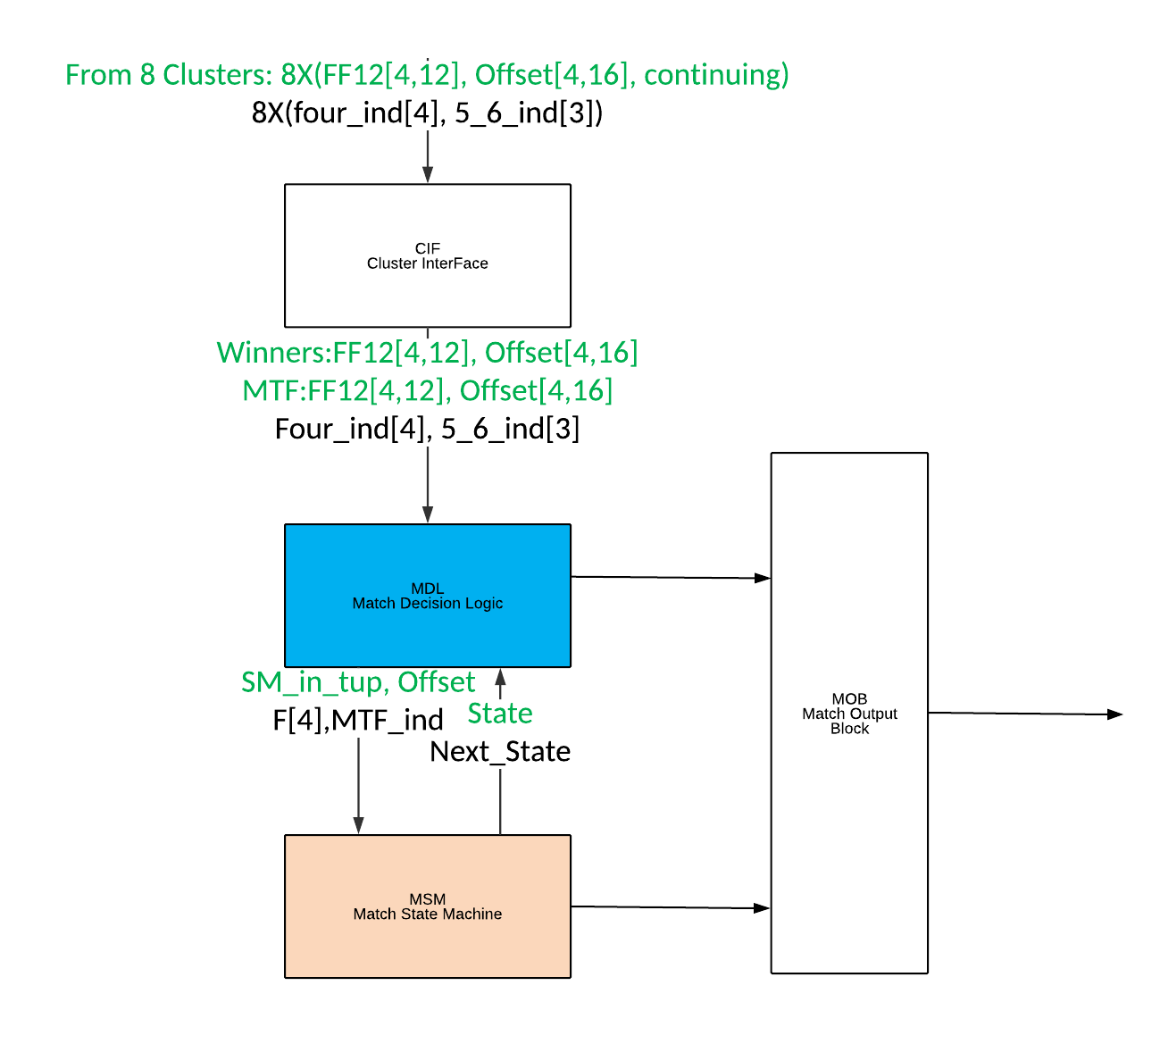

Figure 34 Overview block diagram

On every cycle a winning run is selected based on the run length, run type (MTF or regular), offset and MTF index. The is according to the decision tree shown in Figure 33 MDL Decision Tree.

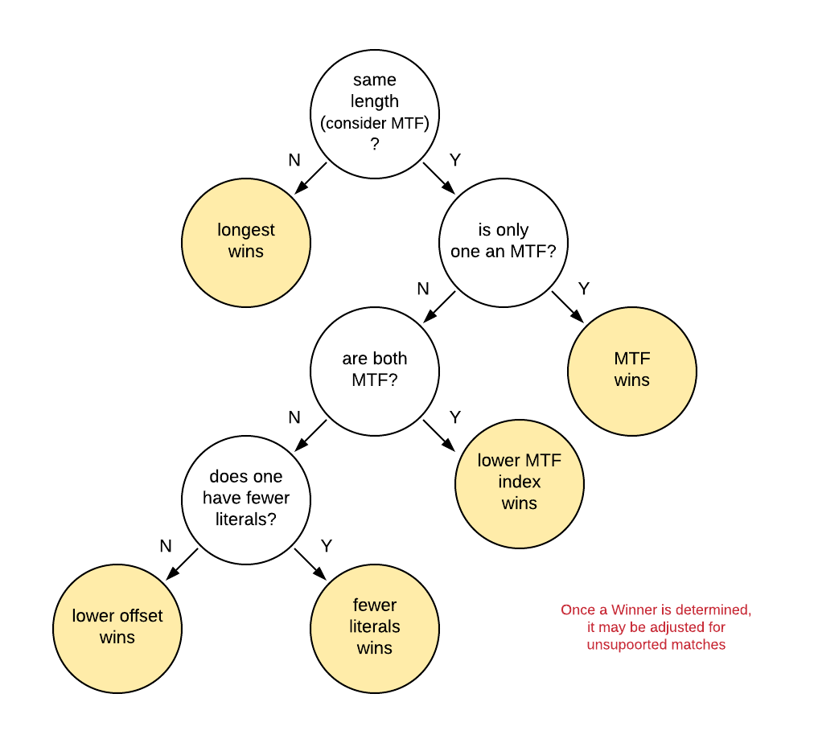

Figure 35 MDL Decision Tree

## State Machine

The state machine is divided into 2 parts. Part 1 handles “new” matches and part 2 handles continuing matches. New are matches that are non-continuing. A continuing match is a match which has the lsb of the forward therm set to 1. Considering the start phase (1, 2, 3 or 4) a continuing match has a length of between 13 to 16. That is, a continuing run for phases 1, 2, 3 or 4 have lengths 13, 14, 15 and 16 respectively. Non-continuing matches are smaller than that. Start phase is limited to 4,3,2, or 1. These are the four bytes that arrive per clock cycle.

Start states are U0 (used 0 input bytes), U1 (used 1 input bytes), U2 (used 2 input bytes), U3 (used 3 input bytes), UM1 (used minus 1) and UM2 (used minus 2). The state machine receives a tuple representing the largest match for the current cycle. The Tuple = [start phase, FF12], where FF12 is “forward from 12” (or a forward thermometer anchored at position 12).

Assume, in the text, a maximum DMW of 2. G = global length which is added to continuing runs to calculate their actual length. G increases by 4 per continuing cycle. F = flag, a four bit vector which means that at least 1 of the input phases which is in the DMW is a continuing match.

### New Matches



Figure 36: New Match State Diagram

There are 6 primary states in the non-continuing (New) part of the state machine. They are U0, U1, U2, U3, UM1 and UM2. The primary states are states in which all or part of the current input samples are not yet consumed (used) by a previous match and so can potentially be the start of a match. There are 8 secondary or delay states in the state machine. They are U4, U5, U6, U7, U8, U9, U10 and U11. The delay states are states in which all the current inputs have already been consumed (used) by a previous match.

#### U0 (used 0):

In U0, all four of the current inputs are available to potentially start a match. If the input indicates a non-continuing match from phase 4 or 3 then all possible matches in the DMW are known and if F = 0, then no continuing matches exist. In this case, the output match (and a leading literal in the case of a phase 3 match) is known, the SM can move to the appropriate next state and a match can be output. In the case of a non-continuing match from phase 2 or 1, the DMW may extend to the next cycle (phase 4 or phase 3) and so the SM will transition to UM1 or UM2 and then a match will be output when the entire DMW is known. Matches starting in Phase 3 will output 1 literal. Matches starting in Phase 2 will output 2 literals. Matches starting in Phase 1 will output 3 literals. If no match is indicated, 4 literals are output and the next state is U0.

If the F bits indicate a continuing match, the SM will transition to the appropriate continuing dummy state. After the dummy state, an additional tuple or tuples from later cycles will indicate the winning match. If it is possible for a phase 4 match to be the winner, the next state will be UM4D. If it is possible for a phase 3 match to be the winner but not a phase 4, the next state will be UM3D. If it is possible for a phase 2 match to be the winner but not a phase 4 or 3, the next state will be UM2D. If it is possible for a phase 1 match to be the winner but not a phase 4, 3 or 2, the next state will be UM1D. To elaborate further, it is possible for a [4,11] length 15 non-continuing match to beat a continuing match from phase 3, 2 or 1. The next state is UM4D because it is possible for the phase 4 match, even though not continuing, to be the winner. If the [4,11] length 15 non-continuing match is an MTF, it could also beat a phase 4 continuing match. There are several such cases in the table below. Matches which can only win if they are an MTF have an M in the MTF column.

When the winner is [2,2], a phase 2 length 4 match, the DMW output must be gated by the 5_6_indicator_r(1) which means that a phase 4 match of length 5 or more will beat the phase 2 match and consequently the phase 1 and 2 bytes will be consumed and the DMW should not be output. When the winner is [2,3], a phase 2 length 5 match, the DMW output must be gated by the 5_6_indicator_r(2) which means that a phase 4 match of length 6 or more will beat the phase 2 match and consequently the phase 1 byte will be consumed and the DMW should not be output. When the winner is [1,3], a phase 1 length 4 match, the DMW output must be gated by the 5_6_indicator_r(1:0) which means that a phase3 or phase 4 match of length 5 or more will beat the phase 1 match and consequently the phase 1 byte will be consumed and the DMW should not be output.

Table 26: State U0 Transitions

|  |  |  |  |  |  |  |
| --- | --- | --- | --- | --- | --- | --- |
| Winner | MTF | Continue | Len | Next State | Next DMW | notes |
| [4,0] |  | ~|F(3:0) | 4 | U0 | Max(4ind_r(3:0)) |  |
| [4,1] |  | ~|F(3:0) | 5 | U1 | Max(4ind_r(2:0)) |  |
| [4,2] |  | ~|F(3:0) | 6 | U2 | Max(4ind_r(1:0)) |  |
| [4,3] |  | ~|F(3:0) | 7 | U3 | Max(4ind_r(0)) |  |
| [4,4] |  | ~|F(3:0) | 8 | U4 | 0 |  |
| [4,5] |  | ~|F(3:0) | 9 | U5 | 0 |  |
| [4,6] |  | ~|F(3:0) | 10 | U6 | 0 |  |
| [4,7] |  | ~|F(3:0) | 11 | U7 | 0 |  |
| [4,8] |  | ~|F(3:0) | 12 | U8 | 0 |  |
| [4,9] |  | ~|F(3:0) | 13 | U9 | 0 |  |
| [4,10] |  | ~|F(3:0) | 14 | U10 | 0 |  |
| [4,11] |  | ~|F(3:0) | 15 | U11 | 0 |  |
| L,[3,1] |  | ~|F(3:0) | 4 | U1 | Max(4ind_r(2:0)) |  |
| L,[3,2] |  | ~|F(3:0) | 5 | U2 | Max(4ind_r(1:0)) |  |
| L,[3,3] |  | ~|F(3:0) | 6 | U3 | Max(4ind_r(0)) |  |
| L,[3,4] |  | ~|F(3:0) | 7 | U4 | 0 |  |
| L,[3,5] |  | ~|F(3:0) | 8 | U5 | 0 |  |
| L,[3,6] |  | ~|F(3:0) | 9 | U6 | 0 |  |
| L,[3,7] |  | ~|F(3:0) | 10 | U7 | 0 |  |
| L,[3,8] |  | ~|F(3:0) | 11 | U8 | 0 |  |
| L,[3,9] |  | ~|F(3:0) | 12 | U9 | 0 |  |
| L,[3,10] |  | ~|F(3:0) | 13 | U10 | 0 |  |
| L,[3,11] |  | ~|F(3:0) | 14 | U11 | 0 |  |
| 2L,[2,2] |  | ~|F(3:0) | 4 | UM2 | Max(4ind_r(1:0)) | AND ~56indicator_r(1) |
| 2L,[2,3] |  | ~|F(3:0) | 5 | UM2 | Max(4ind_r(0)) | AND ~56indicator_r(2) |
| 2L,[2,4] |  | ~|F(3:0) | 6 | UM2 | 0 |  |
| 2L,[2,5] |  | ~|F(3:0) | 7 | UM2 | 0 |  |
| 2L,[2,6] |  | ~|F(3:0) | 8 | UM2 | 0 |  |
| 2L,[2,7] |  | ~|F(3:0) | 9 | UM2 | 0 |  |
| 2L,[2,8] |  | ~|F(3:0) | 10 | UM2 | 0 |  |
| 2L,[2,9] |  | ~|F(3:0) | 11 | UM2 | 0 |  |
| 2L,[2,10] |  | ~|F(3:0) | 12 | UM2 | 0 |  |
| 2L,[2,11] |  | ~|F(3:0) | 13 | UM2 | 0 |  |
| 3L,[1,3] |  | ~|F(3:0) | 4 | UM1 | Max(4ind_r(0)) | AND ~(|56indicator_r(1:0)) |
| 3L,[1,4] |  | ~|F(3:0) | 5 | UM1 | 0 |  |
| 3L,[1,5] |  | ~|F(3:0) | 6 | UM1 | 0 |  |
| 3L,[1,6] |  | ~|F(3:0) | 7 | UM1 | 0 |  |
| 3L,[1,7] |  | ~|F(3:0) | 8 | UM1 | 0 |  |
| 3L,[1,8] |  | ~|F(3:0) | 9 | UM1 | 0 |  |
| 3L,[1,9] |  | ~|F(3:0) | 10 | UM1 | 0 |  |
| 3L,[1,10] |  | ~|F(3:0) | 11 | UM1 | 0 |  |
| 3L,[1,11] |  | ~|F(3:0) | 12 | UM1 | 0 |  |
| 4L |  | ~|F(3:0) | 0 | U0 | Max(4ind_r(3:0)) |  |
| [4,7] | M | F(1) | 11 | UM4D | 0 | Unsupported: do not go to UM4D go to UM2D  MTF only, can beat [2,12] |
| [4,8] | M | |F(2:1) | 12 | UM4D | 0 | MTF only, can beat [2,12], [3,12] |
| [4,9] | M | |F(3:1) | 13 | UM4D | 0 | MTF only, can beat [2,12], [3,12],[4,12] |
| [4,10] |  | |F(3:1) | 14 | UM4D | 0 | MTF can beat [2,12], [3,12],[4,12]- no MTF [2,12] |
| [4,11] |  | |F(3:1) | 15 | UM4D | 0 | MTF can beat [2,12], [3,12],[4,12]- no MTF [2,12], [3,12] |
| [4,12] |  | F(3),?F(2:1) | 16+ | UM4D | 0 | May ultimately be beaten by [2,12] or [3,12] |
| L,[3,7] | M | F(0) | 10 | UM3D | 0 | Unsupported: do not go to UM3D go to UM1D  MTF only, can beat [1,12] |
| L,[3,8] | M | |F(1:0) | 11 | UM3D | 0 | MTF only, can beat [1,12], [2,12] |
| L,[3,9] | M | |F(2:0) | 12 | UM3D | 0 | MTF only, can beat [1,12], [2,12], [3,12] |
| L,[3,10] |  | ~F(3),|F(2:0) | 13 | UM3D | 0 | No [4,12], MTF can beat [1,12], [2,12], [3,12]- no MTF [1,12] |
| [3,10] | M | F(3),?F(2:1) | 13 | UM4D | 0 | MTF can beat [4,12]. May ultimately be beaten by [2,12] or [3,12] |
| L,[3,11] |  | ~F(3),|F(2:0) | 14 | UM3D | 0 | No [4,12], MTF can beat [1,12], [2,12], [3,12]- no MTF [1,12], [2,12] |
| [3,11] | M | F(3),?F(2:1) | 14 | UM4D | 0 | MTF only, can beat [4,12]. May ultimately be beaten by [2,12] or [3,12] |
| [3,12] | M | F(3:2),?F(1) | 15+ | UM4D | 0 | MTF only, can beat [4,12]. May ultimately be beaten by [2,12] or [3,12] |
| L,[3,12] |  | ~F(3),F(2),?F(1:0) | 15+ | UM3D | 0 | May ultimately be beaten by [2,12] or [1,12] |
| 2L,[2,8] | M | F(0) | 10 | UM2D | 0 | MTF only, can beat [1,12] |
| 2L,[2,9] | M | |F(1:0) | 11 | UM2D | 0 | MTF only, can beat [1,12], [2,12] |
| 2L,[2,10] | M | ~F(2),|F(1:0) | 12 | UM2D | 0 | No [3,12], MTF only, can beat [1,12], [2,12] |
| L,[2,10] | M | F(2),?F(1:0) | 12 | UM3D | 0 | MTF can beat [3,12]. May ultimately be beaten by [2,12] or [1,12] |
| 2L,[2,11] |  | ~F(3:2),|F(1:0) | 13 | UM2D | 0 | No [3,12] or [4,12], MTF can beat [1,12], [2,12]- no MTF [1,12] |
| L,[2,11] | M | ~F(3),F(2),?F(1:0) | 13 | UM3D | 0 | No [4,12], MTF only, can beat [3,12]. May ultimately be beaten by [2,12] or [1,12] |
| [2,11] | M | F(3),?F(2:1) | 13 | UM4D | 0 | MTF only, can beat [4,12]. May ultimately be beaten by [2,12] or [3,12] |
| L,[2,12] | M | ~F(3),F(2:1),?F(0) | 14+ | UM3D | 0 | No [4,12], MTF only, can beat [3,12]. May ultimately be beaten by [2,12] or [1,12] |
| [2,12] | M | F(3),F(1),?F(2) | 14+ | UM4D | 0 | MTF only, can beat [4,12]. May ultimately be beaten by [2,12] or [3,12] |
| 2L,[2,12] |  | ~F(3:2),F(1),?F(0) | 14+ | UM2D | 0 | May ultimately be beaten by [1,12] or next cycle [4,12] |
| 3L,[1,9] | M | F(0) | 10 | UM1D | 0 | MTF only, can beat [1,12] |
| 3L,[1,10] | M | ~F(1),F(0) | 11 | UM1D | 0 | No [2,12], MTF only, can beat [1,12] |
| 2L,[1,10] | M | F(1),?F(0) | 11 | UM2D | 0 | MTF only, can beat [2,12]. May ultimately be beaten by [1,12] or next cycle [4,12] |
| 3L,[1,11] | M | ~F(2:1),F(0) | 12 | UM1D | 0 | No [2,12] or [3,12], MTF only, can beat [1,12] |
| 2L,[1,11] | M | ~F(2),F(1),?F(0) | 12 | UM2D | 0 | No [3,12], MTF only, can beat [2,12] |
| L,[1,11] | M | F(2),?F(1:0) | 12 | UM3D | 0 | MTF only, can beat [3,12]. May ultimately be beaten by [2,12] or [1,12] |
| 2L,[1,12] | M | ~F(2),F(1),F(0) | 13+ | UM2D | 0 | No [3,12], MTF only, can beat [2,12] |
| L,[1,12] | M | F(2),?F(1),F(0) | 13+ | UM3D | 0 | MTF only, can beat [3,12]. May ultimately be beaten by [2,12] or [1,12] |
| 3L,[1,12] |  | ~F(2:1),F(0) | 13+ | UM1D | 0 | May ultimately be beaten by next cycle [4,12] or [3,12] |

#### U1 (used 1):

In U1, phases 1, 2 and 3 of the current inputs are available to potentially start a match. Phase 4 is not an allowed input and is adjusted before the SM to a phase 3. If the input indicates a non-continuing match from phase 3 then all possible matches in the DMW are known and if F = 0, then no continuing matches exist. In this case, the output match is known, the SM can move to the appropriate next state and a match can be output. In the case of a non-continuing match from phase 2 or 1, the DMW may extend to the next cycle (phase 4 or phase 3) and so the SM will transition to UM1 or UM2 and then a match will be output when the entire DMW is known. Matches starting in Phase 2 will output 1 literal. Matches starting in Phase 1 will output 2 literals. If no match is indicated, 3 literals are output and the next state is U0.

If the F bits indicate a continuing match, the SM will transition to the appropriate continuing dummy state. After the dummy state, an additional tuple or tuples from later cycles will indicate the winning match. If it is possible for a phase 3 match to be the winner, the next state will be UM3D. If it is possible for a phase 2 match to be the winner but not a phase 3, the next state will be UM2D. If it is possible for a phase 1 match to be the winner but not a phase 3 or 2, the next state will be UM1D. To elaborate further, it is possible for a [3,11] length 14 non-continuing match to beat a continuing match from phase 2 or 1. The next state is UM3D because it is possible for the phase 3 match, even though not continuing, to be the winner. If the [3,11] length 14 non-continuing match is an MTF, it could also beat a phase 3 continuing match. There are several such cases in the table below. Matches which can only win if they are an MTF have an M in the MTF column.

When the winner is [2,2], a phase 2 length 4 match, the DMW output must be gated by the 5_6_indicator_r(1) which means that a phase 4 match of length 5 or more will beat the phase 2 match and consequently the phase 1 and 2 bytes will be consumed and the DMW should not be output. When the winner is [2,3], a phase 2 length 5 match, the DMW output must be gated by the 5_6_indicator_r(2) which means that a phase 4 match of length 6 or more will beat the phase 2 match and consequently the phase 1 byte will be consumed and the DMW should not be output. When the winner is [1,3], a phase 1 length 4 match, the DMW output must be gated by the 5_6_indicator_r(1:0) which means that a phase3 or phase 4 match of length 5 or more will beat the phase 1 match and consequently the phase 1 byte will be consumed and the DMW should not be output.

Table 27: State U1 Transitions

|  |  |  |  |  |  |  |
| --- | --- | --- | --- | --- | --- | --- |
| Winner | MTF | Continue | Len | Next State | Next DMW | notes |
| [3,1] |  | ~|F(2:0) | 4 | U1 | Max(4ind_r(2:0)) |  |
| [3,2] |  | ~|F(2:0) | 5 | U2 | Max(4ind_r(1:0)) |  |
| [3,3] |  | ~|F(2:0) | 6 | U3 | Max(4ind_r(0)) |  |
| [3, 4] |  | ~|F(2:0) | 7 | U4 | 0 |  |
| [3,5] |  | ~|F(2:0) | 8 | U5 | 0 |  |
| [3,6] |  | ~|F(2:0) | 9 | U6 | 0 |  |
| [3,7] |  | ~|F(2:0) | 10 | U7 | 0 |  |
| [3,8] |  | ~|F(2:0) | 11 | U8 | 0 |  |
| [3,9] |  | ~|F(2:0) | 12 | U9 | 0 |  |
| [3,10] |  | ~|F(2:0) | 13 | U10 | 0 |  |
| [3,11] |  | ~|F(2:0) | 14 | U11 | 0 |  |
| L,[2,2] |  | ~|F(2:0) | 4 | UM2 | Max(4ind_r(1:0)) | AND ~56indicator_r(1) |
| L,[2,3] |  | ~|F(2:0) | 5 | UM2 | Max(4ind_r(0)) | AND ~56indicator_r(2) |
| L,[2,4] |  | ~|F(2:0) | 6 | UM2 | 0 |  |
| L,[2,5] |  | ~|F(2:0) | 7 | UM2 | 0 |  |
| L,[2,6] |  | ~|F(2:0) | 8 | UM2 | 0 |  |
| L,[2,7] |  | ~|F(2:0) | 9 | UM2 | 0 |  |
| L,[2,8] |  | ~|F(2:0) | 10 | UM2 | 0 |  |
| L,[2,9] |  | ~|F(2:0) | 11 | UM2 | 0 |  |
| L,[2,10] |  | ~|F(2:0) | 12 | UM2 | 0 |  |
| L,[2,11] |  | ~|F(2:0) | 13 | UM2 | 0 |  |
| 2L,[1,3] |  | ~|F(2:0) | 4 | UM1 | Max(4ind_r(0)) | AND ~(|56indicator_r(1:0)) |
| 2L,[1,4] |  | ~|F(2:0) | 5 | UM1 | 0 |  |
| 2L,[1,5] |  | ~|F(2:0) | 6 | UM1 | 0 |  |
| 2L,[1,6] |  | ~|F(2:0) | 7 | UM1 | 0 |  |
| 2L,[1,7] |  | ~|F(2:0) | 8 | UM1 | 0 |  |
| 2L,[1,8] |  | ~|F(2:0) | 9 | UM1 | 0 |  |
| 2L,[1,9] |  | ~|F(2:0) | 10 | UM1 | 0 |  |
| 2L,[1,10] |  | ~|F(2:0) | 11 | UM1 | 0 |  |
| 2L,[1,11] |  | ~|F(2:0) | 12 | UM1 | 0 |  |
| 3L |  | ~|F(2:0) | 0 | U0 | Max(4ind_r(3:0)) |  |
| [3,7] | M | F(0) | 10 | UM3D | 0 | Unsupported: do not go to UM3D go to UM1D  MTF only, can beat [1,12] |
| [3,8] | M | |F(1:0) | 11 | UM3D | 0 | MTF only, can beat [1,12], [2,12] |
| [3,9] | M | |F(2:0) | 12 | UM3D | 0 | MTF only, can beat [1,12], [2,12], [3,12] |
| [3,10] |  | |F(2:0) | 13 | UM3D | 0 | MTF can beat [1,12], [2,12], [3,12]- no MTF [1,12] |
| [3,11] |  | |F(2:0) | 14 | UM3D | 0 | MTF can beat [1,12], [2,12], [3,12]- no MTF [1,12], [2,12] |
| [3,12] |  | F(2),?F(1:0) | 15+ | UM3D | 0 | May ultimately be beaten by [2,12] or [1,12] |
| L,[2,8] | M | F(0) | 10 | UM2D | 0 | MTF only, can beat [1,12] |
| L,[2,9] | M | |F(1:0) | 11 | UM2D | 0 | MTF only, can beat [1,12], [2,12] |
| L,[2,10] | M | ~F(2),|F(1:0) | 12 | UM2D | 0 | No [3,12], MTF only, can beat [1,12], [2,12] |
| [2,10] | M | F(2),?F(1:0) | 12 | UM3D | 0 | MTF can beat [3,12]. May ultimately be beaten by [2,12] or [1,12] |
| L,[2,11] |  | ~F(2),|F(1:0) | 13 | UM2D | 0 | No [3,12] MTF can beat [1,12], [2,12]- no MTF [1,12] |
| [2,11] | M | F(2),?F(1:0) | 13 | UM3D | 0 | MTF only, can beat [3,12]. May ultimately be beaten by [2,12] or [1,12] |
| [2,12] | M | F(2:1),?F(0) | 14+ | UM3D | 0 | MTF only, can beat [3,12]. May ultimately be beaten by [2,12] or [1,12] |
| L,[2,12] |  | ~F(2),F(1),?F(0) | 14+ | UM2D | 0 | May ultimately be beaten by [1,12] or next cycle [4,12] |
| 2L,[1,9] | M | F(0) | 10 | UM1D | 0 | MTF only, can beat [1,12] |
| 2L,[1,10] | M | ~F(1),F(0) | 11 | UM1D | 0 | No [2,12], MTF only, can beat [1,12] |
| L,[1,10] | M | F(1),?F(0) | 11 | UM2D | 0 | MTF only, can beat [2,12]. May ultimately be beaten by [1,12] or next cycle [4,12] |
| 2L,[1,11] | M | ~F(2:1),F(0) | 12 | UM1D | 0 | No [2,12] or [3,12], MTF only, can beat [1,12] |
| L,[1,11] | M | ~F(2),F(1),?F(0) | 12 | UM2D | 0 | No [3,12], MTF only, can beat [2,12] |
| [1,11] | M | F(2),?F(1:0) | 12 | UM3D | 0 | MTF only, can beat [3,12]. May ultimately be beaten by [2,12] or [1,12] |
| [1,12] | M | F(2),?F(1),F(0) | 13+ | UM3D | 0 | MTF only, can beat [3,12]. May ultimately be beaten by [2,12] or [1,12] |
| L,[1,12] | M | ~F(2),F(1:0) | 13+ | UM2D | 0 | No [3,12], MTF only, can beat [2,12] |
| 2L,[1,12] |  | ~F(2:1),F(0) | 13+ | UM1D | 0 | May ultimately be beaten by next cycle [4,12] or [3,12] |

#### U2 (used 2):

In U2, phases 1 and 2 of the current inputs are available to potentially start a match. Phases 4 and 3 are not allowed inputs and are adjusted before the SM to a phase 2. If the input indicates a non-continuing match from phase 2 or 1, the DMW may extend to the next cycle (phase 4 or phase 3) and so the SM will transition to UM1 or UM2 and then a match will be output when the entire DMW is known. Matches starting in Phase 1 will output 1 literal. If no match is indicated, 2 literals are output and the next state is U0.

If the F bits indicate a continuing match, the SM will transition to the appropriate continuing dummy state. After the dummy state, an additional tuple or tuples from later cycles will indicate the winning match. If it is possible for a phase 2 match to be the winner, the next state will be UM2D. If it is possible for a phase 1 match to be the winner but not a phase 2, the next state will be UM1D. To elaborate further, it is possible for a [2,11] length 13 non-continuing match to beat a continuing match from phase 1. The next state is UM2D because it is possible for the phase 2 match, even though not continuing, to be the winner. If the [2,11] length 13 non-continuing match is an MTF, it could also beat a phase 2 continuing match. There are several such cases in the table below. Matches which can only win if they are an MTF have an M in the MTF column.

When the winner is [2,2], a phase 2 length 4 match, the DMW output must be gated by the 5_6_indicator_r(1) which means that a phase 4 match of length 5 or more will beat the phase 2 match and consequently the phase 1 and 2 bytes will be consumed and the DMW should not be output. When the winner is [2,3], a phase 2 length 5 match, the DMW output must be gated by the 5_6_indicator_r(2) which means that a phase 4 match of length 6 or more will beat the phase 2 match and consequently the phase 1 byte will be consumed and the DMW should not be output. When the winner is [1,3], a phase 1 length 4 match, the DMW output must be gated by the 5_6_indicator_r(1:0) which means that a phase3 or phase 4 match of length 5 or more will beat the phase 1 match and consequently the phase 1 byte will be consumed and the DMW should not be output.

Table 28: State U2 Transitions

|  |  |  |  |  |  |  |
| --- | --- | --- | --- | --- | --- | --- |
| Winner | MTF | Continue | Len | Next State | Next DMW | notes |
| [2,2] |  | ~|F(1:0) | 4 | UM2 | Max(4ind_r(1:0)) | AND ~56indicator_r(1) |
| [2,3] |  | ~|F(1:0) | 5 | UM2 | Max(4ind_r(0)) | AND ~56indicator_r(2) |
| [2,4] |  | ~|F(1:0) | 6 | UM2 | 0 |  |
| [2,5] |  | ~|F(1:0) | 7 | UM2 | 0 |  |
| [2,6] |  | ~|F(1:0) | 8 | UM2 | 0 |  |
| [2,7] |  | ~|F(1:0) | 9 | UM2 | 0 |  |
| [2,8] |  | ~|F(1:0) | 10 | UM2 | 0 |  |
| [2,9] |  | ~|F(1:0) | 11 | UM2 | 0 |  |
| [2,10] |  | ~|F(1:0) | 12 | UM2 | 0 |  |
| [2,11] |  | ~|F(1:0) | 13 | UM2 | 0 |  |
| L,[1,3] |  | ~|F(1:0) | 4 | UM1 | Max(4ind_r(0)) | AND ~(|56indicator_r(1:0)) |
| L,[1,4] |  | ~|F(1:0) | 5 | UM1 | 0 |  |
| L,[1,5] |  | ~|F(1:0) | 6 | UM1 | 0 |  |
| L,[1,6] |  | ~|F(1:0) | 7 | UM1 | 0 |  |
| L,[1,7] |  | ~|F(1:0) | 8 | UM1 | 0 |  |
| L,[1,8] |  | ~|F(1:0) | 9 | UM1 | 0 |  |
| L,[1,9] |  | ~|F(1:0) | 10 | UM1 | 0 |  |
| L,[1,10] |  | ~|F(1:0) | 11 | UM1 | 0 |  |
| L,[1,11] |  | ~|F(1:0) | 12 | UM1 | 0 |  |
| 2L |  | ~|F(1:0) | 0 | U0 | Max(4ind_r(3:0)) |  |
| [2,8] | M | F(0) | 10 | UM2D | 0 | MTF only, can beat [1,12] |
| [2,9] | M | |F(1:0) | 11 | UM2D | 0 | MTF only, can beat [1,12], [2,12] |
| [2,10] | M | |F(1:0) | 12 | UM2D | 0 | MTF only, can beat [1,12], [2,12] |
| [2,11] |  | |F(1:0) | 13 | UM2D | 0 | MTF can beat [1,12], [2,12]- no MTF [1,12] |
| [2,12] |  | F(1),?F(0) | 14+ | UM2D | 0 | May ultimately be beaten by [1,12] or next cycle [4,12] |
| L,[1,9] | M | F(0) | 10 | UM1D | 0 | MTF only, can beat [1,12] |
| L,[1,10] | M | ~F(1),F(0) | 11 | UM1D | 0 | No [2,12], MTF only, can beat [1,12] |
| [1,10] | M | F(1),?F(0) | 11 | UM2D | 0 | MTF only, can beat [2,12]. May ultimately be beaten by [1,12] or next cycle [4,12] |
| L,[1,11] | M | ~F(1),F(0) | 12 | UM1D | 0 | No [2,12], MTF only, can beat [1,12] |
| [1,11] | M | F(1),?F(0) | 12 | UM2D | 0 | MTF only, can beat [2,12] |
| [1,12] | M | F(1:0) | 13+ | UM2D | 0 | MTF only, can beat [2,12]. May ultimately be beaten by next cycle [4,12] |
| L,[1,12] |  | F(0) | 13+ | UM1D | 0 | May ultimately be beaten by next cycle [4,12] or [3,12] |

#### U3 (used 3):

In U3, phase 1 of the current inputs is available to potentially start a match. Phases 4, 3 and 2 are not allowed inputs and are adjusted before the SM to a phase 1. If the input indicates a non-continuing match from phase 1, the DMW may extend to the next cycle (phase 4 or phase 3) and so the SM will transition to UM1 and then a match will be output when the entire DMW is known. If no match is indicated, 1 literal is output and the next state is U0.

If the F(0) bit indicates a continuing match, the SM will transition to the UM1D continuing dummy state. After the dummy state, an additional tuple or tuples from later cycles will indicate the winning match. To elaborate further, it is possible for a [1,11] length 13 non-continuing MTF match to beat a continuing match from phase 1. There are three such cases in the table below. Matches which can only win if they are an MTF have an M in the MTF column.

When the winner is [1,3], a phase 1 length 4 match, the DMW output must be gated by the 5_6_indicator_r(1:0) which means that a phase3 or phase 4 match of length 5 or more will beat the phase 1 match and consequently the phase 1 byte will be consumed and the DMW should not be output.

Table 29: State U3 Transitions

|  |  |  |  |  |  |  |
| --- | --- | --- | --- | --- | --- | --- |
| Winner | MTF | Continue | Len | Next State | Next DMW | notes |
| [1,3] |  | ~F(0) | 4 | UM1 | Max(4ind_r(0)) | AND ~(|56indicator_r(1:0)) |
| [1,4] |  | ~F(0) | 5 | UM1 | 0 |  |
| [1,5] |  | ~F(0) | 6 | UM1 | 0 |  |
| [1,6] |  | ~F(0) | 7 | UM1 | 0 |  |
| [1,7] |  | ~F(0) | 8 | UM1 | 0 |  |
| [1,8] |  | ~F(0) | 9 | UM1 | 0 |  |
| [1,9] |  | ~F(0) | 10 | UM1 | 0 |  |
| [1,10] |  | ~F(0) | 11 | UM1 | 0 |  |
| [1,11] |  | ~F(0) | 12 | UM1 | 0 |  |
| 1L |  | ~F(0) | 0 | U0 | Max(4ind_r(3:0)) |  |
| [1,9] | M | F(0) | 10 | UM1D | 0 | MTF only, can beat [1,12] |
| [1,10] | M | F(0) | 11 | UM1D | 0 | MTF only, can beat [1,12] |
| [1,11] | M | F(0) | 12 | UM1D | 0 | MTF only, can beat [1,12] |
| [1,12] |  | F(0) | 13+ | UM1D | 0 | May ultimately be beaten by next cycle [4,12] or [3,12] |

#### UM1 (used minus 1):

To arrive in state UM1, there needs to have been a non-continuing match in phase 1 of the previous cycle. The match from the previous cycle is held until the rest of the phases arrive in this cycle. Phase 4 and phase 3 may be in the DMW. If a non-continuing match is indicated from phase 4 that is longer than the held match from phase 1, it is output after a literal. If a non-continuing match is indicated from phase 3 that is longer than the held match from phase 1, it is output after 2 literals. If the incoming match is not larger than the held phase 1 match, the held phase 1 match is output. If there is no incoming match on phase 3 or 4, the held phase 1 match is output.

If a continuing match occurs in the DMW, the next state will be either UM4 if a phase 4 match can be the winner or UM3 if there is not a possible phase 4 winner. Note that this is not a dummy state. Because the DMW was sent back to the LPOs based on the start of the match in the previous cycle, state UM1 is the dummy cycle for any continuing matches. Also note that a held [1,11] length 12 match that is an MTF could beat a continuing phase 3 match [2,12] of length 15. In this case, the held match may need to be held for a second cycle before it can be determined if it is a winner or not.

If the held match is output and it is length 4, [1,3], then another match may start in phase 1 of the current cycle. In this case, if there is no match in the current phase 1, a literal is output and the SM goes to state U0. If the held match is output and it is length 4, [1,3], and there is a non-continuing match in phase 1, the current phase 1 match is held and the SM remains in state UM1. If the held match is output and it is length 4, [1,3], and there is a continuing match in phase 1, indicated by F(0), then the next state will be a dummy state UM1D. To elaborate further, it is possible for a [1,11] length 13 non-continuing MTF match to beat a continuing match from phase 1.

When, after a [1,3], the next winner is also a [1,3], a phase 1 length 4 match, the DMW output must be gated by the 5_6_indicator_r(1:0) which means that a phase3 or phase 4 match of length 5 or more will beat the phase 1 match and consequently the phase 1 byte will be consumed and the DMW should not be output.

In the table below, green text indicated held matches from the previous cycle.

Table 30: State UM1 Transitions

|  |  |  |  |  |  |  |
| --- | --- | --- | --- | --- | --- | --- |
| Winner | MTF | Continue | Len | Next State | Next DMW | notes |
| [1,3],L |  | ~|F(3:2) | 4 | U0 | Max(4ind_r(3:0)) | IF MTF and current winner is ph 3 or ph 4 len 5,6 or 7, ph3 or ph 4 wins |
| [1,4] |  | ~|F(3:2) | 5 | U0 | Max(4ind_r(3:0)) |  |
| [1,5] |  | ~|F(3:2) | 6 | U1 | Max(4ind_r(2:0)) |  |
| [1,6] |  | ~|F(3:2) | 7 | U2 | Max(4ind_r(1:0)) |  |
| [1,7] |  | ~|F(3:2) | 8 | U3 | Max(4ind_r(0)) |  |
| [1,8] |  | ~|F(3:2) | 9 | U4 | 0 |  |
| [1,9] |  | ~|F(3:2) | 10 | U5 | 0 |  |
| [1,10] |  | ~|F(3:2) | 11 | U6 | 0 |  |
| [1,11] |  | ~|F(3:2) | 12 | U7 | 0 |  |
| L,[4,0] |  | ~|F(3:2) | 4 | U0 | Max(4ind_r(3:0)) | IF MTF and held match is ph 1 len 4, ph 1 match wins |
| L,[4,1] |  | ~|F(3:2) | 5 | U1 | Max(4ind_r(2:0)) |  |
| L,[4,2] |  | ~|F(3:2) | 6 | U2 | Max(4ind_r(1:0)) |  |
| L,[4,3] |  | ~|F(3:2) | 7 | U3 | Max(4ind_r(0)) |  |
| L,[4,4] |  | ~|F(3:2) | 8 | U4 | 0 |  |
| L,[4,5] |  | ~|F(3:2) | 9 | U5 | 0 |  |
| L,[4,6] |  | ~|F(3:2) | 10 | U6 | 0 |  |
| L,[4,7] |  | ~|F(3:2) | 11 | U7 | 0 |  |
| L,[4,8] |  | ~|F(3:2) | 12 | U8 | 0 |  |
| L,[4,9] |  | ~|F(3:2) | 13 | U9 | 0 |  |
| L,[4,10] |  | ~|F(3:2) | 14 | U10 | 0 |  |
| L,[4,11] |  | ~|F(3:2) | 15 | U11 | 0 |  |
| 2L,[3,1] |  | ~|F(3:2) | 4 | U1 | Max(4ind_r(2:0)) | IF MTF and held match is ph 1 len 4, ph 1 match wins |
| 2L,[3,2] |  | ~|F(3:2) | 5 | U2 | Max(4ind_r(1:0)) |  |
| 2L,[3,3] |  | ~|F(3:2) | 6 | U3 | Max(4ind_r(0)) |  |
| 2L,[3,4] |  | ~|F(3:2) | 7 | U4 | 0 |  |
| 2L,[3,5] |  | ~|F(3:2) | 8 | U5 | 0 |  |
| 2L,[3,6] |  | ~|F(3:2) | 9 | U6 | 0 |  |
| 2L,[3,7] |  | ~|F(3:2) | 10 | U7 | 0 |  |
| 2L,[3,8] |  | ~|F(3:2) | 11 | U8 | 0 |  |
| 2L,[3,9] |  | ~|F(3:2) | 12 | U9 | 0 |  |
| 2L,[3,10] |  | ~|F(3:2) | 13 | U10 | 0 |  |
| 2L,[3,11] |  | ~|F(3:2) | 14 | U11 | 0 |  |
| [1,11] | M | F(2) | 12 | UM3 | 0 | MTF only, can beat [3,12] |
| L,[4,8] | M | F(2) | 12 | UM4_1 | 0 | MTF only, can beat [3,12] |
| L,[4,9] | M | |F(3:2) | 13 | UM4_1 | 0 | MTF only, can beat [4,12], [3,12] |
| L,[4,10] | M | |F(3:2) | 14 | UM4_1 | 0 | MTF only, can beat [4,12], [3,12] |
| L,[4,11] |  | |F(3:2) | 15 | UM4_1 | 0 | MTF can beat [3,12], [4,12]- no MTF [3,12] |
| L,[4,12] |  | F(3),?F(2) | 16+ | UM4_1 | 0 | May ultimately be beaten by [3,12] |
| 2L,[3,9] | M | F(2) | 12 | UM3 | 0 | MTF only, can beat [3,12] |
| 2L,[3,10] | M | ~F(3),F(2) | 13 | UM3 | 0 | No [4,12], MTF only, can beat [3,12] |
| L,[3,10] | M | F(3),?F(2) | 13 | UM4_1 | 0 | MTF only, can beat [4,12], [3,12]. |
| 2L,[3,11] | M | ~F(3),F(2) | 14 | UM3 | 0 | No [4,12], MTF only, can beat [3,12] |
| L,[3,11] | M | F(3),?F(2) | 14 | UM4_1 | 0 | MTF only, can beat [4,12], [3,12]. |
| L,[3,12] |  | F(3),F(2) | 15+ | UM4_1 | 0 | MTF only, can beat [4,12]. |
| 2L,[3,12] |  | ~F(3),F(2) | 15+ | UM3 | 0 |  |
|  |  |  |  |  |  |  |
| AFTER [1,3] |  | ~|F(3:2) | 4 |  |  |  |
| [1,3] |  | ~F(0) | 4 | UM1 | Max(4ind_r(0)) | AND ~(|56indicator_r(1:0)) |
| [1,4] |  | ~F(0) | 5 | UM1 | 0 |  |
| [1,5] |  | ~F(0) | 6 | UM1 | 0 |  |
| [1,6] |  | ~F(0) | 7 | UM1 | 0 |  |
| [1,7] |  | ~F(0) | 8 | UM1 | 0 |  |
| [1,8] |  | ~F(0) | 9 | UM1 | 0 |  |
| [1,9] |  | ~F(0) | 10 | UM1 | 0 |  |
| [1,10] |  | ~F(0) | 11 | UM1 | 0 |  |
| [1,11] |  | ~F(0) | 12 | UM1 | 0 |  |
| [1,9] | M | F(0) | 10 | UM1D | 0 | MTF only, can beat [1,12] |
| [1,10] | M | F(0) | 11 | UM1D | 0 | MTF only, can beat [1,12] |
| [1,11] | M | F(0) | 12 | UM1D | 0 | MTF only, can beat [1,12] |
| [1,12] |  | F(0) | 13+ | UM1D | 0 | May ultimately be beaten by next cycle [4,12] or [3,12] |

#### UM2 (used minus 2):

To arrive in state UM2, there needs to have been a non-continuing match in phase 2 of the previous cycle. The match from the previous cycle is held until the phase 4 arrives in this cycle. Phase 4 may be in the DMW. If a non-continuing match is indicated from phase 4 that is longer than the held match from phase 2, it is output after 2 literals. If the incoming match is not larger than the held phase 2 match, the held phase 2 match is output. If there is no incoming match on phase 4, the held phase 2 match is output.

If a continuing match occurs in the DMW, the next state will be UM4. Note that this is not a dummy state. Because the DMW was sent back to the LPOs based on the start of the match in the previous cycle, state UM2 is the dummy cycle for any continuing matches. Also note that a held [2,11] length 13 match that is an MTF could beat a continuing phase 4 match [4,12] of length 16. In this case, the held match may need to be held for a second cycle before it can be determined if it is a winner or not.

If the held match is output and it is length 4, [2,2], then another match may start in phase 2 or 1 of the current cycle. In this case, if there is no match in the current phase 2 or 1, two literals are output and the SM goes to state U0. If the held match is output it is length 4, [2,2], and there is a non-continuing match in phase 2, the current phase 2 match is held and the SM remains in state UM2.

If the held match is output and it is length 4, [2,2] or length 5 [2,3] and there is a continuing match in phase 1, indicated by F(0), then the next state will be a dummy state UM1D. If the held match is output and it is length 4, [2,2] or length 5, [2,3], and there is a winning non-continuing match in phase 1, the current phase 1 match is held and the SM goes to state UM1.

When, after a [2,2], the next winner is another [2,2], a phase 2 length 4 match, the DMW output must be gated by the 5_6_indicator_r(1) which means that a phase 4 match of length 5 or more will beat the phase 2 match and consequently the phase 1 and 2 bytes will be consumed and the DMW should not be output. When, after a [2,2], the next winner is [2,3], a phase 2 length 5 match, the DMW output must be gated by the 5_6_indicator_r(2) which means that a phase 4 match of length 6 or more will beat the phase 2 match and consequently the phase 1 byte will be consumed and the DMW should not be output. When, after a [2,2], the next winner is [1,3], a phase 1 length 4 match, the DMW output must be gated by the 5_6_indicator_r(1:0) which means that a phase3 or phase 4 match of length 5 or more will beat the phase 1 match and consequently the phase 1 byte will be consumed and the DMW should not be output.

When, after a [2,3], the next winner is [1,3], a phase 1 length 4 match, the DMW output must be gated by the 5_6_indicator_r(1:0) which means that a phase3 or phase 4 match of length 5 or more will beat the phase 1 match and consequently the phase 1 byte will be consumed and the DMW should not be output.

In the table below, green text indicated held matches from the previous cycle.

Table 31: State UM2 Transitions

|  |  |  |  |  |  |  |
| --- | --- | --- | --- | --- | --- | --- |
| Winner | MTF | Continue | Len | Next State | Next DMW | notes |
| [2,2] ,2L |  | ~F(3) | 4 | U0 | Max(4ind_r(3:0)) | IF MTF and current winner is ph 4 len 5,6 or 7 ph 4 wins |
| [2,3] ,L |  | ~F(3) | 5 | U0 | Max(4ind_r(3:0)) | IF MTF and current winner is ph 4 len 6,7 or 8 ph 4 wins |
| [2,4] |  | ~F(3) | 6 | U0 | Max(4ind_r(3:0)) |  |
| [2,5] |  | ~F(3) | 7 | U1 | Max(4ind_r(2:0)) |  |
| [2,6] |  | ~F(3) | 8 | U2 | Max(4ind_r(1:0)) |  |
| [2,7] |  | ~F(3) | 9 | U3 | Max(4ind_r(0)) |  |
| [2,8] |  | ~F(3) | 10 | U4 | 0 |  |
| [2,9] |  | ~F(3) | 11 | U5 | 0 |  |
| [2,10] |  | ~F(3) | 12 | U6 | 0 |  |
| [2,11] |  | ~F(3) | 13 | U7 | 0 |  |
| 2L,[4,0] |  | ~F(3) | 4 | U0 | Max(4ind_r(3:0)) | IF MTF and held match is ph 2 len 4, ph 2 match wins |
| 2L,[4,1] |  | ~F(3) | 5 | U1 | Max(4ind_r(2:0)) | IF MTF and held match is ph 2 len 5, ph 2 match wins |
| 2L,[4,2] |  | ~F(3) | 6 | U2 | Max(4ind_r(1:0)) |  |
| 2L,[4,3] |  | ~F(3) | 7 | U3 | Max(4ind_r(0)) |  |
| 2L,[4,4] |  | ~F(3) | 8 | U4 | 0 |  |
| 2L,[4,5] |  | ~F(3) | 9 | U5 | 0 |  |
| 2L,[4,6] |  | ~F(3) | 10 | U6 | 0 |  |
| 2L,[4,7] |  | ~F(3) | 11 | U7 | 0 |  |
| 2L,[4,8] |  | ~F(3) | 12 | U8 | 0 |  |
| 2L,[4,9] |  | ~F(3) | 13 | U9 | 0 |  |
| 2L,[4,10] |  | ~F(3) | 14 | U10 | 0 |  |
| 2L,[4,11] |  | ~F(3) | 15 | U11 | 0 |  |
| [2,11] |  | F(3) | 13 | UM4_2 | 0 | MTF only, can beat [4,12] |
| 2L,[4,9] | M | F(3) | 13 | UM4_2 | 0 | MTF only, can beat [4,12] |
| 2L,[4,10] | M | F(3) | 14 | UM4_2 | 0 | MTF only, can beat [4,12] |
| 2L,[4,11] | M | F(3) | 15 | UM4_2 | 0 | MTF only can beat [4,12] |
| 2L,[4,12] |  | F(3) | 16+ | UM4_2 | 0 |  |
|  |  |  |  |  |  |  |
| AFTER [2,2] |  | ~|F(3:2) | 4 |  |  |  |
| [2,2] |  | ~|F(1:0) | 4 | UM2 | Max(4ind_r(1:0)) | AND ~56indicator_r(1) |
| [2,3] |  | ~|F(1:0) | 5 | UM2 | Max(4ind_r(0)) | AND ~56indicator_r(2) |
| [2,4] |  | ~|F(1:0) | 6 | UM2 | 0 |  |
| [2,5] |  | ~|F(1:0) | 7 | UM2 | 0 |  |
| [2,6] |  | ~|F(1:0) | 8 | UM2 | 0 |  |
| [2,7] |  | ~|F(1:0) | 9 | UM2 | 0 |  |
| [2,8] |  | ~|F(1:0) | 10 | UM2 | 0 |  |
| [2,9] |  | ~|F(1:0) | 11 | UM2 | 0 |  |
| [2,10] |  | ~|F(1:0) | 12 | UM2 | 0 |  |
| [2,11] |  | ~|F(1:0) | 13 | UM2 | 0 |  |
| L,[1,3] |  | ~|F(1:0) | 4 | UM1 | Max(4ind_r(0)) | AND ~(|56indicator_r(1:0)) |
| L,[1,4] |  | ~|F(1:0) | 5 | UM1 | 0 |  |
| L,[1,5] |  | ~|F(1:0) | 6 | UM1 | 0 |  |
| L,[1,6] |  | ~|F(1:0) | 7 | UM1 | 0 |  |
| L,[1,7] |  | ~|F(1:0) | 8 | UM1 | 0 |  |
| L,[1,8] |  | ~|F(1:0) | 9 | UM1 | 0 |  |
| L,[1,9] |  | ~|F(1:0) | 10 | UM1 | 0 |  |
| L,[1,10] |  | ~|F(1:0) | 11 | UM1 | 0 |  |
| L,[1,11] |  | ~|F(1:0) | 12 | UM1 | 0 |  |
| [2,8] | M | F(0) | 10 | UM2D | 0 | MTF only, can beat [1,12] |
| [2,9] | M | |F(1:0) | 11 | UM2D | 0 | MTF only, can beat [1,12], [2,12] |
| [2,10] | M | |F(1:0) | 12 | UM2D | 0 | MTF only, can beat [1,12], [2,12] |
| [2,11] |  | |F(1:0) | 13 | UM2D | 0 | MTF can beat [1,12], [2,12]- no MTF [1,12] |
| [2,12] |  | F(1),?F(0) | 14+ | UM2D | 0 | May ultimately be beaten by [1,12] or next cycle [4,12] |
| L,[1,9] | M | F(0) | 10 | UM1D | 0 | MTF only, can beat [1,12] |
| L,[1,10] | M | ~F(1),F(0) | 11 | UM1D | 0 | No [2,12], MTF only, can beat [1,12] |
| [1,10] | M | F(1),?F(0) | 11 | UM2D | 0 | MTF only, can beat [2,12]. May ultimately be beaten by [1,12] or next cycle [4,12] |
| L,[1,11] | M | ~F(1),F(0) | 12 | UM1D | 0 | No [2,12], MTF only, can beat [1,12] |
| [1,11] | M | F(1),?F(0) | 12 | UM2D | 0 | MTF only, can beat [2,12] |
| [1,12] | M | F(1:0) | 13+ | UM2D | 0 | MTF only, can beat [2,12]. May ultimately be beaten by next cycle [4,12] |
| L,[1,12] |  | F(0) | 13+ | UM1D | 0 | May ultimately be beaten by next cycle [4,12] or [3,12] |
| AFTER [2,3] |  | ~|F(3:2) | 5 |  |  |  |
| [1,3] |  | ~F(0) | 4 | UM1 | Max(4ind_r(0)) | AND ~(|56indicator_r(1:0)) |
| [1,4] |  | ~F(0) | 5 | UM1 | 0 |  |
| [1,5] |  | ~F(0) | 6 | UM1 | 0 |  |
| [1,6] |  | ~F(0) | 7 | UM1 | 0 |  |
| [1,7] |  | ~F(0) | 8 | UM1 | 0 |  |
| [1,8] |  | ~F(0) | 9 | UM1 | 0 |  |
| [1,9] |  | ~F(0) | 10 | UM1 | 0 |  |
| [1,10] |  | ~F(0) | 11 | UM1 | 0 |  |
| [1,11] |  | ~F(0) | 12 | UM1 | 0 |  |
| 1L |  | ~F(0) | 0 | U0 | Max(4ind_r(3:0)) | No Phase 1 match begins |
| [1,9] | M | F(0) | 10 | UM1D | 0 | MTF only, can beat [1,12] |
| [1,10] | M | F(0) | 11 | UM1D | 0 | MTF only, can beat [1,12] |
| [1,11] | M | F(0) | 12 | UM1D | 0 | MTF only, can beat [1,12] |
| [1,12] |  | F(0) | 13+ | UM1D | 0 | May ultimately be beaten by next cycle [4,12] or [3,12] |

#### U4 (used 4) through U11 (used 11):

In U4 through U11, none of the four current inputs are available to potentially start a match. Because of this, the current input is not relevant to the next state. The next state is the current state -4. For example U10 will go to U6 on the next cycle and then to U2 on the cycle after that. In addition, there are no active continuing matches.

It is, however, necessary to output a DMW for states U4 through U7. This is indicated in the table below.

Table 32: State U0 Transitions

|  |  |  |  |  |
| --- | --- | --- | --- | --- |
| Current State | Continue | Next State | Next DMW | notes |
| U4 | 0 | U0 | Max(4ind_r(3:0)) | Input match is not relevant |
| U5 | 0 | U1 | Max(4ind_r(2:0)) | Input match is not relevant |
| U6 | 0 | U2 | Max(4ind_r(1:0)) | Input match is not relevant |
| U7 | 0 | U3 | Max(4ind_r(0)) | Input match is not relevant |
| U8 | 0 | U4 | 0 | Input match is not relevant |
| U9 | 0 | U5 | 0 | Input match is not relevant |
| U10 | 0 | U6 | 0 | Input match is not relevant |
| U11 | 0 | U7 | 0 | Input match is not relevant |

### Phase 4 Continuing Matches

Start states that support a phase 4 continuing match ([4,12]) are U0, UM1 and UM2. States U1, U2 and U3 have already consumed the phase 4 sample. The length of a continuing Ph 4 match is minimum 16. It may happen that a non-continuing Ph 4 match that is MTF would be chosen as a winner over a continuing match in the same DMW. Just as other non-continuing MTF matches may be longer than a continuing Ph 4 match. The state machine must take all of this into account.

If the phase 4 continuing match F(3) arrives in state U0, the next state will be UM4D because a dummy state is needed before the continuing match is available to the state machine. If the F(3) is received in state UM1 or UM2, the next state is UM4 because a dummy state is not needed before the continuing match is available to the state machine.



Figure 37: Continuing phase 4 match state diagram

#### In U0 (used 0 phases):

A continuing match starting in phase 4 [4,12] is length 16. It could ultimately be beaten by a phase 3 continuing match [3,12] or a phase 2 continuing match [2,12]. Phase 1 is outside the DMW of 4,3,2 and not considered. Go to UM4D.

It is possible for a non-continuing MTF match to beat a continuing match. If the F(3), F(2) or F(1) bit is set (indicating that a match is continuing) when the match input indicates a non-continuing phase 4 MTF or non-MTF match is the longest match so far, then we must wait until the continuing match is resolved to make a decision. Hold the phase 4 match in case it wins. Go to state UM4D. If the F(3) bit is set when the match input indicates a non-phase 4 MTF, then we must wait until the continuing match is resolved to make a decision. Hold the non-phase 4 match in case it wins. Go to state UM4D.

#### In Um2 (used minus 2 phases):

In this state, a completed match of phase 2 (Max = [2,11] = len 13) was received the previous cycle. A continuing match starting in phase 4 [4,12] (Min len 16) is the largest possible match. There are no other possible matches that can beat it except non-continuing MTF matches of length 13+ because the DMW was 2,1,4 and no continuing runs were started in phases 2 or 1. Hold possible MTF winners. Go to UM4_2.

#### In Um1 (used minus 1 phase):

In this state, a completed match of phase 1 (Max = [1,11] = len 12) was received the previous cycle. A continuing match starting in phase 4 [4,12] (Min len 16) is the largest possible match. It could ultimately be beaten by a phase 3 continuing match [3,12]. The DMW is 1,4,3 and no continuing match was started in phase 1. Hold possible MTF winners. Go to UM4_1.

#### UM4D (used -4 phases, dummy): G = 4

This state is only reachable when a continuing match starting in phase 4 [4,12] has started on the previous cycle F(3) OR a phase 4 match is the winner so far when another match is continuing (ph4 AND (|F(2:1)). This requires a dummy state in which no useful data on any possible winning match will arrive. Go to (unconditionally) UM8. Keep holding any non-continuing winners from U0.

#### UM8 (used -8 phases): G = 8

This state is only reachable when in U0 a continuing match starting in phase 4 [4,12] or a continuing phase 2 or 3 match that is beaten (maybe temporarily) by a phase 4 match (MTF or not MTF), has started 2 cycles earlier. If the any match continues it will be F(3) OR F(2) OR F(1) and will go to state C4. The DMW for this match is 4,3,2. Also, any phase 2, phase 3 or phase 4 non-continuing MTF matches are held if they are long enough to potentially beat the continuing match.

If no runs continue in this state then the match will be output and the next state will be determined by how many input bytes were part of the winning match. The table below shows the input, len, next state and the DMW for the next match. Blue text is a match held for 2 cycles. Green text is a match held for 1 cycle. Red is a current match. Purple indicates matches that only win if they are MTF.

Table 33: State UM8 Transitions

|  |  |  |  |  |  |  |
| --- | --- | --- | --- | --- | --- | --- |
| Winner | MTF | Continue | Len | Next State | Next DMW | notes |
| [4,7] | M | ~|F(3:1) | 11 |  |  | Unsupported: pick 2L,[2,4] len = 14 |
| [4,8] | M | ~|F(3:1) | 12 | U0 | Max(4ind_r(3:0)) | MTF held 2 cycles can beat ph2 len 14,15 ph3 len 15 |
| [4,9] | M | ~|F(3:1) | 13 | U1 | Max(4ind_r(2:0)) | MTF held 2 cycles can beat ph2 len 14,15,16 ph3 len 15,16 ph4 len 16 |
| [4,10] |  | ~|F(3:1) | 14 | U2 | Max(4ind_r(1:0)) | held 2 cycles can beat ph2 len 14 MTF can beat ph4,3,2 up to len = 17 |
| [4,11] |  | ~|F(3:1) | 15 | U3 | Max(4ind_r(0)) | held 2 cycles can beat ph2 len 14,15 ph3 len 15 MTF can beat ph4,3,2 up to len = 18 |
| [4,4] |  | ~|F(3:1) | 16 | U4 | 0 |  |
| [4,5] |  | ~|F(3:1) | 17 | U5 | 0 |  |
| [4,6] |  | ~|F(3:1) | 18 | U6 | 0 |  |
| [4,7] |  | ~|F(3:1) | 19 | U7 | 0 |  |
| [4,8] |  | ~|F(3:1) | 20 | U8 | 0 |  |
| [4,9] |  | ~|F(3:1) | 21 | U9 | 0 |  |
| [4,10] |  | ~|F(3:1) | 22 | U10 | 0 |  |
| [4,11] |  | ~|F(3:1) | 23 | U11 | 0 |  |
| L,[3,10] | M | ~|F(3:1) | 13 | U2 | Max(4ind_r(1:0)) | MTF held 2 cycles can beat ph4 len 16 |
| L,[3,11] | M | ~|F(3:1) | 14 | U3 | Max(4ind_r(0)) | MTF held 2 cycles can beat ph4 len 16,17 |
| L,[3,4] | M | ~|F(3:1) | 15 | U4 | 0 | MTF can beat ph4 len 16,17,18 |
| L,[3,5] |  | ~|F(3:1) | 16 | U5 | 0 | Non-MTF can beat ph 4 len 15 |
| L,[3,6] |  | ~|F(3:1) | 17 | U6 | 0 |  |
| L,[3,7] |  | ~|F(3:1) | 18 | U7 | 0 |  |
| L,[3,8] |  | ~|F(3:1) | 19 | U8 | 0 |  |
| L,[3,9] |  | ~|F(3:1) | 20 | U9 | 0 |  |
| L,[3,10] |  | ~|F(3:1) | 21 | U10 | 0 |  |
| L,[3,11] |  | ~|F(3:1) | 22 | U11 | 0 |  |
| 2L,[2,11] | M | ~|F(3:1) | 13 | U3 | Max(4ind_r(0)) | MTF held 2 cycles can beat ph4 len 16 |
| 2L,[2,4] | M | ~|F(3:1) | 14 | U4 | 0 | MTF can beat ph4 len 14,15,16,17 |
| 2L,[2,5] |  | ~|F(3:1) | 15 | U5 | 0 |  |
| 2L,[2,6] |  | ~|F(3:1) | 16 | U6 | 0 |  |
| 2L,[2,7] |  | ~|F(3:1) | 17 | U7 | 0 |  |
| 2L,[2,8] |  | ~|F(3:1) | 18 | U8 | 0 |  |
| 2L,[2,9] |  | ~|F(3:1) | 19 | U9 | 0 |  |
| 2L,[2,10] |  | ~|F(3:1) | 20 | U10 | 0 |  |
| 2L,[2,11] |  | ~|F(3:1) | 21 | U11 | 0 |  |
| [4,7] | M | |F(3:1) | 19 | C4 | 0 | Beats [2,12] for now |
| [4,8] | M | |F(3:1) | 20 | C4 | 0 | Beats [2,12],[3,12] for now |
| [4,9] | M | |F(3:1) | 21 | C4 | 0 | Beats [2,12],[3,12],[4,12] for now |
| [4,10] |  | |F(3:1) | 22 | C4 | 0 | Beats [2,12],[3,12],[4,12] for now |
| [4,11] |  | |F(3:1) | 23 | C4 | 0 | Beats [2,12],[3,12],[4,12] for now |
| [3,8] | M | |F(3:1) | 19 | C4 | 0 | Beats [2,12] for now |
| [3,9] | M | |F(3:1) | 20 | C4 | 0 | Beats [2,12],[3,12] for now |
| [3,10] | M | |F(3:1) | 21 | C4 | 0 | Beats [2,12],[3,12],[4,12] for now |
| [3,11] |  | |F(3:1) | 22 | C4 | 0 | Beats [2,12],[3,12],[4,12] for now |
| [2,9] | M | |F(3:1) | 19 | C4 | 0 | Beats [2,12] for now |
| [2,10] | M | |F(3:1) | 20 | C4 | 0 | Beats [2,12],[3,12] for now |
| [2,11] | M | |F(3:1) | 21 | C4 | 0 | Beats [2,12],[3,12],[4,12] for now |
| [2,12] |  | |F(3:1) | 22+ | C4 | 0 |  |
| [3,12] |  | |F(3:1) | 23+ | C4 | 0 |  |
| [4,12] |  | |F(3:1) | 24+ | C4 | 0 |  |

#### UM4_1 (used -4 phases): G = 4

This state is reachable when in UM1, a continuing match starting in phase 4 [4,12] or a continuing phase 3 match that is beaten (maybe temporarily) by a phase 4 match (MTF or not MTF), has started. If the phase 3 or phase 4 match continues output 1 literal (DMW type) and go to state C4. The DMW for this match is 1,4,3. If a continuing match that is beaten (maybe temporarily) by a non-continuing match (MTF or not MTF), hold the non-continuing match, output 1 literal (DMW type) and go to state C4.

If no runs continue in this state then the match will be output and the next state will be determined by how many input bytes were part of the winning match. The table below shows the input, len, next state and the DMW for the next match. Blue text is a match held for 2 cycles. Green text is a match held for 1 cycle. Red is a current match. Purple indicates matches that only win if they are MTF.

Table 34: State UM4_1 Transitions

|  |  |  |  |  |  |  |
| --- | --- | --- | --- | --- | --- | --- |
| Winner | MTF | Continue | Len | Next State | Next DMW | notes |
| L,[4,8] | M | ~|F(3:2) | 12 | U4 | 0 | MTF held 1 cycle can beat ph3 len 15 |
| L,[4,9] | M | ~|F(3:2) | 13 | U5 | 0 | MTF held 1 cycle can beat ph3 len 15,16 ph4 len 16 |
| L,[4,10] | M | ~|F(3:2) | 14 | U6 | 0 | MTF held 1 cycle can beat ph4,3 up to len = 17 |
| L,[4,11] |  | ~|F(3:2) | 15 | U7 | 0 | held 1 cycle can beat ph3 len 15 MTF can beat ph4,3 up to len = 18 |
| L,[4,8] |  | ~|F(3:2) | 16 | U8 | 0 |  |
| L,[4,9] |  | ~|F(3:2) | 17 | U9 | 0 |  |
| L,[4,10] |  | ~|F(3:2) | 18 | U10 | 0 |  |
| L,[4,11] |  | ~|F(3:2) | 19 | U11 | 0 |  |
| 2L,[3,10] | M | ~|F(3:2) | 13 | U6 | 0 | MTF held 1 cycle can beat ph4 len 16 |
| 2L,[3,11] | M | ~|F(3:2) | 14 | U7 | 0 | MTF held 1 cycle can beat ph4,3 up to len = 17 |
| 2L,[3,8] |  | ~|F(3:2) | 15 | U8 | 0 | MTF can beat ph4,3 up to len = 18 |
| 2L,[3,9] |  | ~|F(3:2) | 16 | U9 | 0 |  |
| 2L,[3,10] |  | ~|F(3:2) | 17 | U10 | 0 |  |
| 2L,[3,11] |  | ~|F(3:2) | 18 | U11 | 0 |  |
| L,[4,8] | M | |F(3:2) | 16 | C4 | 0 | Beats [3,12] for now |
| L,[4,9] | M | |F(3:2) | 17 | C4 | 0 | Beats [3,12],[4,12] for now |
| L,[4,10] | M | |F(3:2) | 18 | C4 | 0 | Beats [3,12],[4,12] for now |
| L,[4,11] |  | |F(3:2) | 19 | C4 | 0 | Beats [3,12],[4,12] for now |
| L,[3,9] | M | |F(3:2) | 16 | C4 | 0 | Beats [3,12] for now |
| L,[3,10] | M | |F(3:2) | 17 | C4 | 0 | Beats [3,12],[4,12] for now |
| L,[3,11] | M | |F(3:2) | 18 | C4 | 0 | Beats [3,12],[4,12] for now |
| L,[3,12] |  | |F(3:2) | 19+ | C4 | 0 |  |
| L,[4,12] |  | |F(3:2) | 20+ | C4 | 0 |  |

UM4_2 (used -4 phases): G = 4

This state is reachable when in UM2, a continuing match starting in phase 4 [4,12] has started. If the phase 4 match continues it will be [4,12], it will output 2 literals (DMW type) and will go to state C4. The DMW for this match is 2,1,4. If a continuing phase 4 match is beaten (maybe temporarily) by a phase 4 match (MTF), hold the non-continuing match, output 2 literals (DMW type) and go to state C4.

If no runs continue in this state then the match will be output and the next state will be determined by how many input bytes were part of the winning match. The table below shows the input, len, next state and the DMW for the next match. Blue text is a match held for 2 cycles. Green text is a match held for 1 cycle. Red is a current match. Purple indicates matches that only win if they are MTF.

Table 35: State UM4 Transitions

|  |  |  |  |  |  |  |
| --- | --- | --- | --- | --- | --- | --- |
| Winner | MTF | Continue | Len | Next State | Next DMW | notes |
| 2L,[4,9] | M | ~|F(3:2) | 13 | U5 | 0 | MTF held 1 cycle can beat ph3 len 15,16 ph4 len 16 |
| 2L,[4,10] | M | ~|F(3:2) | 14 | U6 | 0 | MTF held 1 cycle can beat ph4,3 up to len = 17 |
| 2L,[4,11] | M | ~|F(3:2) | 15 | U7 | 0 | held 1 cycle can beat ph3 len 15 MTF can beat ph4,3 up to len = 18 |
| 2L,[4,8] |  | ~|F(3:2) | 16 | U8 | 0 |  |
| 2L,[4,9] |  | ~|F(3:2) | 17 | U9 | 0 |  |
| 2L,[4,10] |  | ~|F(3:2) | 18 | U10 | 0 |  |
| 2L,[4,11] |  | ~|F(3:2) | 19 | U11 | 0 |  |
| [2,11] | M | ~|F(3:2) | 13 | U3 | Max(4ind_r(0)) | MTF held 2 cycles can beat ph4 len 16 |
| 2L,[4,9] | M | F(3) | 17 | C4 | 0 | Beats [4,12] for now |
| 2L,[4,10] | M | F(3) | 18 | C4 | 0 | Beats [4,12] for now |
| 2L,[4,11] | M | F(3) | 19 | C4 | 0 | Beats [4,12] for now |
| 2L,[4,12] |  | F(3) | 20+ | C4 | 0 |  |

#### C4 (continuing match): G = G+4

This state is only reachable when a continuing match has continued for at least 2 cycles. If any match continues it will remain in state C4. Any phase 4, 3 or 2 non-continuing (MTF or non-MTF) matches are held if they are long enough to potentially beat the continuing match.

If no runs continue in this state then the match will be output and the next state will be determined by how many input bytes were part of the winning match. The table below shows the input, len, next state and the DMW for the next match. Blue text is a match held for 2 cycles. Green text is a match held for 1 cycle. Red is a current match. Purple indicates matches that only win if they are MTF.

Table 36: State C4 Transitions

|  |  |  |  |  |  |  |
| --- | --- | --- | --- | --- | --- | --- |
| Winner | MTF | Continue | Len | Next State | Next DMW | notes |
| [4,11] | M | ~|F(3:1) | 7+G | U3 | Max(4ind_r(0)) | MTF held 2 cycle can beat ph2 up to len = 10+G |
| [4,7] | M | ~|F(3:1) | 7+G | U3 | Max(4ind_r(0)) | MTF held 1 cycle can beat ph2 up to len = 10+G |
| [4,8] | M | ~|F(3:1) | 8+G | U4 | 0 | MTF held 1 cycle can beat ph3,2 up to len = 11+G |
| [4,9] | M | ~|F(3:1) | 9+G | U5 | 0 | MTF held 1 cycle can beat ph4,3,2 up to len = 12+G |
| [4,10] |  | ~|F(3:1) | 10+G | U6 | 0 | held 1 cycle can beat ph2 len = 10+G  MTF can beat ph4,3,2 up to len = 13+G |
| [4,11] |  | ~|F(3:1) | 11+G | U7 | 0 | held 1 cycle can beat ph3,2 len = 11+G  MTF can beat ph4,3,2 up to len = 14+G |
| [4,8] |  | ~|F(3:1) | 12+G | U8 | 0 |  |
| [4,9] |  | ~|F(3:1) | 13+G | U9 | 0 |  |
| [4,10] |  | ~|F(3:1) | 14+G | U10 | 0 |  |
| [4,11] |  | ~|F(3:1) | 15+G | U11 | 0 |  |
| L,[3,8] | M | ~|F(3:1) | 7+G | U4 | 0 | MTF held 1 cycle can beat ph2 up to len = 10+G |
| L,[3,9] | M | ~|F(3:1) | 8+G | U5 | 0 | MTF held 1 cycle can beat ph3,2 up to len = 11+G |
| L,[3,10] | M | ~|F(3:1) | 9+G | U6 | 0 | MTF held 1 cycle can beat ph4,3,2 up to len = 12+G |
| L,[3,11] |  | ~|F(3:1) | 10+G | U7 | 0 | held 1 cycle can beat ph2 len = 10+G  MTF can beat ph4,3,2 up to len = 13+G |
| L,[3,8] |  | ~|F(3:1) | 11+G | U8 | 0 |  |
| L,[3,9] |  | ~|F(3:1) | 12+G | U9 | 0 |  |
| L,[3,10] |  | ~|F(3:1) | 13+G | U10 | 0 |  |
| L,[3,11] |  | ~|F(3:1) | 14+G | U11 | 0 |  |
| 2L,[2,9] | M | ~|F(3:1) | 7+G | U5 | 0 | MTF held 1 cycle can beat ph2 up to len = 10+G |
| 2L,[2,10] | M | ~|F(3:1) | 8+G | U6 | 0 | MTF held 1 cycle can beat ph3,2 up to len = 11+G |
| 2L,[2,11] | M | ~|F(3:1) | 9+G | U7 | 0 | MTF held 1 cycle can beat ph4,3,2 up to len = 12+G |
| 2L,[2,8] |  | ~|F(3:1) | 10+G | U8 | 0 |  |
| 2L,[2,9] |  | ~|F(3:1) | 11+G | U9 | 0 |  |
| 2L,[2,10] |  | ~|F(3:1) | 12+G | U10 | 0 |  |
| 2L,[2,11] |  | ~|F(3:1) | 13+G | U11 | 0 |  |
| [4,11] | M | |F(3:1) | 11+G | C4 | 0 | Beats [2,12] for now |
| [4,8] | M | |F(3:1) | 12+G | C4 | 0 | Beats [2,12],[3,12] for now |
| [4,9] | M | |F(3:1) | 13+G | C4 | 0 | Beats [2,12],[3,12],[4,12] for now |
| [4,10] |  | |F(3:1) | 14+G | C4 | 0 | Beats [2,12] for now.  MTF Beats [2,12],[3,12],[4,12] for now |
| [4,11] |  | |F(3:1) | 15+G | C4 | 0 | Beats [2,12],[3,12] for now. MTF Beats [2,12],[3,12],[4,12] for now |
| [3,8] | M | |F(3:1) | 11+G | C4 | 0 | Beats [2,12] for now |
| [3,9] | M | |F(3:1) | 12+G | C4 | 0 | Beats [2,12],[3,12] for now |
| [3,10] | M | |F(3:1) | 13+G | C4 | 0 | Beats [2,12],[3,12],[4,12] for now |
| [3,11] |  | |F(3:1) | 14+G | C4 | 0 | Beats [2,12] for now.  Beats [2,12],[3,12],[4,12] for now |
| [2,9] | M | |F(3:1) | 11+G | C4 | 0 | Beats [2,12] for now |
| [2,10] | M | |F(3:1) | 12+G | C4 | 0 | Beats [2,12],[3,12] for now |
| [2,11] | M | |F(3:1) | 13+G | C4 | 0 | Beats [2,12],[3,12],[4,12] for now |
| [2,12] |  | |F(3:1) | 14+G | C4 | 0 |  |
| [3,12] |  | |F(3:1) | 15+G | C4 | 0 |  |
| [4,12] |  | |F(3:1) | 16+G | C4 | 0 |  |

### Phase 3 Continuing Matches

Start states that support a phase 3 continuing match ([3,12]) are U0, U1 and UM2. States UM1, U2 and U3 have already consumed the phase 3 sample. The length of a continuing Ph 3 match is minimum 15. It may happen that a non-continuing Ph 3 match that is MTF would be chosen as a winner over a continuing match in the same DMW. Just as other non-continuing MTF matches may be longer than a continuing Ph 3 match. The state machine must take all of this into account.

If the phase 3 continuing match F(2) arrives in state U0 or U1, the next state will be UM3D because a dummy state is needed before the continuing match is available to the state machine. If the F(2) is received in state UM2, the next state is UM3 because a dummy state is not needed before the continuing match is available to the state machine.



Figure 38: Continuing phase 3 match state diagram

#### In U1 (used 1 phase):

A continuing match starting in phase 3 [3,12] is length 15. It could ultimately be beaten by a phase 2 continuing match [2,12] or a phase 1 continuing match [1,12]. Phase 4 is outside the DMW of 3,2,1 and not considered. Go to UM3D.

It is possible for a non-continuing MTF match to beat a continuing match. If the F(2), F(1) or F(0) bit is set (indicating that a match is continuing) when the match input indicates a non-continuing phase 3 MTF or non-MTF match is the longest match so far, then we must wait until the continuing match is resolved to make a decision. Hold the phase 3 match in case it wins. Go to state UM3D. If the F(2) bit is set when the match input indicates a non-phase 3 match, then we must wait until the continuing match is resolved to make a decision. Hold the non-phase 3 match in case it wins. Go to state UM3D.

#### In U0 (used 0 phases):

A continuing match starting in phase 3 [3,12] is length 15. It could ultimately be beaten by a phase 2 continuing match [2,12] or a phase 1 continuing match [1,12]. Phase 4 is outside the DMW of 3,2,1 and not considered. Output 1 literal. Go to UM3D.

It is possible for a non-continuing MTF match to beat a continuing match. If the F(2), F(1) or F(0) bit is set (indicating that a match is continuing) when the match input indicates a non-continuing phase 3 MTF or non-MTF match is the longest match so far, then we must wait until the continuing match is resolved to make a decision. Hold the phase 3 match in case it wins. Go to state UM3D. If the F(2) bit is set when the match input indicates a non-phase 3 match, then we must wait until the continuing match is resolved to make a decision. Hold the non-phase 3 match in case it wins. Go to state UM3D.

#### In Um1 (used minus 1 phases):

In this state, a completed match of phase 1 (Max = [1,11] = len 12) was received the previous cycle. A continuing match starting in phase 3 [3,12] (Min len 15) is the longest match. The DMW is 1,4,3 and no continuing match was started in phase 1 or phase 4. Output 2 literals (DMW type) if an MTF is not indicated. Go to UM3. If the F(2) bit is set (indicating that a phase 3 match is continuing) when the match input indicates a non-continuing MTF or non-MTF match is the longest match so far, then we must wait until the continuing match is resolved to make a decision. Hold the non-continuing match in case it wins. Go to state UM3.

#### UM3D (used -3 phases, dummy): G = 4

This state is only reachable when a continuing match starting in phase 3 [3,12] has started on the previous cycle F(2) OR a phase 3 match is the winner so far when another match is continuing (ph3 AND (|F(1:0)). This requires a dummy state in which no useful data on any possible winning match will arrive. Go to (unconditionally) UM7. Keep holding any non-continuing winners from U0 or U1.

If a match is coming into this state from U0, 1 literal is emitted.

#### UM7 (used -7 phases): G = 8

This state is only reachable when in U0 or U1 a continuing match starting in phase 3 [3,12] or a continuing phase 1 or 2 match that is beaten (maybe temporarily) by a phase 3 match (MTF or not MTF), has started 2 cycles earlier. If the match continues it will be |F(2:0) and will go to state C3. The DMW for this match is 4,3,2 or 3,2,1. Also, any non-continuing MTF matches are held if they are long enough to potentially beat the continuing match.

If no runs continue in this state then the match will be output and the next state will be determined by how many input bytes were part of the winning match. The table below shows the input, len, next state and the DMW for the next match. Blue text is a match held for 2 cycles. Green text is a match held for 1 cycle. Red is a current match. Purple indicates matches that only win if they are MTF.

Table 37: State UM7 Transitions

|  |  |  |  |  |  |  |
| --- | --- | --- | --- | --- | --- | --- |
| Winner | MTF | Continue | Len | Next State | Next DMW | notes |
| [3,7] | M | ~|F(2:0) | 10 |  |  | Unsupported: pick 2L,[1,4] len = 13 |
| [3,8] | M | ~|F(2:0) | 11 | U0 | Max(4ind_r(3:0)) | MTF held 2 cycles can beat ph1 len 14,13 ph2 len 14 |
| [3,9] | M | ~|F(2:0) | 12 | U1 | Max(4ind_r(2:0)) | MTF held 2 cycles can beat ph1 len 13,14,15 ph2 len 15,14 ph3 len 15 |
| [3,10] |  | ~|F(2:0) | 13 | U2 | Max(4ind_r(1:0)) | held 2 cycles can beat ph1 len 13 MTF can beat ph3,2,1 up to len = 16 |
| [3,11] |  | ~|F(2:0) | 14 | U3 | Max(4ind_r(0)) | held 2 cycles can beat ph1 len 14,13 ph2 len 14 MTF can beat ph3,2,1 up to len = 17 |
| [3,4] |  | ~|F(2:0) | 15 | U4 | 0 |  |
| [3,5] |  | ~|F(2:0) | 16 | U5 | 0 |  |
| [3,6] |  | ~|F(2:0) | 17 | U6 | 0 |  |
| [3,7] |  | ~|F(2:0) | 18 | U7 | 0 |  |
| [3,8] |  | ~|F(2:0) | 19 | U8 | 0 |  |
| [3,9] |  | ~|F(2:0) | 20 | U9 | 0 |  |
| [3,10] |  | ~|F(2:0) | 21 | U10 | 0 |  |
| [3,11] |  | ~|F(2:0) | 22 | U11 | 0 |  |
| L,[2,10] | M | ~|F(2:0) | 12 | U2 | Max(4ind_r(1:0)) | MTF held 2 cycles can beat ph3 len 15 |
| L,[2,11] | M | ~|F(2:0) | 13 | U3 | Max(4ind_r(0)) | MTF held 2 cycles can beat ph3 len 16,15 |
| L,[2,4] | M | ~|F(2:0) | 14 | U4 | 0 | MTF can beat ph3 len 15,16,17 |
| L,[2,5] |  | ~|F(2:0) | 15 | U5 | 0 | Non-MTF can beat ph 3 len 15 |
| L,[2,6] |  | ~|F(2:0) | 16 | U6 | 0 |  |
| L,[2,7] |  | ~|F(2:0) | 17 | U7 | 0 |  |
| L,[2,8] |  | ~|F(2:0) | 18 | U8 | 0 |  |
| L,[2,9] |  | ~|F(2:0) | 19 | U9 | 0 |  |
| L,[2,10] |  | ~|F(2:0) | 20 | U10 | 0 |  |
| L,[2,11] |  | ~|F(2:0) | 21 | U11 | 0 |  |
| 2L,[1,11] | M | ~|F(2:0) | 12 | U3 | Max(4ind_r(0)) | MTF held 2 cycles can beat ph3 len 15 |
| 2L,[1,4] | M | ~|F(2:0) | 13 | U4 | 0 | MTF can beat ph3 len 13,14,15,16 |
| 2L,[1,5] |  | ~|F(2:0) | 14 | U5 | 0 |  |
| 2L,[1,6] |  | ~|F(2:0) | 15 | U6 | 0 |  |
| 2L,[1,7] |  | ~|F(2:0) | 16 | U7 | 0 |  |
| 2L,[1,8] |  | ~|F(2:0) | 17 | U8 | 0 |  |
| 2L,[1,9] |  | ~|F(2:0) | 18 | U9 | 0 |  |
| 2L,[1,10] |  | ~|F(2:0) | 19 | U10 | 0 |  |
| 2L,[1,11] |  | ~|F(2:0) | 20 | U11 | 0 |  |
| [3,7] | M | |F(2:0) | 18 | C3 | 0 | Beats [1,12] for now |
| [3,8] | M | |F(2:0) | 19 | C3 | 0 | Beats [1,12], [2,12] for now |
| [3,9] | M | |F(2:0) | 20 | C3 | 0 | Beats [1,12], [2,12], [3,12] for now |
| [3,10] |  | |F(2:0) | 21 | C3 | 0 | Beats [1,12], [2,12], [3,12] for now |
| [3,11] |  | |F(2:0) | 22 | C3 | 0 | Beats [1,12], [2,12], [3,12] for now |
| [2,8] | M | |F(2:0) | 18 | C3 | 0 | Beats [1,12] for now |
| [2,9] | M | |F(2:0) | 19 | C3 | 0 | Beats [1,12], [2,12] for now |
| [2,10] | M | |F(2:0) | 20 | C3 | 0 | Beats [1,12], [2,12], [3,12] for now |
| [2,11] |  | |F(2:0) | 21 | C3 | 0 | Beats [1,12], [2,12], [3,12] for now |
| [1,9] | M | |F(2:0) | 18 | C3 | 0 | Beats [1,12] for now |
| [1,10] | M | |F(2:0) | 19 | C3 | 0 | Beats [1,12], [2,12] for now |
| [1,11] | M | |F(2:0) | 20 | C3 | 0 | Beats [1,12], [2,12], [3,12] for now |
| [1,12] |  | |F(2:0) | 21+ | C3 | 0 |  |
| [2,12] |  | |F(2:0) | 22+ | C3 | 0 |  |
| [3,12] |  | |F(2:0) | 23+ | C3 | 0 |  |

#### UM3 (used -3 phases): G = 4

This state is only reachable when in UM1, a continuing match starting in phase 3 [3,12] has started 1 cycle earlier. If the phase 3 match continues it will be [3,12] and will go to state C3. The DMW for this match is 1,4,3. Also, any phase 1 non-continuing MTF matches are held if they are long enough to potentially beat the continuing phase 3 match.

If no runs continue in this state then the match will be output and the next state will be determined by how many input bytes were part of the winning match. The table below shows the input, len, next state and the DMW for the next match. Blue text is a match held for 2 cycles. Green text is a match held for 1 cycle. Red is a current match. Purple indicates matches that only win if they are MTF.

Table 38: State UM3 Transitions

|  |  |  |  |  |  |  |
| --- | --- | --- | --- | --- | --- | --- |
| Winner | MTF | Continue | Len | Next State | Next DMW | notes |
| 2L,[3,9] | M | ~F(2) | 12 | U5 | 0 | MTF held 1 cycle can beat ph3 len 15 |
| 2L,[3,10] | M | ~F(2) | 13 | U6 | 0 | MTF held 1 cycle can beat ph3 up to len = 16 |
| 2L,[3,11] | M | ~F(2) | 14 | U7 | 0 | MTF held 1 cycle can beat ph3 up to len = 17 |
| 2L,[3,8] |  | ~F(2) | 15 | U8 | 0 |  |
| 2L,[3,9] |  | ~F(2) | 16 | U9 | 0 |  |
| 2L,[3,10] |  | ~F(2) | 17 | U10 | 0 |  |
| 2L,[3,11] |  | ~F(2) | 18 | U11 | 0 |  |
| [1,11] |  | ~F(2) | 12 | U3 | Max(4ind_r(0)) | MTF held 2 cycles can beat ph3 len 15 |
| 2L,[3,9] | M | F(2) | 16 | C3 | 0 | Beats [3,12] for now |
| 2L,[3,10] | M | F(2) | 17 | C3 | 0 | Beats [3,12] for now |
| 2L,[3,11] | M | F(2) | 18 | C3 | 0 | Beats [3,12] for now |
| 2L,[3,12] |  | F(2) | 19+ | C3 | 0 |  |

#### C3 (continuing match): G = G+4

This state is only reachable when a continuing match has continued for at least 2 cycles. If any match continues it will remain in state C3. Any phase 3, 2 or 1 non-continuing (MTF or non-MTF) matches are held if they are long enough to potentially beat the continuing match.

If no runs continue in this state then the match will be output and the next state will be determined by how many input bytes were part of the winning match. The table below shows the input, len, next state and the DMW for the next match. Blue text is a match held for 2 cycles. Green text is a match held for 1 cycle. Red is a current match. Purple indicates matches that only win if they are MTF.

Table 39: State C3 Transitions

|  |  |  |  |  |  |  |
| --- | --- | --- | --- | --- | --- | --- |
| Winner | MTF | Continue | Len | Next State | Next DMW | notes |
| [3,11] | M | ~|F(2:0) | 6+G | U3 | Max(4ind_r(0)) | MTF held 2 cycle can beat ph1 up to len = 9+G |
| [3,7] | M | ~|F(2:0) | 6+G | U3 | Max(4ind_r(0)) | MTF held 1 cycle can beat ph1 up to len = 9+G |
| [3,8] | M | ~|F(2:0) | 7+G | U4 | 0 | MTF held 1 cycle can beat ph1,2 up to len = 10+G |
| [3,9] | M | ~|F(2:0) | 8+G | U5 | 0 | MTF held 1 cycle can beat ph3,2,1up to len = 11+G |
| [3,10] |  | ~|F(2:0) | 9+G | U6 | 0 | held 1 cycle can beat ph1 len = 9+G  MTF held 1 cycle can beat ph3,2,1 up to len = 12+G |
| [3,11] |  | ~|F(2:0) | 10+G | U7 | 0 | held 1 cycle can beat ph1,2 up to len = 10+G  MTF held 1 cycle can beat ph ph3,2,1 up to len = 13+G |
| [3,8] |  | ~|F(2:0) | 11+G | U8 | 0 |  |
| [3,9] |  | ~|F(2:0) | 12+G | U9 | 0 |  |
| [3,10] |  | ~|F(2:0) | 13+G | U10 | 0 |  |
| [3,11] |  | ~|F(2:0) | 14+G | U11 | 0 |  |
| L,[2,8] | M | ~|F(2:0) | 6+G | U4 | 0 | MTF held 1 cycle can beat ph1 up to len = 9+G |
| L,[2,9] | M | ~|F(2:0) | 7+G | U5 | 0 | MTF held 1 cycle can beat ph1,2 up to len = 10+G |
| L,[2,10] | M | ~|F(2:0) | 8+G | U6 | 0 | MTF held 1 cycle can beat ph3,2,1 up to len = 11+G |
| L,[2,11] |  | ~|F(2:0) | 9+G | U7 | 0 | held 1 cycle can beat ph1 len = 9+G  MTF held 1 cycle can beat ph3,2,1 up to len = 12+G |
| L,[2,8] |  | ~|F(2:0) | 10+G | U8 | 0 |  |
| L,[2,9] |  | ~|F(2:0) | 11+G | U9 | 0 |  |
| L,[2,10] |  | ~|F(2:0) | 12+G | U10 | 0 |  |
| L,[2,11] |  | ~|F(2:0) | 13+G | U11 | 0 |  |
| 2L,[1,9] | M | ~|F(2:0) | 6+G | U5 | 0 | MTF held 1 cycle can beat ph1 up to len = 9+G |
| 2L,[1,10] | M | ~|F(2:0) | 7+G | U6 | 0 | MTF held 1 cycle can beat ph1,2 up to len = 10+G |
| 2L,[1,11] | M | ~|F(2:0) | 8+G | U7 | 0 | MTF held 1 cycle can beat ph3,2,1 up to len = 11+G |
| 2L,[1,8] |  | ~|F(2:0) | 9+G | U8 | 0 |  |
| 2L,[1,9] |  | ~|F(2:0) | 10+G | U9 | 0 |  |
| 2L,[1,10] |  | ~|F(2:0) | 11+G | U10 | 0 |  |
| 2L,[1,11] |  | ~|F(2:0) | 12+G | U11 | 0 |  |
| [3,8] | M | |F(2:0) | 11+G | C3 | 0 | Beats [1,12], [2,12] for now |
| [3,9] | M | |F(2:0) | 12+G | C3 | 0 | Beats [1,12], [2,12], [3,12] for now |
| [3,10] |  | |F(2:0) | 13+G | C3 | 0 | Beats [1,12], [2,12], [3,12] for now |
| [3,11] |  | |F(2:0) | 14+G | C3 | 0 | Beats [1,12], [2,12], [3,12] for now |
| [2,8] | M | |F(2:0) | 10+G | C3 | 0 | Beats [1,12] for now |
| [2,9] | M | |F(2:0) | 11+G | C3 | 0 | Beats [1,12], [2,12] for now |
| [2,10] | M | |F(2:0) | 12+G | C3 | 0 | Beats [1,12], [2,12], [3,12] for now |
| [2,11] |  | |F(2:0) | 13+G | C3 | 0 | Beats [1,12], [2,12], [3,12] for now |
| [1,9] | M | |F(2:0) | 10+G | C3 | 0 | Beats [1,12] for now |
| [1,10] | M | |F(2:0) | 11+G | C3 | 0 | Beats [1,12], [2,12] for now |
| [1,11] | M | |F(2:0) | 12+G | C3 | 0 | Beats [1,12], [2,12], [3,12] for now |
| [1,12] |  | |F(2:0) | 13+G | C3 | 0 |  |
| [2,12] |  | |F(2:0) | 14+G | C3 | 0 |  |
| [3,12] |  | |F(2:0) | 15+G | C3 | 0 |  |

### Phase 2 Continuing Matches

Start states that support a phase 2 continuing match ([2,12]) are U0, U1, U2 and UM2. States U3, and UM1 have already consumed the phase 2 sample. The length of a continuing Ph 2 match is minimum 14. It may happen that a non-continuing Ph 2 match that is MTF would be chosen as a winner over a continuing match in the same DMW. Just as other non-continuing MTF matches may be longer than a continuing Ph 2 match. The state machine must take all of this into account.

When the phase 2 continuing match F(1) arrives, the next state will be UM2D because a dummy state is needed before the continuing match is available to the state machine.



Figure 39: Continuing phase 2 match state diagram

#### In U0 (used 0 phases):

A continuing match starting in phase 2 [2,12] is length 14. It could ultimately be beaten by a phase 1 continuing match [1,12]. A phase 3 or phase 4 continuing match in this cycle would have beaten the phase 2 match and so did not occur. The DMW could be 2,1,4 which means that a continuing phase 4 match in the subsequent cycle could beat the phase 2 match. Output 2 literals and go to UM2D.

It is possible for a non-continuing (MTF or not) match to beat a continuing match.

A Min phase 1 continuing = [1,12] +0 = len 13. A Max non-continuing phase 2 is [2,11] = len 13. Also, an MTF phase 2 match of length 10 or more could be the ultimate winner. If the F(0) bit is set (indicating that a match is continuing in phase 1) when the match input indicates a non-continuing phase 2 is the longest match so far, then we must wait until the continuing match is resolved to make a decision. Hold the phase 2 match in case it wins. Output 2 literals and go to state UM2D.

#### In U1 (used 1 phase):

A continuing match starting in phase 2 [2,12] is length 14. It could ultimately be beaten by a phase 1 continuing match [1,12]. A phase 3 or phase 4 continuing match in this cycle would have beaten the phase 2 match and so did not occur. The DMW could be 2,1,4 which means that a continuing phase 4 match in the subsequent cycle could beat the phase 2 match. Output 1 literal and go to UM2D.

It is possible for a non-continuing (MTF or not) match to beat a continuing match

A Min phase 1 continuing = [1,12] +0 = len 13. A Max non-continuing phase 2 is [2,11] = len 13. Also, an MTF phase 2 match of length 10 or more could be the ultimate winner. If the F(0) bit is set (indicating that a match is continuing in phase 1) when the match input indicates a non-continuing phase 2 is the longest match so far, then we must wait until the continuing match is resolved to make a decision. Hold the phase 2 match in case it wins. Output 1 literal and go to state UM2D.

#### In U2 (used 2 phases):

A continuing match starting in phase 2 [2,12] is length 14. It could ultimately be beaten by a phase 1 continuing match [1,12]. A phase 3 or phase 4 continuing match in this cycle would have beaten the phase 2 match and so did not occur. The DMW is 2,1,4 which means that a continuing phase 4 match in the subsequent cycle could beat the phase 2 match. Go to UM2D.

It is possible for a non-continuing (MTF or not) match to beat a continuing match

A Min phase 1 continuing = [1,12] +0 = len 13. A Max non-continuing phase 2 is [2,11] = len 13. Also, an MTF phase 2 match of length 10 or more could be the ultimate winner. If the F(0) bit is set (indicating that a match is continuing in phase 1) when the match input indicates a non-continuing phase 2 is the longest match so far, then we must wait until the continuing match is resolved to make a decision. Hold the phase 2 match in case it wins. Go to state UM2D.

#### In Um2 (used minus 2 phases) after [2,2]:

In this state, a completed match of phase 2, [2,2] = len 4 was received the previous cycle. It was not beaten in this cycle by a phase 4 match. This means that in this cycle, phase 3 and phase 4 are already consumed. Matches may, however, start in phase 1 or phase 2. A continuing match starting in phase 2 [2,12] is length 14. It could ultimately be beaten by a phase 1 continuing match [1,12]. The DMW is 2,1,4 which means that a continuing phase 4 match in the subsequent cycle could beat the phase 2 match. Go to UM2D.

It is possible for a non-continuing (MTF or not) match to beat a continuing match

A Min phase 1 continuing = [1,12] +0 = len 13. A Max non-continuing phase 2 is [2,11] = len 13. Also, an MTF phase 2 match of length 10 or more could be the ultimate winner. If the F(0) bit is set (indicating that a match is continuing in phase 1) when the match input indicates a non-continuing phase 2 is the longest match so far, then we must wait until the continuing match is resolved to make a decision. Hold the phase 2 match in case it wins. Go to state UM2D.

#### UM2D (used -2 phases, dummy): G = 4

This state is only reachable when, on the previous cycle, a continuing match starting in phase 2 [2,12] has started or a continuing match in phase 1 is indicated by the continuing flag (F(0)) but the match input indicates a non-continuing phase 2 is the longest match so far. This requires a dummy state for the continuing phase 2 or phase 1 match. If the DMW is 2,1,4 it is possible for a continuing phase 4 match [4,12]to begin in this cycle and it may ultimately be the winner. Go to UM6. It is also possible for a phase 4 non-continuing match (MTF or not) in this cycle to be longer than the continuing match at this time so the phase 4 non-continuing match must be held until the winner is ultimately sorted out. The table below shows the input, len, next state and the DMW for the next match. Green text is a held match. Red is a current match. Purple indicates matches that only win if they are MTF.

Table 40: State UM2D Transitions

|  |  |  |  |  |  |  |
| --- | --- | --- | --- | --- | --- | --- |
| Winner | MTF | Continue | Len | Next State | Next DMW | notes |
| [4,6] | M | ~F(3) | 10 | UM6 | 0 | MTF can beat ph1 up to len = 13 |
| [4,7] | M | ~F(3) | 11 | UM6 | 0 | MTF can beat ph1,2 up to len = 14 |
| [4,8] | M | ~F(3) | 12 | UM6 | 0 | MTF can beat ph1,2 up to len = 15 |
| [4,9] | M | ~F(3) OR F(3) | 13 | UM6 | 0 | MTF can beat ph1,2,4 up to len = 16 |
| [4,10] |  | ~F(3) OR F(3) | 14 | UM6 | 0 | can beat ph1,2 len = 14  MTF can beat ph1,2,4 up to len = 17 |
| [4,11] |  | ~F(3) OR F(3) | 15 | UM6 | 0 | can beat ph1,2 len = 15  MTF can beat ph1,2,4 up to len = 18 |
| [4,12] |  | F(3) | 16 | UM6 | 0 |  |

#### UM6 (used -6 phases): G = 8

This state is only reachable when, two cycles earlier, a continuing match starting in phase 2 [2,12] has started or a continuing match in phase 1 is indicated by the continuing flag (F) bit 0 but the match input indicates a non-continuing phase 2 is the longest match so far. A phase 4 continuing match [4,12] may have started in the previous cycle. If any match continues it will go to state C2.

If no runs continue in this state then the match will be output and the next state will be determined by how many input bytes were part of the winning match. The table below shows the input, len, next state and the DMW for the next match. Green text is a held match. Red is a current match. Purple indicates matches that only win if they are MTF.

Table 41 State UM6 Transitions

|  |  |  |  |  |  |  |
| --- | --- | --- | --- | --- | --- | --- |
| Winner | MTF | Continue | Len | Next State | Next DMW | notes |
| [2,8] | M | ~|F(1:0)~F(3) | 10 | U0 | Max(4ind_r(3:0)) | MTF held 2 cycles can beat ph1 len 13 |
| [2,9] | M | ~|F(1:0)~F(3) | 11 | U1 | Max(4ind_r(2:0)) | MTF held 2 cycles can beat ph1 len 14,13 ph2 len 14 |
| [2,10] | M | ~|F(1:0)~F(3) | 12 | U2 | Max(4ind_r(1:0)) | MTF held 2 cycles can beat ph1 len 13,14,15 ph2 len 15,14 |
| [2,11] |  | ~|F(1:0)~F(3) | 13 | U3 | Max(4ind_r(0)) | held 2 cycles can beat ph1 len 13 MTF can beat ph4,2,1 up to len = 16 |
| [2,4] |  | ~|F(1:0)~F(3) | 14 | U4 | 0 |  |
| [2,5] |  | ~|F(1:0)~F(3) | 15 | U5 | 0 |  |
| [2,6] |  | ~|F(1:0)~F(3) | 16 | U6 | 0 |  |
| [2,7] |  | ~|F(1:0)~F(3) | 17 | U7 | 0 |  |
| [2,8] |  | ~|F(1:0)~F(3) | 18 | U8 | 0 |  |
| [2,9] |  | ~|F(1:0)~F(3) | 19 | U9 | 0 |  |
| [2,10] |  | ~|F(1:0)~F(3) | 20 | U10 | 0 |  |
| [2,11] |  | ~|F(1:0)~F(3) | 21 | U11 | 0 |  |
| L,[1,10] | M | ~|F(1:0)~F(3) | 11 | U2 | Max(4ind_r(1:0)) | MTF held 2 cycles can beat ph1 len 14,13 ph2 len 14 |
| L,[1,11] | M | ~|F(1:0)~F(3) | 12 | U3 | Max(4ind_r(0)) | MTF held 2 cycles can beat ph1 len 13,14,15 ph2 len 15,14 |
| L,[1,4] | M | ~|F(1:0)~F(3) | 13 | U4 | 0 | can beat ph1 len 13 MTF can beat ph4,2,1 up to len = 16 |
| L,[1,5] |  | ~|F(1:0)~F(3) | 14 | U5 | 0 |  |
| L,[1,6] |  | ~|F(1:0)~F(3) | 15 | U6 | 0 |  |
| L,[1,7] |  | ~|F(1:0)~F(3) | 16 | U7 | 0 |  |
| L,[1,8] |  | ~|F(1:0)~F(3) | 17 | U8 | 0 |  |
| L,[1,9] |  | ~|F(1:0)~F(3) | 18 | U9 | 0 |  |
| L,[1,10] |  | ~|F(1:0)~F(3) | 19 | U10 | 0 |  |
| L,[1,11] |  | ~|F(1:0)~F(3) | 20 | U11 | 0 |  |
| 2L,[4,6] | M | ~|F(1:0)~F(3) | 10? | U2 | Max(4ind_r(1:0)) | MTF held 1 cycle can beat ph1 len 13 |
| 2L,[4,7] | M | ~|F(1:0)~F(3) | 11 | U3 | Max(4ind_r(0)) | MTF held 1 cycle can beat ph1 len 14,13 ph2 len 14 |
| 2L,[4,8] | M | ~|F(1:0)~F(3) | 12 | U4 | 0 | MTF held 1 cycle can beat ph1 len 13,14,15 ph2 len 15,14 |
| 2L,[4,9] |  | ~|F(1:0)~F(3) | 13 | U5 | 0 | MTF can beat ph4,2,1 up to len = 16 |
| 2L,[4,10] |  | ~|F(1:0)~F(3) | 14 | U6 | 0 | held 1 cycle can beat ph1,2 up to len 14 MTF can beat ph4,2,1 up to len = 17 |
| 2L,[4,11] |  | ~|F(1:0)~F(3) | 15 | U7 | 0 | held 1 cycle can beat ph1,2 up to len 15 MTF can beat ph4,2,1 up to len = 18 |
| 2L,[4,8] |  | ~|F(1:0)~F(3) | 16 | U8 | 0 |  |
| 2L,[4,9] |  | ~|F(1:0)~F(3) | 17 | U9 | 0 |  |
| 2L,[4,10] |  | ~|F(1:0)~F(3) | 18 | U10 | 0 |  |
| 2L,[4,11] |  | ~|F(1:0)~F(3) | 19 | U11 | 0 |  |
| [2,7] | M | |F(1:0) OR F(3) | 17 | C2 | 0 | Beats [4,12] for now |
| [2,8] | M | |F(1:0) OR F(3) | 18 | C2 | 0 | Beats [4,12], [1,12] for now |
| [2,9] | M | |F(1:0) OR F(3) | 19 | C2 | 0 | Beats [4,12], [1,12], [2,12] for now |
| [2,10] |  | |F(1:0) OR F(3) | 20 | C2 | 0 | Beats [4,12], [1,12], [2,12] for now |
| [2,11] |  | |F(1:0) OR F(3) | 21 | C2 | 0 | Beats [4,12], [1,12], [2,12] for now |
| [1,8] | M | |F(1:0) OR F(3) | 17 | C2 | 0 | Beats [4,12] for now |
| [1,9] | M | |F(1:0) OR F(3) | 18 | C2 | 0 | Beats [4,12], [1,12] for now |
| [1,10] | M | |F(1:0) OR F(3) | 19 | C2 | 0 | Beats [4,12], [1,12], [2,12] for now |
| [1,11] |  | |F(1:0) OR F(3) | 20 | C2 | 0 | Beats [4,12], [1,12], [2,12] for now |
| [4,9] | M | |F(1:0) OR F(3) | 17 | C2 | 0 | Beats [4,12] for now |
| [4,10] | M | |F(1:0) OR F(3) | 18 | C2 | 0 | Beats [4,12], [1,12] for now |
| [4,11] | M | |F(1:0) OR F(3) | 19 | C2 | 0 | Beats [4,12], [1,12], [3,12] for now |
| [4,12] |  | |F(1:0) OR F(3) | 20+ | C2 | 0 |  |
| [1,12] |  | |F(1:0) OR F(3) | 21+ | C2 | 0 |  |
| [2,12] |  | |F(1:0) OR F(3) | 22+ | C2 | 0 |  |

#### C2 (continuing match): G = G+4

This state is only reachable when a continuing match has continued for at least 2 cycles. If any match continues it will remain in state C2. Any phase 4, 2 or 1 non-continuing (MTF or non-MTF) matches are held if they are long enough to potentially beat the continuing match.

If no runs continue in this state then the match will be output and the next state will be determined by how many input bytes were part of the winning match. The table below shows the input, len, next state and the DMW for the next match. Blue text is a match held for 2 cycles. Green text is a match held for 1 cycle. Red is a current match. Purple indicates matches that only win if they are MTF.

Table 42: State C2 Transitions

|  |  |  |  |  |  |  |
| --- | --- | --- | --- | --- | --- | --- |
| Winner | MTF | Continue | Len | Next State | Next DMW | notes |
| [2,11] | M | ~|F(1:0)~F(3) | 5+G | U3 | Max(4ind_r(0)) | MTF held 2 cycle can beat ph4 up to len = 8+G |
| [2,7] | M | ~|F(1:0)~F(3) | 5+G | U3 | Max(4ind_r(0)) | MTF held 1 cycle can beat ph4 up to len = 8+G |
| [2,8] | M | ~|F(1:0)~F(3) | 6+G | U4 | 0 | MTF held 1 cycle can beat ph4,1 up to len = 9+G |
| [2,9] | M | ~|F(1:0)~F(3) | 7+G | U5 | 0 | MTF held 1 cycle can beat ph4,2,1up to len = 10+G |
| [2,10] |  | ~|F(1:0)~F(3) | 8+G | U6 | 0 | held 1 cycle can beat ph4 len = 8+G  MTF held 1 cycle can beat ph4,2,1 up to len = 11+G |
| [2,11] |  | ~|F(1:0)~F(3) | 9+G | U7 | 0 | held 1 cycle can beat ph1,4 up to len = 9+G  MTF held 1 cycle can beat ph ph4,2,1 up to len = 12+G |
| [2,8] |  | ~|F(1:0)~F(3) | 10+G | U8 | 0 |  |
| [2,9] |  | ~|F(1:0)~F(3) | 11+G | U9 | 0 |  |
| [2,10] |  | ~|F(1:0)~F(3) | 12+G | U10 | 0 |  |
| [2,11] |  | ~|F(1:0)~F(3) | 13+G | U11 | 0 |  |
| L,[1,8] | M | ~|F(1:0)~F(3) | 5+G | U4 | 0 | MTF held 1 cycle can beat ph4 up to len = 8+G |
| L,[1,9] | M | ~|F(1:0)~F(3) | 6+G | U5 | 0 | MTF held 1 cycle can beat ph4,1 up to len = 9+G |
| L,[1,10] | M | ~|F(1:0)~F(3) | 7+G | U6 | 0 | MTF held 1 cycle can beat ph4,2,1up to len = 10+G |
| L,[1,11] |  | ~|F(1:0)~F(3) | 8+G | U7 | 0 | held 1 cycle can beat ph4 len = 8+G  MTF held 1 cycle can beat ph4,2,1 up to len = 11+G |
| L,[1,8] |  | ~|F(1:0)~F(3) | 9+G | U8 | 0 |  |
| L,[1,9] |  | ~|F(1:0)~F(3) | 10+G | U9 | 0 |  |
| L,[1,10] |  | ~|F(1:0)~F(3) | 11+G | U10 | 0 |  |
| L,[1,11] |  | ~|F(1:0)~F(3) | 12+G | U11 | 0 |  |
| 2L,[4,9] | M | ~|F(1:0)~F(3) | 5+G | U5 | 0 | MTF held 1 cycle can beat ph4 up to len = 8+G |
| 2L,[4,10] | M | ~|F(1:0)~F(3) | 6+G | U6 | 0 | MTF held 1 cycle can beat ph4,1 up to len = 9+G |
| 2L,[4,11] | M | ~|F(1:0)~F(3) | 7+G | U7 | 0 | MTF held 1 cycle can beat ph4,2,1up to len = 10+G |
| 2L,[4,8] |  | ~|F(1:0)~F(3) | 8+G | U8 | 0 |  |
| 2L,[4,9] |  | ~|F(1:0)~F(3) | 9+G | U9 | 0 |  |
| 2L,[4,10] |  | ~|F(1:0)~F(3) | 10+G | U10 | 0 |  |
| 2L,[4,11] |  | ~|F(1:0)~F(3) | 11+G | U11 | 0 |  |
| [2,8] | M | |F(1:0) OR F(3) | 10+G | C2 | 0 | Beats [4,12], [1,12] for now |
| [2,9] | M | |F(1:0) OR F(3) | 11+G | C2 | 0 | Beats [4,12], [1,12], [2,12] for now |
| [2,10] |  | |F(1:0) OR F(3) | 12+G | C2 | 0 | Beats [4,12], [1,12], [2,12] for now |
| [2,11] |  | |F(1:0) OR F(3) | 13+G | C2 | 0 | Beats [4,12], [1,12], [2,12] for now |
| [1,8] | M | |F(1:0) OR F(3) | 9+G | C2 | 0 | Beats [4,12] for now |
| [1,9] | M | |F(1:0) OR F(3) | 10+G | C2 | 0 | Beats [4,12], [1,12] for now |
| [1,10] | M | |F(1:0) OR F(3) | 11+G | C2 | 0 | Beats [4,12], [1,12], [2,12] for now |
| [1,11] |  | |F(1:0) OR F(3) | 12+G | C2 | 0 | Beats [4,12], [1,12], [2,12] for now |
| [4,9] | M | |F(1:0) OR F(3) | 9+G | C2 | 0 | Beats [4,12] for now |
| [4,10] | M | |F(1:0) OR F(3) | 10+G | C2 | 0 | Beats [4,12], [1,12] for now |
| [4,11] | M | |F(1:0) OR F(3) | 11+G | C2 | 0 | Beats [4,12], [1,12], [3,12] for now |
| [4,12] |  | |F(1:0) OR F(3) | 12+ | C2 | 0 |  |
| [1,12] |  | |F(1:0) OR F(3) | 13+ | C2 | 0 |  |
| [2,12] |  | |F(1:0) OR F(3) | 14+ | C2 | 0 |  |

### Phase 1 Continuing Matches

Start states that support a phase 1 continuing match ([1,12]) are U0, U1, U2, U3, UM1 and UM2. All of them.



Figure 40: Continuing phase 1 match state diagram

#### In U0 (used 0 phases):

A continuing match starting in phase 1 [1,12] is length 13. A phase 2, phase 3 or phase 4 continuing match in this cycle would have beaten the phase 1 match and so did not occur. The DMW could be 1,4,3 which means that a phase 4 or phase 3 match in the subsequent cycle could beat the phase 1 match. Output 3 literals and go to UM1D.

It is possible for a non-continuing phase 1 MTF match to beat a continuing phase 1 match. A Min phase 1 continuing = [1,12] +0 = len 13. MTF phase 1 match of length 10 or more could be the ultimate winner. If the F(0) bit is set (indicating that a match is continuing in phase 1) when the match input indicates a non-continuing phase 1 is the longest match so far, then we must wait until the continuing match is resolved to make a decision. Hold the non-continuing phase 1 match in case it wins. Output 3 literals and go to state UM1D.

#### In U1 (used 1 phase):

A continuing match starting in phase 1 [1,12] is length 13. A phase 2, phase 3 or phase 4 continuing match in this cycle would have beaten the phase 1 match and so did not occur. The DMW could be 1,4,3 which means that a phase 4 or phase 3 match in the subsequent cycle could beat the phase 1 match. Output 2 literals and go to UM1D.

It is possible for a non-continuing phase 1 MTF match to beat a continuing phase 1 match. A Min phase 1 continuing = [1,12] +0 = len 13. MTF phase 1 match of length 10 or more could be the ultimate winner. If the F(0) bit is set (indicating that a match is continuing in phase 1) when the match input indicates a non-continuing phase 1 is the longest match so far, then we must wait until the continuing match is resolved to make a decision. Hold the non-continuing phase 1 match in case it wins. Output 2 literals and go to state UM1D.

#### In U2 (used 2 phases):

A continuing match starting in phase 1 [1,12] is length 13. A phase 2, phase 3 or phase 4 continuing match in this cycle would have beaten the phase 1 match and so did not occur. The DMW could be 1,4,3 which means that a phase 4 or phase 3 match in the subsequent cycle could beat the phase 1 match. Output 1 literal and go to UM1D.

It is possible for a non-continuing phase 1 MTF match to beat a continuing phase 1 match. A Min phase 1 continuing = [1,12] +0 = len 13. MTF phase 1 match of length 10 or more could be the ultimate winner. If the F(0) bit is set (indicating that a match is continuing in phase 1) when the match input indicates a non-continuing phase 1 is the longest match so far, then we must wait until the continuing match is resolved to make a decision. Hold the non-continuing phase 1 match in case it wins. Output 1 literal and go to state UM1D.

#### In U3 (used 3 phases):

A continuing match starting in phase 1 [1,12] is length 13. A phase 2, phase 3 or phase 4 continuing match in this cycle would have beaten the phase 1 match and so did not occur. The DMW could be 1,4,3 which means that a phase 4 or phase 3 match in the subsequent cycle could beat the phase 1 match. Go to UM1D.

It is possible for a non-continuing phase 1 MTF match to beat a continuing phase 1 match. A Min phase 1 continuing = [1,12] +0 = len 13. MTF phase 1 match of length 10 or more could be the ultimate winner. If the F(0) bit is set (indicating that a match is continuing in phase 1) when the match input indicates a non-continuing phase 1 is the longest match so far, then we must wait until the continuing match is resolved to make a decision. Hold the non-continuing phase 1 match in case it wins. Go to UM1D.

#### In Um1 (used minus 1 phase) after [1,3]:

In this state, a completed match of phase 1 [1,3] = len 4 was received the previous cycle. It was not beaten in this cycle by a phase 3 or phase 4 match. This means that in this cycle phase 2, phase 3 and phase 4 are already consumed. Matches may, however, start in phase 1. A continuing match starting in phase 1 [1,12] is length 13. The DMW could be 1,4,3 which means that a phase 4 or phase 3 match in the subsequent cycle could beat the phase 1 match. Go to UM1D.

It is possible for a non-continuing phase 1 MTF match to beat a continuing phase 1 match. A Min phase 1 continuing = [1,12] +0 = len 13. MTF phase 1 match of length 10 or more could be the ultimate winner. If the F(0) bit is set (indicating that a match is continuing in phase 1) when the match input indicates a non-continuing phase 1 is the longest match so far, then we must wait until the continuing match is resolved to make a decision. Hold the non-continuing phase 1 match in case it wins. Go to UM1D.

#### In Um2 (used minus 2 phases) after [2,2]:

In this state, a completed match of phase 2, [2,2] = len 4 was received the previous cycle. It was not beaten in this cycle by a phase 4 match. This means that in this cycle phase 3 and phase 4 are already consumed. Matches may, however, start in phase 1 or phase 2. A continuing match starting in phase 1 [1,12] is length 13. A phase 2 continuing match in this cycle would have beaten the phase 1 match and so did not occur. The DMW could be 1,4,3 which means that a phase 4 or phase 3 match in the subsequent cycle could beat the phase 1 match. Output 1 literal and go to UM1D.

It is possible for a non-continuing phase 1 MTF match to beat a continuing phase 1 match. A Min phase 1 continuing = [1,12] +0 = len 13. MTF phase 1 match of length 10 or more could be the ultimate winner. If the F(0) bit is set (indicating that a match is continuing in phase 1) when the match input indicates a non-continuing phase 1 is the longest match so far, then we must wait until the continuing match is resolved to make a decision. Hold the non-continuing phase 1 match in case it wins. Output 1 literal and go to state UM1D.

#### In Um2 (used minus 2 phases) after [2,3]:

In this state, a completed match of phase 2 [2,3] = len 5 was received the previous cycle. It was not beaten in this cycle by a phase 4 match. This means that in this cycle phase 2, phase 3 and phase 4 are already consumed. Matches may, however, start in phase 1. A continuing match starting in phase 1 [1,12] is length 13. The DMW could be 1,4,3 which means that a phase 4 or phase 3 match in the subsequent cycle could beat the phase 1 match. Go to UM1D.

It is possible for a non-continuing phase 1 MTF match to beat a continuing phase 1 match. A Min phase 1 continuing = [1,12] +0 = len 13. MTF phase 1 match of length 10 or more could be the ultimate winner. If the F(0) bit is set (indicating that a match is continuing in phase 1) when the match input indicates a non-continuing phase 1 is the longest match so far, then we must wait until the continuing match is resolved to make a decision. Hold the non-continuing phase 1 match in case it wins. Go to UM1D.

#### UM1D (used -1 phases, dummy): G = 4

This state is only reachable when, on the previous cycle, a continuing match starting in phase 1 [1,12] has started. This requires a dummy state for the continuing phase 1 match. If the DMW is 1, 4, 3 it is possible for a continuing phase 4 match [4,12] or phase 3 [3,12] to begin in this cycle and it may ultimately be the winner. Go to UM5. It is also possible for a phase 4 or phase 3 non-continuing match (MTF or not) in this cycle to be longer than the continuing match at this time so the phase 4 or phase 3 non-continuing match must be held until the winner is ultimately sorted out. The table below shows the input, len, next state and the DMW for the next match. Green text is a held match. Red is a current match. Purple indicates matches that only win if they are MTF.

Table 43: State UM1D Transitions

|  |  |  |  |  |  |  |
| --- | --- | --- | --- | --- | --- | --- |
| Winner | MTF | Continue | Len | Next State | Next DMW | notes |
| [3,7] | M | ~F(3:2) | 10 | UM5 | 0 | MTF can beat ph1 up to len = 13 |
| [3,8] | M | ~F(3:2) | 11 | UM5 | 0 | MTF can beat ph1 up to len = 14 |
| [3,9] | M | ~F(3) | 12 | UM5 | 0 | MTF can beat ph1,3 up to len = 15 |
| [3,10] | M | ~F(3:2) OR |F(3:2) | 13 | UM5 | 0 | MTF can beat ph1,3,4 up to len = 16 |
| [3,11] |  | ~F(3:2) OR |F(3:2) | 14 | UM5 | 0 | can beat ph1 up to len = 13  MTF can beat ph1,3,4 up to len = 17 |
| [4,6] | M | ~|F(3:2) | 10 | UM5 | 0 | MTF can beat ph1 up to len = 13 |
| [4,7] | M | ~|F(3:2) | 11 | UM5 | 0 | MTF can beat ph1 up to len = 14 |
| [4,8] | M | ~F(3) | 12 | UM5 | 0 | MTF can beat ph1,3 up to len = 15 |
| [4,9] | M | ~F(3:2) OR |F(3:2) | 13 | UM5 | 0 | MTF can beat ph1,3,4 up to len = 16 |
| [4,10] |  | ~F(3:2) OR |F(3:2) | 14 | UM5 | 0 | can beat ph1 up to len = 13  MTF can beat ph1,3,4 up to len = 17 |
| [4,11] |  | ~F(3:2) OR |F(3:2) | 15 | UM5 | 0 | can beat ph1 up to len = 14  MTF can beat ph1,2,4 up to len = 18 |
| [3,12] |  | F(2) | 16 | UM5 | 0 |  |
| [4,12] |  | F(3) | 16 | UM5 | 0 |  |

#### UM5 (used -5 phases): G = 8

This state is only reachable when, two cycles earlier, a continuing match starting in phase 1 [1,12] has started. A phase 4 or phase 3 continuing match may have started in the previous cycle. If any match continues it will go to state C1.

If no runs continue in this state then the match will be output and the next state will be determined by how many input bytes were part of the winning match. The table below shows the input, len, next state and the DMW for the next match. Green text is a held match. Red is a current match. Purple indicates matches that only win if they are MTF.

Table 44 State UM5 Transitions

|  |  |  |  |  |  |  |
| --- | --- | --- | --- | --- | --- | --- |
| Winner | MTF | Continue | Len | Next State | Next DMW | notes |
| [1,9] | M | ~|F(3:2)~F(0) | 10 | U1 | Max(4ind_r(2:0)) | MTF held 2 cycles can beat ph1 len 13 |
| [1,10] | M | ~|F(3:2)~F(0) | 11 | U2 | Max(4ind_r(1:0)) | MTF held 2 cycles can beat ph1 len 13,14 |
| [1,11] |  | ~|F(3:2)~F(0) | 12 | U3 | Max(4ind_r(0)) | MTF can beat ph1,3 up to len = 15 |
| [1,4] |  | ~|F(3:2)~F(0) | 13 | U4 | 0 |  |
| [1,5] |  | ~|F(3:2)~F(0) | 14 | U5 | 0 |  |
| [1,6] |  | ~|F(3:2)~F(0) | 15 | U6 | 0 |  |
| [1,7] |  | ~|F(3:2)~F(0) | 16 | U7 | 0 |  |
| [1,8] |  | ~|F(3:2)~F(0) | 17 | U8 | 0 |  |
| [1,9] |  | ~|F(3:2)~F(0) | 18 | U9 | 0 |  |
| [1,10] |  | ~|F(3:2)~F(0) | 19 | U10 | 0 |  |
| [1,11] |  | ~|F(3:2)~F(0) | 20 | U11 | 0 |  |
| L,[4,6] | M | ~|F(3:2)~F(0) | 10 | U2 | Max(4ind_r(1:0)) | MTF held 1 cycle can beat ph1 len 13 |
| L,[4,7] | M | ~|F(3:2)~F(0) | 11 | U3 | Max(4ind_r(0)) | MTF held 1 cycle can beat ph1 len 14,13 |
| L,[4,8] | M | ~|F(3:2)~F(0) | 12 | U4 | 0 | MTF held 1 cycle can beat ph1 len 13,14,15 ph3 len 15 |
| L,[4,9] |  | ~|F(3:2)~F(0) | 13 | U5 | 0 | MTF can beat ph4,3,1 up to len = 16 |
| L,[4,10] |  | ~|F(3:2)~F(0) | 14 | U6 | 0 | held 1 cycle can beat ph1 up to len 14 MTF can beat ph4,3,1 up to len = 17 |
| L,[4,11] |  | ~|F(3:2)~F(0) | 15 | U7 | 0 | held 1 cycle can beat ph1,3 up to len 15 MTF can beat ph4,3,1 up to len = 18 |
| L,[4,8] |  | ~|F(3:2)~F(0) | 16 | U8 | 0 |  |
| L,[4,9] |  | ~|F(3:2)~F(0) | 17 | U9 | 0 |  |
| L,[4,10] |  | ~|F(3:2)~F(0) | 18 | U10 | 0 |  |
| L,[4,11] |  | ~|F(3:2)~F(0) | 19 | U11 | 0 |  |
| 2L,[3,7] | M | ~|F(3:2)~F(0) | 10 | U3 | Max(4ind_r(0)) | MTF held 1 cycle can beat ph1 len 13 |
| 2L,[3,8] | M | ~|F(3:2)~F(0) | 11 | U4 | 0 | MTF held 1 cycle can beat ph1 len 14,13 |
| 2L,[3,9] | M | ~|F(3:2)~F(0) | 12 | U5 | 0 | MTF held 1 cycle can beat ph1 len 13,14,15 ph3 len 15 |
| 2L,[3,10] | M | ~|F(3:2)~F(0) | 13 | U6 | 0 | MTF can beat ph4,3,1 up to len = 16 |
| 2L,[3,11] |  | ~|F(3:2)~F(0) | 14 | U7 | 0 | held 1 cycle can beat ph1 up to len 14 MTF can beat ph4,3,1 up to len = 17 |
| 2L,[3,8] |  | ~|F(3:2)~F(0) | 15 | U8 | 0 | held 1 cycle can beat ph1,3 up to len 15 MTF can beat ph4,3,1 up to len = 18 |
| 2L,[3,9] |  | ~|F(3:2)~F(0) | 16 | U9 | 0 |  |
| 2L,[3,10] |  | ~|F(3:2)~F(0) | 17 | U10 | 0 |  |
| 2L,[3,11] |  | ~|F(3:2)~F(0) | 18 | U11 | 0 |  |
| [1,7] | M | |F(3:2) OR F(0) | 16 | C1 | 0 | Beats [3,12] for now |
| [1,8] | M | |F(3:2) OR F(0) | 17 | C1 | 0 | Beats [4,12] ,[3,12] for now |
| [1,9] | M | |F(3:2) OR F(0) | 18 | C1 | 0 | Beats [4,12], [3,12], [1,12] for now |
| [1,10] |  | |F(3:2) OR F(0) | 19 | C1 | 0 | Beats [4,12], [3,12], [1,12] for now |
| [1,11] |  | |F(3:2) OR F(0) | 20 | C1 | 0 | Beats [4,12], [3,12], [1,12] for now |
| [4,8] | M | |F(3:2) OR F(0) | 16 | C1 | 0 | Beats [3,12] for now |
| [4,9] | M | |F(3:2) OR F(0) | 17 | C1 | 0 | Beats [4,12] ,[3,12] for now |
| [4,10] | M | |F(3:2) OR F(0) | 18 | C1 | 0 | Beats [4,12], [3,12], [1,12] for now |
| [4,11] |  | |F(3:2) OR F(0) | 19 | C1 | 0 | Beats [4,12], [3,12], [1,12] for now |
| [3,9] | M | |F(3:2) OR F(0) | 16 | C1 | 0 | Beats [3,12] for now |
| [3,10] | M | |F(3:2) OR F(0) | 17 | C1 | 0 | Beats [4,12] ,[3,12] for now |
| [3,11] | M | |F(3:2) OR F(0) | 18 | C1 | 0 | Beats [4,12], [3,12], [1,12] for now |
| [3,12] |  | |F(3:2) OR F(0) | 19+ | C1 | 0 |  |
| [4,12] |  | |F(3:2) OR F(0) | 20+ | C1 | 0 |  |
| [1,12] |  | |F(3:2) OR F(0) | 21+ | C1 | 0 |  |

#### C1 (continuing match): G = G+4

This state is only reachable when a continuing match has continued for at least 2 cycles. If any match continues it will remain in state C1. Any phase 4, 3 or 1 non-continuing (MTF or non-MTF) matches are held if they are long enough to potentially beat the continuing match.

If no runs continue in this state then the match will be output and the next state will be determined by how many input bytes were part of the winning match. The table below shows the input, len, next state and the DMW for the next match. Blue text is a match held for 2 cycles. Green text is a match held for 1 cycle. Red is a current match. Purple indicates matches that only win if they are MTF.

Table 45: State C1 Transitions

|  |  |  |  |  |  |  |
| --- | --- | --- | --- | --- | --- | --- |
| Winner | MTF | Continue | Len | Next State | Next DMW | notes |
| [1,11] | M | ~|F(3:2)~F(0) | 4+G | U3 | Max(4ind_r(0)) | MTF held 2 cycle can beat ph3 up to len = 7+G |
| [1,7] | M | ~|F(3:2)~F(0) | 4+G | U3 | Max(4ind_r(0)) | MTF held 1 cycle can beat ph3 up to len = 7+G |
| [1,8] | M | ~|F(3:2)~F(0) | 5+G | U4 | 0 | MTF held 1 cycle can beat ph4,3 up to len = 8+G |
| [1,9] | M | ~|F(3:2)~F(0) | 6+G | U5 | 0 | MTF held 1 cycle can beat ph4,3,1 up to len = 9+G |
| [1,10] |  | ~|F(3:2)~F(0) | 7+G | U6 | 0 | held 1 cycle can beat ph3 len = 7+G  MTF held 1 cycle can beat ph4,3,1 up to len = 10+G |
| [1,11] |  | ~|F(3:2)~F(0) | 8+G | U7 | 0 | held 1 cycle can beat ph3,4 up to len = 8+G  MTF held 1 cycle can beat ph ph4,3,1 up to len = 11+G |
| [1,8] |  | ~|F(3:2)~F(0) | 9+G | U8 | 0 |  |
| [1,9] |  | ~|F(3:2)~F(0) | 10+G | U9 | 0 |  |
| [1,10] |  | ~|F(3:2)~F(0) | 11+G | U10 | 0 |  |
| [1,11] |  | ~|F(3:2)~F(0) | 12+G | U11 | 0 |  |
| L,[4,8] | M | ~|F(3:2)~F(0) | 4+G | U4 | 0 | MTF held 1 cycle can beat ph3 up to len = 7+G |
| L,[4,9] | M | ~|F(3:2)~F(0) | 5+G | U5 | 0 | MTF held 1 cycle can beat ph4,3 up to len = 8+G |
| L,[4,10] | M | ~|F(3:2)~F(0) | 6+G | U6 | 0 | MTF held 1 cycle can beat ph4,3,1up to len = 9+G |
| L,[4,11] |  | ~|F(3:2)~F(0) | 7+G | U7 | 0 | held 1 cycle can beat ph3 len = 7+G  MTF held 1 cycle can beat ph4,3,1 up to len = 10+G |
| L,[4,8] |  | ~|F(3:2)~F(0) | 8+G | U8 | 0 |  |
| L,[4,9] |  | ~|F(3:2)~F(0) | 9+G | U9 | 0 |  |
| L,[4,10] |  | ~|F(3:2)~F(0) | 10+G | U10 | 0 |  |
| L,[4,11] |  | ~|F(3:2)~F(0) | 11+G | U11 | 0 |  |
| 2L,[3,9] | M | ~|F(3:2)~F(0) | 4+G | U5 | 0 | MTF held 1 cycle can beat ph3 up to len = 7+G |
| 2L,[3,10] | M | ~|F(3:2)~F(0) | 5+G | U6 | 0 | MTF held 1 cycle can beat ph4,3 up to len = 8+G |
| 2L,[3,11] | M | ~|F(3:2)~F(0) | 6+G | U7 | 0 | MTF held 1 cycle can beat ph4,3,1 up to len = 9+G |
| 2L,[3,8] |  | ~|F(3:2)~F(0) | 7+G | U8 | 0 |  |
| 2L,[3,9] |  | ~|F(3:2)~F(0) | 8+G | U9 | 0 |  |
| 2L,[3,10] |  | ~|F(3:2)~F(0) | 9+G | U10 | 0 |  |
| 2L,[3,11] |  | ~|F(3:2)~F(0) | 10+G | U11 | 0 |  |
| [1,8] | M | |F(3:2) OR F(0) | 9+G | C1 | 0 | Beats [4,12], [3,12] for now |
| [1,9] | M | |F(3:2) OR F(0) | 10+G | C1 | 0 | Beats [4,12], [1,12], [3,12] for now |
| [1,10] |  | |F(3:2) OR F(0) | 11+G | C1 | 0 | Beats [4,12], [1,12], [3,12] for now |
| [1,11] |  | |F(3:2) OR F(0) | 12+G | C1 | 0 | Beats [4,12], [1,12], [3,12] for now |
| [4,8] | M | |F(3:2) OR F(0) | 8+G | C1 | 0 | Beats [3,12] for now |
| [4,9] | M | |F(3:2) OR F(0) | 9+G | C1 | 0 | Beats [4,12], [3,12] for now |
| [4,10] | M | |F(3:2) OR F(0) | 10+G | C1 | 0 | Beats [4,12], [1,12], [3,12] for now |
| [4,11] |  | |F(3:2) OR F(0) | 11+G | C1 | 0 | Beats [4,12], [1,12], [3,12] for now |
| [3,9] | M | |F(3:2) OR F(0) | 8+G | C1 | 0 | Beats [3,12] for now |
| [3,10] | M | |F(3:2) OR F(0) | 9+G | C1 | 0 | Beats [4,12], [3,12] for now |
| [3,11] | M | |F(3:2) OR F(0) | 10+G | C1 | 0 | Beats [4,12], [1,12], [3,12] for now |
| [3,12] |  | |F(3:2) OR F(0) | 11+G | C1 | 0 |  |
| [4,12] |  | |F(3:2) OR F(0) | 12+G | C1 | 0 |  |
| [1,12] |  | |F(3:2) OR F(0) | 13+G | C1 | 0 |  |

## Move To Front (MTF)

The Move To Front (MTF) approach is two-fold. In Tile0 (offsets 0 to 511), all MTFs are found. In all other offsets, MTFs are only found if one of the thirty-two cluster phase winners happens to be an MTF. The Cluster Interface block (CIF) in the ME maintains the list of four MTFs. When the cluster phase winners get to the CIF, they are checked against the MTF list.

The Tile0 MTF logic will find all potential MTF winners for Tile0 and send them to the CIF (with one pipeline stage.) When the Tile0 potential MTFs get to the CIF, they are checked against the MTF list. Any MTF matches are merged with the cluster winner MTF matches to become the up to four MTF matches from the CIF.

The MDL will then decide if one of the up to four MTF matches from the CIF is the winner over the four overall phase winners from the CIF.

### Cluster Winners Move To Front (MTF)

The MTF list consists of the last four unique (16 bit) offsets that were output as winning pointers or MTFs. This list resides in the CIF block of the Match Engine. If any of the potential MTFs from Tile0 or any of the 32 cluster phase winners are the same offset as one of the offsets on the MTF list, it will be sent to the MDL as an MTF. The CIF will also determine the four phase winners from the 32 cluster phase winners to send to the MDL.

The list control logic maintains the MTF list of four offsets. If there is no output match in the current cycle, the MTF list is unchanged. If there is a non-MTF output match, its offset becomes MTF0 and the other MTF offsets move up the list (MTF0 = ptr_offset, MTF1 = MTF0, MTF2 = MTF1, and MTF3 = MTF2). If there is an MTF output match, the winning MTF moves to MTF0 and the other MTFs are moved up or stay the same accordingly.



Figure 41: ME MTF Overview

### Tile0 Move To Front (MTF)

The tile0 MTF selects all the offsets in tile0 that might be an MTF. The actual list of MTF is in the ME CIF. It is sent to tile0 but requires 2 clock cycle to get there. At most 1 additional MTF could occur in tile0 per cycle. Because it takes the tile0 winners 1 clock cycle to get to the ME CIF and 1 clock cycle to get the MTF list back to Tile0, up to 3 additional MTFs could have potentially occurred in tile0. If they are an existing MTF, they will already be on the registered MTF list. If they are not on the MTF list then they must come from a tile0 winner. It is impossible, with short matches, to know which if any of the 4 phase winners of tile0 might become a winner and thereby the next MTF. If all 4 phase winners are added to a potential MTF list and then kept for 4 (3 + 1 for margin) clock cycles until the MTF list updates can confirm or deny the potential winners, all possible tile0 MTFs are covered. This results in 20 potential MTF winners from tile0. These are sent to the ME CIF and compared with the actual MTF list to determine if any are actual MTFs. The figure below shows a high level diagram of the tile0 MTF.

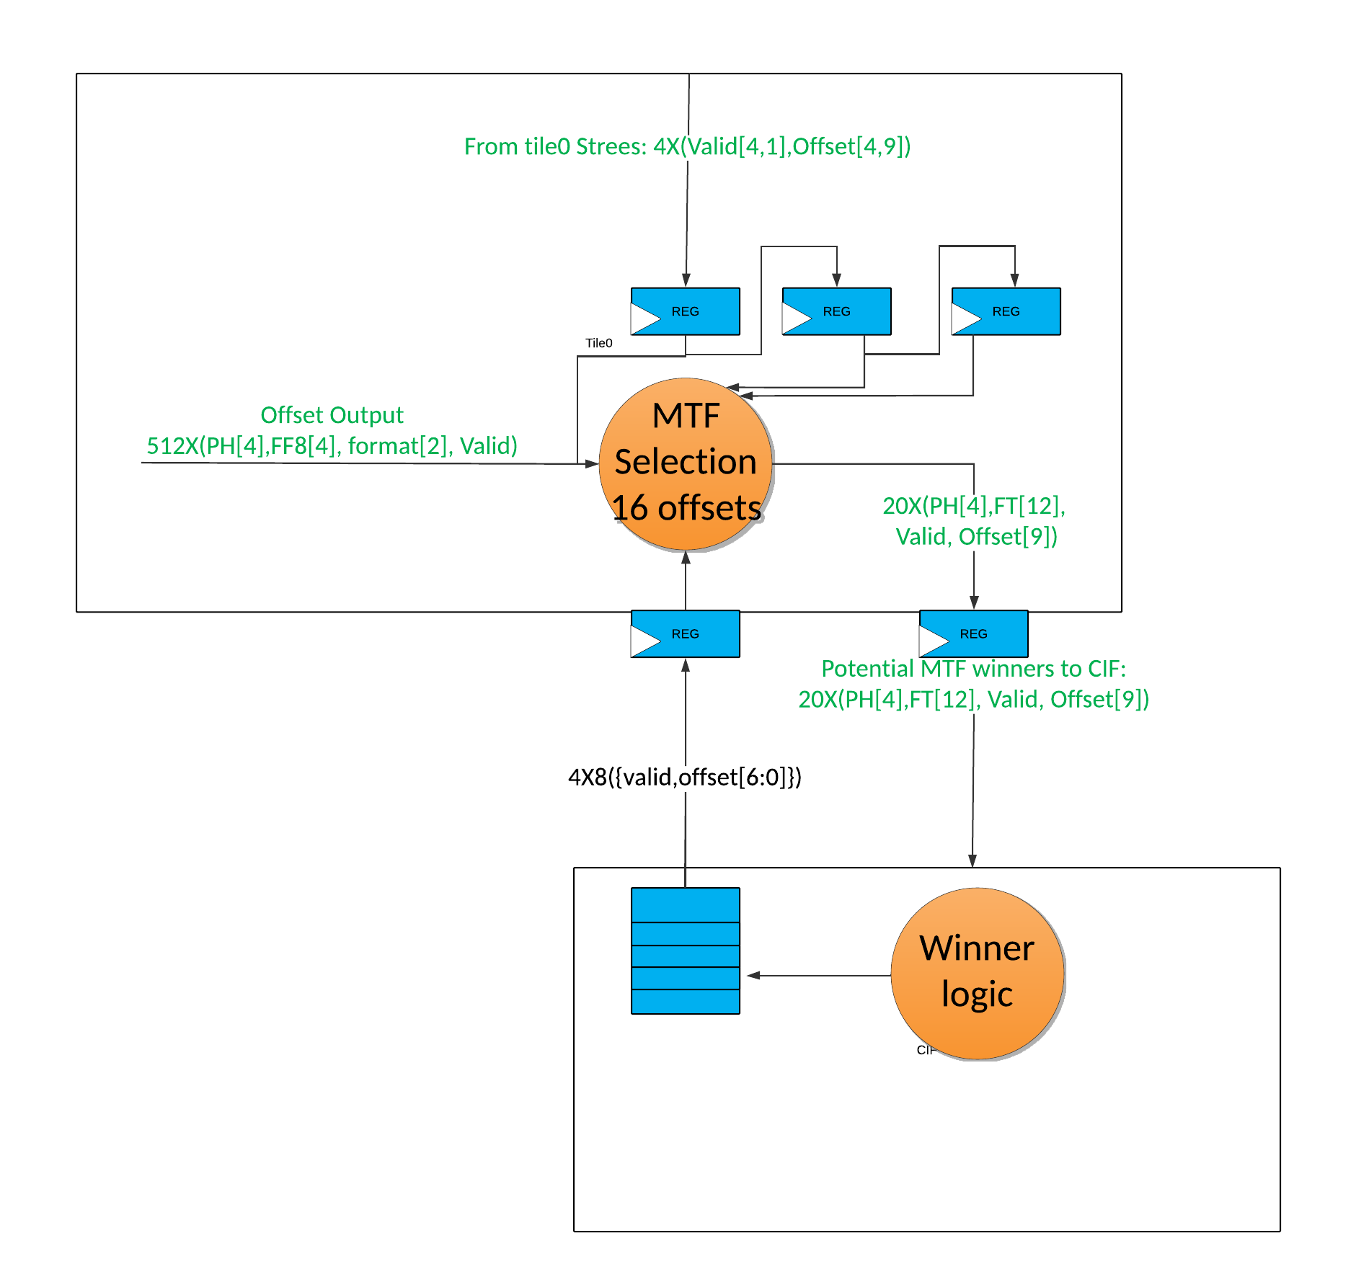

Figure 42 Tile0 MTF

The mtf output of the LPOs in tile0 requires a separate output from the regular matches. The tile logic will take all 512 of the tuples from the LPOs and multiplex them based on the 20 potential MTF offsets. This will result in 20 MTF tuples which are sent to the ME CIF to be compared with the current MTF list.

## Unsupported Matches

There are several MTF matches that are unsupported by the design.

### Unsupported phase 4 match

The first unsupported match is a length 11 phase 4 MTF match that beats a length 14 phase 2 continuing match. Due to the dummy cycle needed to determine the actual length of the phase 2 match, it is not possible to detect a third match which starts with the first byte following the end of the phase 4 MTF match. In the diagram below, in CLK 4 both the phase 2 continuing match [2,12] and the phase 4 [4,7] MTF match are output from their LPOs. In CLK 5 both arrive at the ME MDL and the [4,7] is selected as the winner. However, the [2,12] match is continuing. Also in CLK 5, based on the next state calculation and the four_indication, the MDL sends out a DMW of 4 (4,3,2). The MDL must wait until the LPO with the [2,12] goes into continuing mode before its final length can be known and a decision on which match to output can be made. In CLK 6 the LPO with the [2,12] outputs a [2,4] indicating that the match has ended with a final length of 14. Also in CLK 6 a new run which started with the byte after the end of the [4,7] MTF match is output from its LPO as [1,12] length 13. This match in not within the DMW and does not enter continuing and so will either be masked out at the LPO if it is in a cluster that is in continuing mode or is masked out at the ME CIF if it in a cluster not in continuing mode. In CLK 7 the [2,4] is sent to the MDL and the [4,7] is determined to be the winner. Unfortunately, this results in sending the SM to an illegal state. Also it is too late to send the DMW back to enable continuing for the match which is missed.



Figure 43 The unsupported phase 4 MTF match

For this design, in the event of a length 11 phase 4 MTF match occurring with a length 14 phase 2 continuing match, the MTF will be missed and the length 14 phase 2 continuing match will be output.

This is illustrated in the figure below. In this case, in CLK 7 the [2,4] is the winner, sending the SM to state U0. This allows the next continuing match to start after the length 14 match. The next continuing match is the phase 1 match truncated by 5 bytes to be a phase 4 match [4,8] with length 12.



Figure 44 Ignoring of phase 4 unsupported match

For completeness, an illustration of a length 12 phase 4 MTF match that beats a length 14 phase 2 continuing match is shown below.



Figure 45 Supported phase 4 MTF match

The tricky question is what to do when the length 11 phase 4 MTF [4,7] occurs with a length 14 phase 4 match [4,10] and a length 14 phase 2 match [2,12]. If there is no MTF, the [4,10] will win but if we have the MTF, the [4,10] will lose to the MTF and then the MTF will lose to the [2,12] due to the unsupported match. If these all happen in the same cluster, the MTF match is not detected and the [4,10] will win. In a different cluster case, the MTF is detected and it will win. The result will be MTF [4,7] with F[1] and this is specified to select [2,12] and miss the MTF.

### Unsupported phase 3 match

The second unsupported match is a length 10 phase 3 MTF match that beats a length 13 phase 1 continuing match. Due to the dummy cycle needed to determine the actual length of the phase 1 match, it is not possible to detect a third match which starts with the first byte following the end of the phase 3 MTF match. In the diagram below, in CLK 4 both the phase 1 continuing match [1,12] and the phase 3 [3,7] MTF match are output from their LPOs. In CLK 5 both arrive at the ME MDL and the [3,7] is selected as the winner. However, the [1,12] match is continuing. Also in CLK 5, based on the next state calculation and the four_indication, the MDL sends out a DMW of 3 (3,2,1). The MDL must wait until the LPO with the [1,12] goes into continuing mode before its final length can be known and a decision on which match to output can be made. In CLK 6 the LPO with the [1,12] outputs a [1,4] indicating that the match has ended with a final length of 13. Also in CLK 6 a new run which started with the byte after the end of the [3,7] MTF match is output from its LPO as [1,12] length 13. This match in not within the DMW and does not enter continuing and so will either be masked out at the LPO if it is in a cluster that is in continuing mode or is masked out at the ME CIF if it in a cluster not in continuing mode. In CLK 7 the [1,4] is sent to the MDL and the [3,7] is determined to be the winner. Unfortunately, this results in sending the SM to an illegal state. Also it is too late to send the DMW back to enable continuing for the match which is missed.



Figure 46 The unsupported phase 3 MTF match

For this design, in the event of a length 10 phase 3 MTF match occurring with a length 13 phase 1 continuing match, the MTF will be missed and the length 13 phase 1 continuing match will be output.

This is illustrated in the figure below. In this case, in CLK 7 the [1,4] is the winner, sending the SM to state U0. This allows the next continuing match to start after the length 13 match. The next continuing match is the phase 1 match truncated by 5 bytes to be a phase 4 match [4,8] with length 12.



Figure 47 Ignoring of phase 3 unsupported match

For completeness, an illustration of a length 11 phase 3 MTF match that beats a length 13 phase 1 continuing match is shown below.



Figure 48 supported phase 3 MTF match

The tricky question is what to do when the length 10 phase 3 MTF [3,7] occurs with a length 13 phase 3 match [3,10] and a length 13 phase 1 match [1,12]. If there is no MTF, the [3,10] will win but if we have the MTF, the [3,10] will lose to the MTF and then the MTF will lose to the [1,12] due to the unsupported match. If these all happen in the same cluster, the MTF match is not detected and the [3,10] will win. In a different cluster case, the MTF is detected and it will win. The result will be MTF [3,7] with F[0] and this is specified to select [1,12] and miss the MTF.

### Unsupported short matches

The use of the 5_6 indicators to compute the DMW when there is a short (len 4 or 5) phase 2 or phase 1 match, causes an issue when the short match is MTF. The 5_6 indicators mean a match of at least 6 starting at ph4, match of at least 5 starting at ph4, ph3 exists. The 5_6indicators are used to determine three cases. First, when a length 4 phase 2 match will be beaten by a phase 4 match in the current DMW, the MDL will not output a DMW in this cycle. Second, when a length 5 phase 2 match will be beaten by a phase 4 match in the current DMW, the MDL will not output a DMW in this cycle. Third, when a length 4 phase 1 match will be beaten by a phase 3 or phase 4 match in the current DMW, the MDL will not output a DMW in this cycle. If, for example, the phase 2 length 4 match is an MTF, then it will not be beaten by a length 5, 6 or 7 phase 4 match. A phase 3 match would have to have a length of 8+ to beat a phase 2 length 4 MTF. Since the MDL does not have access to an 8+ indicator, the phase 2 length 4 MTF match will be treated as a non-MTF.

This results in the following unsupported MTF cases:

US1: [2,2] MTF will be missed when followed by [4,1], [4,2] or [4,3]

US2: [2,3] MTF will be missed when followed by [4,2], [4,3] or [4,4]

US3: [1,3] MTF will be missed when followed by [4,1], [4,2], [4,3], [3,2], [3,3], or [3,4]

The figure below shows one of the US1 cases. The fact that the [2,2] is MTF is ignored and the [4,3] is selected as the winning match.



Figure 49 US1: unsupported short MTF #1

The case where the second small match is MTF also creates some unsupported cases. If, for example, a phase 2 length 4 match is followed by a phase 4 length 4 match, then the phase 2 match will win. However, if the phase 4 length 4 match is an MTF, it would be the winner. Because the MTF information is not available when the DMW information must be sent, the phase 4 length 4 MTF match will be treated as a non-MTF and the phase 2 match will win.

US4: [2,2] followed by a [4,0] MTF will miss the [4,0] MTF

US5: [2,3] followed by a [4,0] MTF will miss the [4,0] MTF

US6: [2,3] followed by a [4,1] MTF will miss the [4,1] MTF

US7: [1,3] followed by a [4,0] MTF will miss the [4,0] MTF

US8: [1,3] followed by a [3,1] MTF will miss the [3,1] MTF

The figure below shows the US4 case. The fact that the [4,0] is MTF is ignored and the [2,2] is selected as the winning match. This allows a continuing phase 1 match [1,12] to start immediately.



Figure 50 US4: Unsupported Short #4

#### Unsupported XP9 truncated MTFs

In XP9, special handling is required if an MTF symbol follows immediately after either a PTR or another MTF. In this case the lookup accesses one entry further back in the MTF index table (i.e. the entry associated with the immediately preceding back-reference is inaccessible), AND an MTF index of 3 is not allowed (i.e. an index of 3 causes an error). For example, an MTF index of 0 actually refers to MTF[1]. Similarly, an index of 1 actually refers to MTF[2], and an index of 2 actually refers to MTF[3]. This special handling does not apply to XP10.

MTF[0] is only available if a literal has been emitted after the most recent pointer (or MTF).

When a match exceeds the Maximum Length, it is truncated to the Maximum Length. There are cases when ideally, an MTF0 match would be available in XP9 but the design will not find the match as an MTF.

1. The design will not support outputting a literal to shorten a match so that it would be an MTF matching MTF offset 0.
   1. This can only occur if there is no literal between the previous match at offset N and the current match at offset N meaning they are the same match. This will only occur if a match exceeds the maximum match length and is truncated.
   2. If a match is truncated the second segment of the match will not be an MTF it will only be a PTR.
   3. If the second segment wins, the offset (N) will be put on the MTF offset list a second time and both MTF[0] and MTF[1] will be N.
   4. A third segment would be an MTF and it would be MTF[1] which receives an MTF index of 0.
   5. A fourth segment would be an MTF and it would be MTF[1] which receives an MTF index of 0. Etc.
2. The design will also miss an offset matching MTF offset 0, in the following specific cases:
   1. if the winning match at offset (N) is truncated by 1 byte only and a LIT0 match exists (a match at offset (M) starts at the byte which is truncated. The second match at offset N is not seen as an MTF if it is Phase 4 < Len16 or phase 3 < Len15. The second match at offset N is also not seen as an MTF if the match at offset M is Phase 2 > Len13 or phase 1 > Len12.

Table 46:Examples of case a XP9 Max Length MTF Miss

|  |  |  |  |  |  |  |  |
| --- | --- | --- | --- | --- | --- | --- | --- |
| Case a: | Clock Cycles |  |  |  |  |  |  |
| ph2, trunc 1B, gap 1 lit2 ptr10 | 00NN | ... | NNNN | NNN0 | NNNN | NNNN | NN00 |
| ptr 4 |  |  | 0000 | 00MM | MM00 | 0000 |  |
| Case a: |  |  |  |  |  |  |  |
| ph1, trunc 1B, gap 1 lit2 ptr10 | 000N | ... | NNNN | NNNN | 0NNN | NNNN | NNN0 |
| ptr 4 |  |  | 0000 | 000M | MMM0 | 0000 |  |

* 1. Phase2 MTF (maxlen -3) beats Phase 2 truncated. LIT0 match exists. MTF0 match (lit1 or lit2)
  2. Phase3 MTF (maxlen -1) beats Phase 3 truncated. LIT0 match exists. MTF0 match (lit1 or lit2)
  3. Phase2 MTF (maxlen -1) beats Phase 2 truncated. LIT0 match exists. MTF0 match (lit1 or lit2)
  4. Phase2 MTF (maxlen -2) beats Phase 2 truncated. LIT0 match exists. MTF0 match (lit1 or lit2)
  5. Phase1 MTF (maxlen -1) beats Phase 1 truncated. LIT0 match exists. MTF0 match (lit1 or lit2)
  6. Phase1 MTF (maxlen -2) beats Phase 1 truncated. LIT0 match exists. MTF0 match (lit1 or lit2)
  7. Phase1 MTF (maxlen -3) beats Phase 1 truncated. LIT0 match exists. MTF0 match (lit1 or lit2)

Table 47: Examples of cases b thru h XP9 Max Length MTF Miss

|  |  |  |  |  |  |  |  |
| --- | --- | --- | --- | --- | --- | --- | --- |
| Case b: | Clock Cycles |  |  |  |  |  |  |
| ph2, trunc | 00TT | ... | TTTT | TTTT | TTT0 |  |  |
| ph2 (maxlen -3), MTF, gap 1 lit1 ptr | 00NN | ... | NNNN | NNN0 | NNNN | NNNN | NN |
| ptr 4 |  |  | 0000 | 000M | MMM0 | 0000 |  |
| Case c: |  |  |  |  |  |  |  |
| Ph3, trunc | 0TTT | ... | TTTT | TTTT | TT00 |  |  |
| Ph3 (maxlen -1), MTF, gap 1 lit1 ptr | 0NNN | ... | NNNN | NNNN | 0NNN | NNNN | NN |
| ptr 4 |  |  | 0000 | 0000 | MMMM | 0000 |  |
| Case d: |  |  |  |  |  |  |  |
| ph2, trunc | 00TT | ... | TTTT | TTTT | TTT0 |  |  |
| ph2 (maxlen -1), MTF, gap 1 lit1 ptr | 00NN | ... | NNNN | NNNN | N0NN | NNNN | NN |
| ptr 4 |  |  | 0000 | 0000 | 0MMM | M000 |  |
| Case e: |  |  |  |  |  |  |  |
| ph2, trunc | 00TT | ... | TTTT | TTTT | TTT0 |  |  |
| ph2 (maxlen -2), MTF, gap 1 lit1 ptr | 00NN | ... | NNNN | NNNN | 0NNN | NNNN | NN |
| ptr 4 |  |  | 0000 | 0000 | MMMM | 0000 |  |
| Case f: |  |  |  |  |  |  |  |
| Ph1, trunc | 000T | ... | TTTT | TTTT | TTTT |  |  |
| Ph1 (maxlen -1), MTF, gap 1 lit1 ptr | 000N | ... | NNNN | NNNN | N0NN | NNNN | NNNN |
| ptr 4 |  |  | 0000 | 0000 | 0MMM | M000 |  |
| Case g: |  |  |  |  |  |  |  |
| Ph1, trunc | 000T | ... | TTTT | TTTT | TTTT |  |  |
| Ph1 (maxlen -2), MTF, gap 1 lit1 ptr | 000N | ... | NNNN | NNNN | 0NNN | NNNN | NN |
| ptr 4 |  |  | 0000 | 0000 | MMMM | 0000 |  |
| Case h: |  |  |  |  |  |  |  |
| Ph1, trunc | 000T | ... | TTTT | TTTT | TTTT |  |  |
| Ph1 (maxlen -2), MTF, gap 1 lit1 ptr | 000N | ... | NNNN | NNN0 | NNNN | NNNN | NN |
| ptr 4 |  |  | 0000 | 000M | MMM0 | 0000 |  |

There are cases where the MTF0 is found as an MTF due to the State Machine behavior. In other words, there are several exceptions to the cases above meaning that the design will give the ideal results.

`The MTF0 will be found if the matches cause the state machine to:

1. Go to state UM1 and then to state UM4_1 or state UM3
2. Go to state UM2 and then to state UM4_2
3. Go to state U0 and then to state UM3d
4. Go to state U1 and then to state UM2d
5. Go to state U2 and then to state UM1d
6. Go to state U1 and then to state UM1d
7. Go to state U0 and then to state UM2d
8. Go to state U0, when MTF0 is in tile0 and there is a continuing match
9. Go to state U1, when MTF0 is in tile0 and there is a continuing match

# LZ77 Output

The LZ77 output block receives compression results (length, offset and literals) from the LZ77 compressor and converts them to data formatted for the Huffman Encoder. The output is TLV formatted, packed, and is fed to the TLV Reassembler before going to the AXI Master interface connected to the Huffman Encoder. The LZ77 output block may also receive bypass data directly from the TLV processing block. Bypass data received is already “TLV formatted”. No format translation is needed on the bypass data in the LZ77 output block. The inbound data frames are written into a FIFO. A programmable watermark exists to apply backpressure using the out_stall signal. The LZ77 output block contains the performance monitoring unit which generates events for global counting.

Each input is read from the FIFO and converted into output message format to be sent to the TLV Reassembler block. If the TLV Reassembler is unable to accept a message, it applies backpressure by not activating the TLV_rd signal. When in bypass mode, the out_bypass_active signal will be set and the entire frame of data will be written to the FIFO from the TLV Processing Block. If the frame is not to be bypassed the TLV Processing block will send a single message for the frame and all of the frame data will be formed from the output of the LZ77 Compression Block. The interfaces to the LZ77 Output block are shown in Table 46.

Table 48: LZ77 Output Block Interfaces

|  |  |  |
| --- | --- | --- |
| Name | I/O | Description |
| **input to LZ77 output from Compressor** | | |
| Lz77_type0[1:0] | I | slot0 type = 00:null, 01:literal |
| Lz77_type1[1:0] | I | slot1 type = 00:null, 01: literal |
| Lz77_type2[1:0] | I | slot2 type = 00:null, 01: literal |
| Lz77_type3[1:0] | I | slot3 type = 00:null, 01: literal |
| Lz77_type4[1:0] | I | Slot4 type = 10:PTR, 11:MTF |
| Lz77_literal0[7:0] | I | slot0 literal : null if not valid |
| Lz77_literal 1[7:0] | I | slot1 literal : null if not valid |
| Lz77_literal 2[7:0] | I | slot2 literal : null if not valid |
| Lz77_literal 3[7:0] | I | slot3 literal : null if not valid |
| Lz77_Ptr_length[15:0] | I | The length for the match: null if not valid |
| Lz77_Ptr_offset[15:0] | I | Offset for match (or MTF) : null if not valid |
| Lz77_comp_last | I | 1: indicates that this is End Of Frame (EOF) |
| **to LZ77 Output from TLV processing block** | | |
| out_stall | O | LZ77 output block cannot accept any more data |
| out_ready | I | 1: indicates that output sample is Valid on the output interface |
| out_data[63:0] | I | bypass Data Sample on the output interface |
| out_tid[8:0] | I | AXI4 tid |
| out_tuser[7:0] | I | AXI4S tuser |
| out_ordern[7:0] | I | TLV order Number |
| out_typen[7:0] | I | TLV type number |
| out_sot | I | Start of TLV |
| out_eot | I | End of TLV |
| out_bypass_active | I | 1: indicates that bypass mode is on |
| **Control and Status** | | |
| PMU_event[25:0] | O | Events from Performance Monitoring Unit |
| **LZ77 output (User outbound) to TLV Reassembler** | | |
| usr_ob_full | I | Reassembler FIFO full flag |
| usr_obafull | I | Reassembler almost full flag (parameter AFULL_VAL) |
| usr_ob_wr | O | User logic write strobe to write TLV to Reassembler |
| usr_ob_tlv.insert | O | TLV insert indicates a new TLV will be inserted after the Typen |
| usr_ob_tlv.ordern[7:0] | O | TLV order Number |
| usr_ob_tlv.typen[7:0] | O | TLV type number (tlv insert uses this field as after type number) |
| usr_ob_tlv.sot | O | Start of Type |
| usr_ob_tlv.eot | O | End of Type |
| usr_ob_tlv.tlast | O | AXI4S tlast |
| usr_ob_tlv.tid[13:0] | O | AXI4 tid |
| usr_ob_tlv.tuser[7:0] | O | AXI4S tuser |
| usr_ob_tlv.tdata[63:0] | O | TLV data |

The connections from the input message as it exits the FIFO to the output to the TLV Reassembler are one to one if the out_bypass_active signal is set. If it is not set, then the data portion of the output message to the TLV Reassembler is formed from the output of the LZ77 Compressor. The TLV_Type_Num signal will be used to indicate the difference between a bypass TLV and an LZ77 Compressed TLV. The format for the data to the TLV Reassembler when not in bypass mode is shown in Table 47. The necessary output to the TLV Reassembler based on the input from the LZ77 Compressor are shown in **Error! Reference source not found.**. Any output from the LZ77 Compressor that includes EOF will result in an additional output to the TLV Reassembler which is an EOF with the lz77_framing[3:0] = 15 and no associated data.

Table 49: LZ77 payload TLV Format

|  |  |  |
| --- | --- | --- |
| **lz77_henc_ tdata** | **LZ77 Payload TLV Header Type** | **Description** |
| 63:60 | lz77_framing[3:0] | Framing information: |
| ·        [0,4] – 0 through 4 lanes valid |
| ·        [15] – EOF only, no data associated with transfer |
| 59:52 | lz77_data0[7:0] | Literal data or lower bits of back reference offset |
| 51:44 | lz77_data1[7:0] | ·        For PTR – ptr_offset[7:0] |
| 43:36 | lz77_data2[7:0] | ·        For MTF – mtf_num[1:0] |
| 35:28 | lz77_data3[7:0] |  |
| 27 | lz77_backref_vld | Bus Qualifier |
| ·        0 – back reference is not present |
| ·        1 – back reference is present |
| 26 | lz77_backref_type | Back reference type |
| ·        0 – PTR |
| ·        1 – MTF |
| 25:24 | lz77_backref_lane[1:0] | Lane number containing the back reference |
| ·        0 – Lane 0 |
| ·        1 – Lane 1 |
| ·        2 – Lane 2 |
| ·        3 – Lane 3 |
| 23:16 | lz77_offset_msb[7:0] | Upper bits of PTR offset |
| 15:0 | lz77_length[15:0] | Back reference length |

### Packing

The purpose of the packing function is to prevent backpressure from being created in the LZ77 output block because the interface to the Huffman is not being maximally utilized. The goal is to ensure that coding block boundaries are predictable regardless of the bus occupancy of the LZ77 symbol data. The packing function is used to fill (if possible) the values going to the TLV Reassembler. Data that does not fill an entry for the Huffman Interface will remain in the packing function until additional data arrive to complete the entry or force out the data that has been stored.

Rules:

1. If there are no literals or matches that are “left over” from a previous FIFO read, there is no old data to pack
2. If there are no additional values in the FIFO, there is no new data to pack.
3. If the lz77_framing[3:0] associated with the “left over” data is 4, the message is sent to the TLV Reassembler.
4. If there is a match that is “left over” from a previous FIFO read (lz77_backref_vld = 1), no addition match may be packed.
5. Data must be packed in order: “left over” data, new data.
6. If an EOF arrives, any “left over” is sent as is to the TLV Reassembler, and an EOF message without data is sent to the TLV Reassembler.

### Performance Monitor Unit / Statistics

The performance monitor unit (PMU) is tightly coupled with the LZ77 Output block and generates strobes based on characteristics of the LZ77 Compressed Symbols. This unit monitors the packed interface and decodes the events shown below in Table 48.

Table 50: Performance Monitor Events

|  |  |  |  |
| --- | --- | --- | --- |
| Num | Description | Trigger | Condition |
| 1 | 1 Literal Present | usr_ob_wr | (lz77_backref_vld = 0 and lz77_framing[3:0] = 1) or (lz77_backref_vld = 1 and lz77_framing[3:0] = 2) |
| 2 | 2 Literals Present | usr_ob_wr | (lz77_backref_vld = 0 and lz77_framing[3:0] = 2) or (lz77_backref_vld = 1 and lz77_framing[3:0] = 3) |
| 3 | 3 Literals Present | usr_ob_wr | (lz77_backref_vld = 0 and lz77_framing[3:0] = 3) or (lz77_backref_vld = 1 and lz77_framing[3:0] = 4) |
| 4 | 4 Literals Present | usr_ob_wr | lz77_backref_vld = 0 and lz77_framing[3:0] = 4 |
| 5 | LZ77 PTR Symbol Generated | usr_ob_wr | lz77_backref_vld = 1 and lz77_backref_type = 0 |
| 6 | MTF Symbol Generated | usr_ob_wr | lz77_backref_vld = 1 and lz77_backref_type = 1 |
| 7 | Matches of Length = 3 Event | usr_ob_wr | lz77_backref_vld = 1 and lz77_length[15:0] = 3 |
| 8 | Matches of Length=4 Event | usr_ob_wr | lz77_backref_vld = 1 and lz77_length[15:0] = 4 |
| 9 | Matches of Length=5 Event | usr_ob_wr | lz77_backref_vld = 1 and lz77_length[15:0] = 5 |
| 10 | Matches of Length=6 Event | usr_ob_wr | lz77_backref_vld = 1 and lz77_length[15:0] = 6 |
| 11 | Matches of Length=7 Event | usr_ob_wr | lz77_backref_vld = 1 and lz77_length[15:0] = 7 |
| 12 | Matches of Length=8 Event | usr_ob_wr | lz77_backref_vld = 1 and lz77_length[15:0] = 8 |
| 13 | Matches of Length= 9 Event | usr_ob_wr | lz77_backref_vld = 1 and lz77_length[15:0] = 9 |
| 14 | Matches of Length=10 Event | usr_ob_wr | lz77_backref_vld = 1 and lz77_length[15:0] = 10 |
| 15 | Matches of Length >10 & Length <32 Event | usr_ob_wr | lz77_backref_vld = 1 and lz77_length[15:0] > 10 and lz77_length[15:0] < 32 |
| 16 | Matches of Length >=32 & Length <64 Event | usr_ob_wr | lz77_backref_vld = 1 and lz77_length[15:0] > 31 and lz77_length[15:0] < 64 |
| 17 | Matches of Length >=64 and Length <128 Event | usr_ob_wr | lz77_backref_vld = 1 and lz77_length[15:0] > 63 and lz77_length[15:0] < 128 |
| 18 | Matches of Length >=128 and Length <256 Event | usr_ob_wr | lz77_backref_vld = 1 and lz77_length[15:0] > 127 and lz77_length[15:0] < 256 |
| 19 | Matches of Length =>256 Event | usr_ob_wr | lz77_backref_vld = 1 and lz77_length[15:0] > 255 |
| 20 | MTF 0 detected | usr_ob_wr | lz77_backref_vld = 1 and lz77_backref_type = 1 and ((lz77_backref_lane[1:0]= 0 and lz77_data0[7:0] = 0) or (lz77_backref_lane[1:0]= 1 and lz77_data0[7:0] = 0) or (lz77_backref_lane[1:0]= 2 and lz77_data0[7:0] = 0) or (lz77_backref_lane[1:0]= 3 and lz77_data0[7:0] = 0)) |
| 21 | MTF 1 detected | usr_ob_wr | lz77_backref_vld = 1 and lz77_backref_type = 1 and ((lz77_backref_lane[1:0]= 0 and lz77_data0[7:0] = 1) or (lz77_backref_lane[1:0]= 1 and lz77_data0[7:0] = 1) or (lz77_backref_lane[1:0]= 2 and lz77_data0[7:0] = 1) or (lz77_backref_lane[1:0]= 3 and lz77_data0[7:0] = 1)) |
| 22 | MTF 2 detected | usr_ob_wr | lz77_backref_vld = 1 and lz77_backref_type = 1 and ((lz77_backref_lane[1:0]= 0 and lz77_data0[7:0] = 2) or (lz77_backref_lane[1:0]= 1 and lz77_data0[7:0] = 2) or (lz77_backref_lane[1:0]= 2 and lz77_data0[7:0] = 2) or (lz77_backref_lane[1:0]= 3 and lz77_data0[7:0] = 2)) |
| 23 | MTF 3 detected | usr_ob_wr | lz77_backref_vld = 1 and lz77_backref_type = 1 and ((lz77_backref_lane[1:0]= 0 and lz77_data0[7:0] = 3) or (lz77_backref_lane[1:0]= 1 and lz77_data0[7:0] = 3) or (lz77_backref_lane[1:0]= 2 and lz77_data0[7:0] = 3) or (lz77_backref_lane[1:0]= 3 and lz77_data0[7:0] = 3)) |
| 24 | Bypass Frame detected | fifo_rd | out_ready = 1 and out_stall = 0 and out_bypass_active= 1 and out_sot = 1 |
| 25 | EOF detected | usr_ob_wr | lz77_framing[3:0] = 15 |

All PMU signals have been defined to be Event strobes rather than counts, so in the case of 1/2/3/4 literals valid on the interface, separate strobes will be generated. At the STATS interface (the top level) a pure literal counter will be properly incremented by the correct amount (+1, +2, +3 or +4).

The necessary connections to the PMU are shown in Table 49.

Table 51: Performance Monitor Interfaces

|  |  |  |  |
| --- | --- | --- | --- |
| ***Signal*** | ***Width*** | ***I/O*** | ***Description*** |
| clk | 1 | I | Block Clock. 800 Mhz |
| rst_n | 1 | I | Asynchronous block reset. Active Low |
| **User TLV** | | | |
| lz77_length | 16 | I | PTR or MTF Length (16 bits allows a 64K back reference length) |
| Lz77_backref_lane | 2 | I | Lane that PTR or MTF resides |
| Lz77_backref_vld | 1 | I | PTR or MTF is Valid |
| Lz77_backref_type | 1 | I | Indicator for type of LZ77 reference used  0: PTR  1: MTF |
| Lz77_data0 | 8 | I | Literal or PTR Offset [7:0] or MTF Index[1:0] |
| LZ77_data1 | 8 | I | Literal of PTR Offset[7:0] or MTF Index[1:0] |
| Lz77_data2 | 8 | I | Literal or PTR Offset[7:0] or MTF Index[1:0] |
| Lz77_data3 | 8 | I | Literal or PTR Offset[7:0] or MTF Index[1:0] |
| Lz77_framing | 4 | I | Bus Decode indicator |
| **Compressor Output** | | | |
| Type0 | 2 | I | 2: a second match pointer; 3: a second match MTF |
| **FIFO Output** | | | |
| Bypass_en | 1 | I | 1: a bypass frame has occurred |
| **Performance Monitor Stats** | | | |
| lz_pmu_evt | 28 | O | 0=literal_cnt_1  1=literal_cnt_2  2=literal_cnt_3  3=literal_cnt_4  4=ptr  5=mtf  6=ptr_len_3  7=ptr_len_4  8=ptr_len_5  9=ptr_len_6  10=ptr_len_7  11=ptr_len_8  12=ptr_len_9  13=ptr_len_10  14=ptr_len_11_31  15=ptr_len_32_63  16=ptr_len_64_127  17=ptr_len_128_255  18=ptr_len_256_64k  19=mtf_0  20=mtf_1  21=mtf_2  22=mtf_3  23=bypass  24=eof |

# TLV Reassembler and AXI Master (LZ77 instantiation)

The TLV Reassembler reassemble the outbound data stream from the Pass-through FIFO and the User generated TLV’s using the TLV Order Number.

The TLV Reassembler will work using the following rules to arbitrate the two input interfaces:

1. A new outbound frame always begins with TLV Order number 1.
2. The reassemble will keep track of the next order number expected by incrementing the last order number written into the output FIFO.
3. The Reassembler will keep track of the last tlv number written into the output FIFO.
4. If either interface has a TLV available and it matches the next order number then that interface will be serviced.
5. If both pass-through and User interfaces have tlv’s available, and neither matches the next order number, then the interface with the lowest Order Number will be serviced first. Note this allows an order number to be skipped, i.e. deleted TLV’s.
6. If the User interface has a TLV available and the insert bit is set, then the user tlv type number field will be used as the “tlv after” number. When the next tlv number equals the user “tlv after” number then insert tlv will be processed. Note the order number is not used in this case. After the tlv is inserted the reassemble will return to normal processing.
7. The TLV Reassembler will use the outbound FIFO full flag to stall reading of the pass-through and User Data.
8. Only the TLV data will be written into the outbound FIFO. The sideband signals, SOT/EOT, TLV order number etc. will be stripped prior to the FIFO.

The block diagram, Figure 2, shows how the TLV Reassembler is connected to the other blocks in the LZ77 Compression Engine. The interfaces are shown in Table 50. The configuration into the TLV Reassembler will not be used in the LZ77 Compression Block and so Insert_TLV, Insert_Type and Insert_After will be set to zero.

Table 52: TLV Reassembler and AXI Master Block Interfaces

| Name | I/O | Description |
| --- | --- | --- |
| **Clocks and resets** |  |  |
| clk | I | 800MHz clock |
| Rst_n | I | Active low reset |
| **AXI4S Master** |  |  |
| tid[8:0] | O | Data block identifier. |
| tvalid | O | TVALID indicates that the master is driving a valid transfer.  A transfer takes place when both TVALID and TREADY are asserted.  0: not valid; 1: valid. |
| tlast | O | Last data phase of the data block. |
| tstrb[7:0] | O | Byte strobes corresponding to:  TSTRB[0] : TDATA[7:0]  TSTRB[1] : TDATA[15:8]  …  TSTRB[7] : TDATA[63:0]  Data Byte Valid: 0 : Not valid; 1 : Valid.  Only thermometer codes allowed (e.g. 0000_0001 through 1111_1111) |
| tuser[7:0] | O | TUSER[0] : Start of TLV (first beat)  TUSER[1] : End of TLV (last beat)  TUSER[7:2] : All 0 |
| tdata[63:0] | O | TDATA is the primary payload that is used to provide the data that is passing across the interface. The width of the data payload is an integer number of bytes. |
| tready | I | TREADY indicates that the slave can accept a transfer in the current cycle.  0: not accepted; 1: accepted |
| **LZ77 Output to TLV Reassembler** | | |
| usr_ob_full | O | Reassembler FIFO full flag |
| usr_obafull | O | Reassembler almost full flag (parameter AFULL_VAL) |
| usr_ob_wr | I | User logic write strobe to write TLV to Reassembler |
| usr_ob_tlv.insert | I | TLV insert indicates a new TLV will be inserted after the typen |
| usr_ob_tlv.ordern[7:0] | I | TLV order Number |
| usr_ob_tlv.typen[7:0] | I | TLV type number (tlv insert uses this field as after type number) |
| usr_ob_tlv.sot | I | Start of Type |
| usr_ob_tlv.eot | I | End of Type |
| usr_ob_tlv.tlast | I | AXI4S tlast |
| usr_ob_tlv.tid[13:0] | I | AXI4 tid |
| usr_ob_tlv.tuser[7:0] | I | AXI4S tuser |
| usr_ob_tlv.tdata[63:0] | I | TLV data |
| **TLV Passthrough to TLV Reassembler** | | |
| tlvp_pt_rd | O | Passthrough FIFO read strobe |
| tlvp_pt_empty | I | Passthrough FIFO empty |
| tlvp_pt_aempty | I | Passthrough FIFO almost empty (parameter AEMPTY_VAL) |
| tlvp_pt_tlv.insert | I | TLV insert (will always be 0 for Pass through interface) |
| tlvp_pt_tlv.ordern[7:0] | I | TLV order Number |
| tlvp_pt_tlv.typen[7:0] | I | TLV type number |
| tlvp_pt_tlv.sot | I | Start of Type |
| tlvp_pt_tlv.eot | I | End of Type |
| tlvp_pt_tlv.tlast | I | AXI4S tlast |
| tlvp_pt_tlv.tid[8:0] | I | AXI4S tid |
| tlvp_pt_tlv.tuser[7:0] | I | AXI4S tuser |
| tlvp_pt_tlv.tdata[63:0] | I | Passthrough FIFO read data |

### AXI4S Master

The AXI4S master reads data from the TLVP output FIFO, registers it, and drives the AXI4 Streaming interface. The input tready is used along with the FIFO flags to create the FIFO read.

# Backpressure

Backpressure is supported throughout the LZ77 Compression Engine Block. Figure 49 shows the backpressure diagram. Backpressure will come from two sources.

The Huffman Encoder is the primary source of backpressure. It will cause axi4s_ready to be low which would ultimately cause the TLV reassembler to become full. This will cause the LZ77 to not write on the user path and the TLV disassembler on the pass through path to not be read. When the LZ77 becomes almost full, output stall is sent to the TLV processing block which will in turn not read from the TLV disassembler. When the TLV disassembler is full, it will not read from the AXI streaming interface. When the AXI streaming interface is full, it will set axi ready to 0 thus backpressuring the prefix engine.

The LZ77 Output block is the second source of backpressure. When the LZ77 becomes almost full, output stall is sent to the TLV processing block which will in turn not read from the TLV disassembler. When the TLV disassembler is full, it will not read from the AXI streaming interface. When the AXI streaming interface is full, it will set axi ready to 0 thus backpressuring the prefix engine.

The LZ77 compressor is not backpressured and does not generate backpressure. It will always keep up with the incoming data stream. In the event the LZ77 output block cannot keep up, due to it being only able to output one match per clock cycle, the LZ77 output block will backpressure the TLV processing block via output stall. The TLV processing block will then stop sending data to the LZ77 compressor. The LZ77 output block will send the stall while it still has enough room in the FIFO to accept all the data that is in process in the LZ77 Compressor.



Figure 51: Backpressure Diagram

# Debug

Several features exist to support debug of the LZ77 compressor.

1. 26 Performance Monitor Statistics as described in 11.1.2
2. Frame and Byte counters as described in 14.1.1.
3. TLV_Processing_status word for configuration error detection as shown in Table 7.
4. Debug configurations:
   * LZ77MaxSymbolLen = 64B or 14B + Min
   * compAlgorithm = bypass
   * Number_MTF = 0
   * LZ77DelayMatchWin = 1 or 0
   * LZ77WinSize = 64B

### Statistics

The lz77 compressor maintains counters which can be read via the RBUS interface. All counters are set to zero at reset time and can be set to zero via a CSR register access via the RBUS interface.

The following counters shall be included:

1. Number of Incoming Frames i.e. SOF received
2. Number of Outgoing Frames i.e. SOF sent
3. Number of Incoming Frames with errors
4. Incoming bytes
5. Outgoing bytes

# Software Interface Overview

Most control information needed by the LZ77 Compression Engine are received via TLV’s. However, there is a small amount of control held in registers which require SW configuration. These are listed below (see cr_lz77_comp.rdb for complete details).

SW should configure the tlv_parse_action register according to

Table 53: TLV Parser Action Settings for LZ77 Compression Engine

|  |  |  |  |  |
| --- | --- | --- | --- | --- |
| revision_config | Revision read only register | | | |
| Field name | Field | Default | Description | |
| revid | [7:0] | 0 | Revision control register.  Connect to TIE cells in order to change via 1 layer metal spin. | |
| spare_config | Spare configuration register | | | |
| Field name | Field | Default | Description | |
| spare | [31:0] | 0 | Spare control register. | |
| tlv_parse_action_hi | Per type TLV Parser Action where actions enumerations are   * REPLICATE * PASS * MODIFY * DELETE | | | |
| Field name | Field | Default | Description | |
| Type31_action | [63:62] | PASS | type number 31 action | |
| Type30_action | [61:60] | PASS | type number 30 action | |
| Type29_action | [59:58] | PASS | type number 29 action | |
| Type28_action | [57:56] | PASS | type number 28 action | |
| Type27_action | [55:54] | PASS | type number 27 action | |
| Type26_action | [53:52] | PASS | type number 26 action | |
| Type25_action | [51:50] | PASS | type number 25 action | |
| Type24_action | [49:48] | PASS | type number 24 action | |
| Type23_action | [47:46] | PASS | type number 23 action | |
| Type22_action | [45:44] | PASS | type number 22 action | |
| Type21_action | [43:42] | PASS | type number 21 action | |
| Type20_action | [41:40] | PASS | type number 20 action | |
| type19_action | [39:38] | PASS | type number 19 action | |
| type18_action | [37:36] | PASS | type number 18 action | |
| type17_action | [35:34] | PASS | type number 17 action | |
| type16_action | [33:32] | PASS | type number 16 action | |
| tlv_parse_action_lo | Per type TLV Parser Action where actions enumerations are   * REPLICATE * PASS * MODIFY * DELETE | | | |
| type15_action | [31:30] | PASS | type number 15 action | |
| type14_action | [29:28] | PASS | type number 14 action | |
| type13_action | [27:26] | PASS | type number 13 action | |
| type12_action | [25:24] | PASS | type number 12 action | |
| type12_action | [23:22] | PASS | type number 11 action | |
| type10_action | [21:20] | PASS | type number 10 action | |
| type9_action | [19:18] | PASS | type number 9 action | |
| type8_action | [17:16] | PASS | type number 8 action | |
| type7_action | [15:14] | PASS | type number 7 action | |
| type6_action | [13:12] | PASS | type number 6 action | |
| type5_action | [11:10] | PASS | type number 5 action | |
| type4_action | [9:8] | PASS | type number 4 action | |
| type3_action | [7:6] | PASS | type number 3 action | |
| type2_action | [5:4] | PASS | type number 2 action | |
| type1_action | [3:2] | PASS | type number 1 action | |
| type0_action | [1:0] | PASS | type number 0 action | |
| compression_config | Control to configure various compression features | | | |
| Field name | Field | | Default | Description |
| mtf_en | [0] | | 0 | Enable the Move-To-Front feature. |

1. Vocabulary

Move To Front

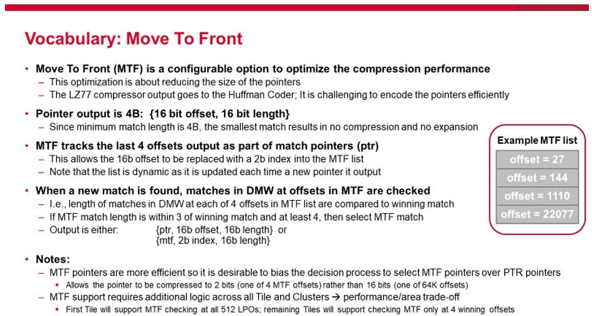

Phase:

* LPO byte match results are illustrated with grey box shown 🡺
  + Major hash marks show the clock cycles, minor hash marks show byte match per phase
  + Four input bytes so four byte match results per clock cycle
* Numbering along bottom is byte offset from the newest input byte at the LPO
  + E.g. Byte match result at position 12 arrived 3 clocks ago on phase 1



Figure 52 Vocabulary: Phase

Anchor

* LPO anchors it’s local data around input bytes from 3 clocks earlier
  + The Match Engine makes a decision each clock cycle based on data generated relative to the anchor position
    - E.g. Decides to output Literals or start/continue/track Matches
* The anchor is the phase1 input at position 12 in LPO 🡪 this is chosen to allow the LPO to collect forward data for 3 clocks
  + Three clocks is chosen to accommodate the 3 clock cycle feedback loop between Match Engine & LPOs
  + Note: numbering in Match Engine is +4 since state is one clock cycle delayed



Figure 53 Vocabulary – Anchor

Thermometer

* Thermometer is an encoding of a number ‘n’ using a series of ‘n’ ones followed by a zero
  + LZ77 uses thermometer encoding to represent match length because it is easier to compare and find largest
    - e.g. Match length of 5 = 0’b0001_1111
  + LZ77 uses both forward and backward thermometers
    - Convention here is:
      * bkwd_fromN[p:0] 🡪 starting at position ‘N’ count the number of ‘1’s (matches) going backward in time; once a 0 is reached the rest of the thermometer is all zeros
      * fwd_fromN[q:0] 🡪 starting at position ‘N’ count the number of ‘1’s (matches) going forward in time (newer data); once a 0 is reached the rest of the thermometer is all zeros
      * Note: therm encodings start at the lsb; see examples 🡪
* For example, given 3 bit thermometer, therm[2:0], the only possible encodings are,
  + therm[2:0] = 000 (referred to as, "thermometer value 0")
  + therm[2:0] = 001 (referred to as, "thermometer value 1")
  + therm[2:0] = 011 (referred to as, "thermometer value 2")
  + therm[2:0] = 111 (referred to as, "thermometer value 3")

Thermometers are used as an efficient way to compare match results from different offsets

* In hardware is it easier to compare therms: 0111_1111 and 0001_1111
* than hex values: 0x7 and 0x5 (length of the matches)



Figure 54 Vocabulary - Thermometer

1. Match Examples

Basic Match – no MTF, DMW = 0, 1B input per clock

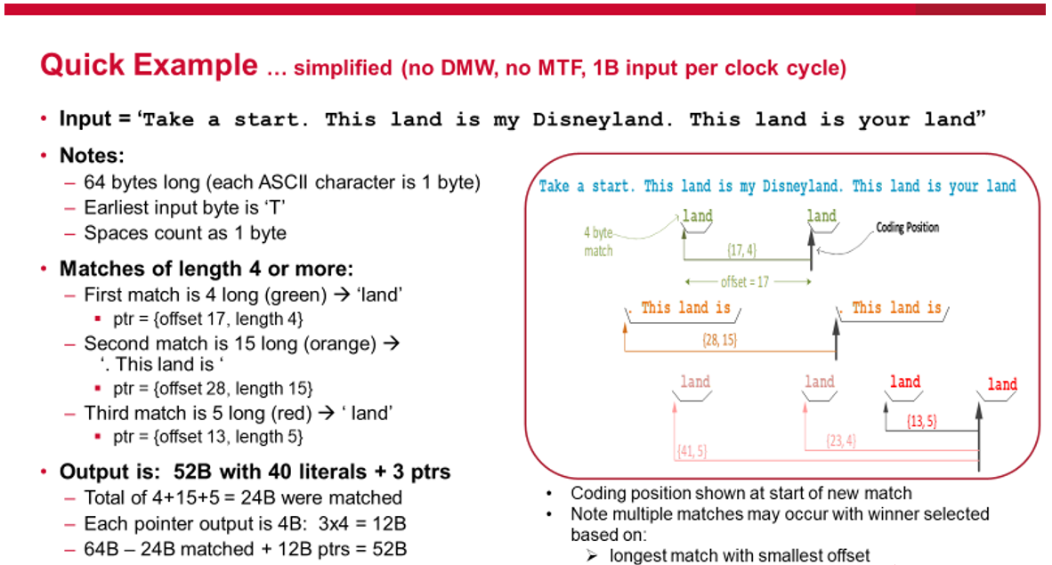

Example of DMW = 2

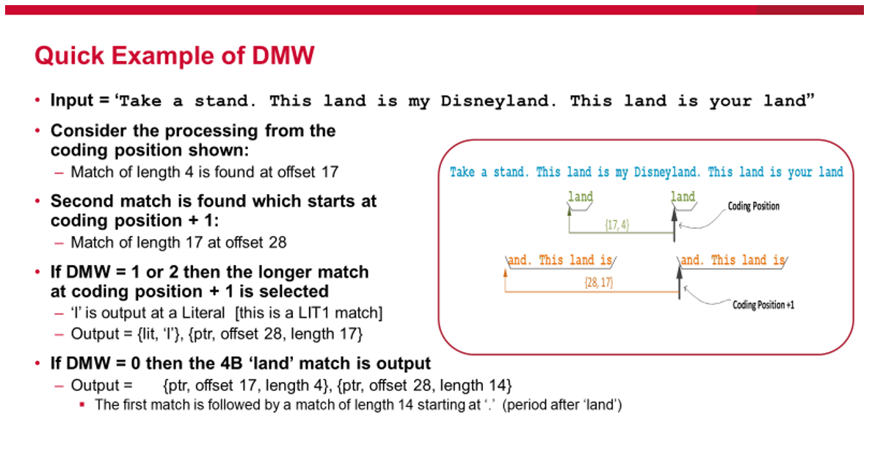

Example of MTF with DMW = 2

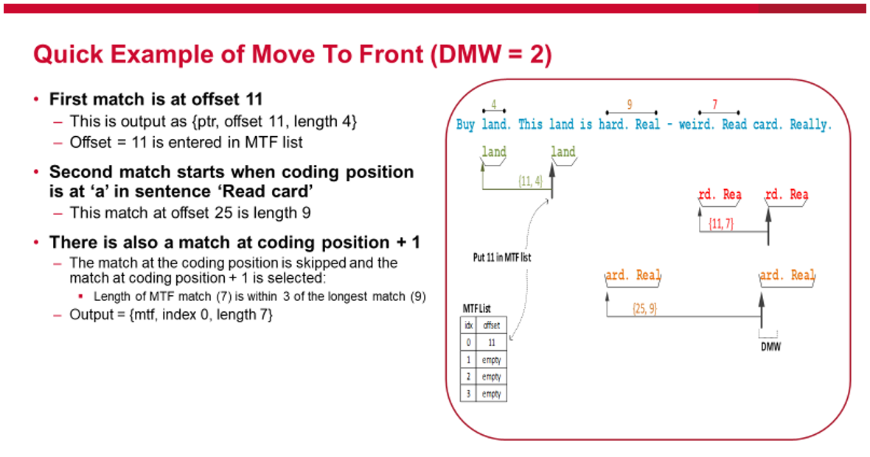

1. See specific sections for exact signal names